*Florida International University*

*School of Computing and Information Sciences*

CIS 4911 – Senior Capstone Project

Software Engineering Focus

Final Deliverable

Virtual Job Fair 6.0

Team #X

**Product Owners**

Fernando Figueredo, Ph.D., APR.

Emmanuela Stanislaus, M.Sc.

Ivette Duarte, M.S.

**Instructor and Mentor**

Masoud Sadjadi, Ph.D.

**Team Members**

Rene Alfonso

Yanniel Malagon

2015

Copyright © Florida International University 2015. All Rights Reserved. No part of the Virtual Job Fair Project or documentation may be reproduced or modified without the express consent of Florida International University. Redistribution or commercial use is strictly prohibited.

***Abstract***

*The Virtual Job fair system is an efficient way to make a connection between job-seeking students and employers. It facilities the hiring process for both parties involved, and provides a simple and efficient solution for our technologically driven job market. The Final Deliverable document includes a detailed analysis of the Virtual Job Fair system as of version 6.0. The main purpose of this documented is to facilitate, in a well-documented manner, all the information about the system as well as the updated work completed during this version.*

*This document includes extensive details about the current system’s user stories, the newly developed user stories implemented during the last five sprints of version 6.0, all the bugs that were patched, an in-depth explanation of the software architecture used, the design patterns implemented to enhance the solution, testing criteria, analysis, UML diagrams, pictures of the system’s features, a breakdown of all sprint review meetings, and sprint retrospective reviews. Ultimately this document is a powerful guide that documents all the work done as of version 6.0. It, also, serves as a structured-guide for future developers so that they can quickly become familiar with the system.*

Table of Contents

Introduction 5

Current System 5

Purpose of New System 9

User Stories 19

Implemented User Stories 19

Pending User Stories 19

Project Plan 45

Hardware and Software Resources 45

Sprints Plan 47

Sprint 1 47

Sprint 2 51

Sprint 3 64

Sprint 4 76

Sprint 5 86

Project Gantt Chart 88

System Design 91

Architectural Patterns 92

System and Subsystem Decomposition 92

Deployment Diagram 98

Design Patterns 99

System Validation 100

Glossary 108

Appendix 110

Appendix A - UML Diagrams 110

Static UML Diagrams 110

Dynamic UML Diagrams 116

Appendix B - User Interface Design 125

Appendix C - Sprint Review Reports 141

Appendix D - Sprint Retrospective Reports 143

References 145

# Introduction

This chapter introduces the current version of Virtual Job Fair as well as the new version of Virtual Job Fair, version 6.0. All past features shall be mentioned as well as new features, updates, and bug patches.

This document is divided into sections: User Stories which includes information about the user stories that were generated per demand of the product owners. Project Plan which includes details about how the work of the project was planned. System Design which provides detailed information about the architectural patterns, system, subsystems, deployment diagram, and design patterns. The System Validation section which describes the tests used to validate the system. The Glossary, which covers key terms used in the document. The Appendix section which has essential diagrams, UI pictures, sprint review reports, and retrospective reports. The References section, which has all of this document’s references.

## Current System

The current system of Virtual Job Fair, version 5.0, was developed by Rogelio Alonso with the overview and guidance of Dr. Sadjadi.

The Virtual Job Fair project was introduced by Dr. Masoud Sadjadi as one of the assigned projects for the Senior Project class in the spring of 2013. It was initially developed by a team of five students, along with the overview and guidance of Dr. Sadjadi and Juan Caraballo. Then the project was [continued] in the fall of 2013 by another group that [was] assigned with the task of improving [the] existing application and of developing additional functionality. (Alonso)

Since then, every semester, students are assigned with the task of improving past features and adding new features to the system. In this section we shall discuss the state of the system as of version 5.0. This section will be divided by subsystem so that we can simplify the way we analyze the current system.

**Alternative Logins Subsystem**:

The current version of the system provided users with the ability to register a new account using Gmail, so that the user could register easily. However, when the account was created, it was missing the Basic Profile info relation in the database. So the profile was being displayed incorrectly.

Users could login as guest students or guest employers, but their accounts had no restrictions to the site. That is, a guest student or employer could post a new job. Both of the guest accounts were linked in a very codependent way. Either account could edit the other, and they had too much access to the system for a guest. The guest account relied heavily on identical copy pasted pages from the student and employer, instead of providing rules for the already created views for the student.

The LinkedIn profile login and sync was working at the end of version 5.0. However, shortly before we started working on version 6.0 the LinkedIn login was not working. This was because it was using OAuth1 and that has been deprecated (OAuth).

**User Subsystem**:

The student subsystem provided incredible access to the system. It gave access to students, employers, and admins. Students had their own profile and the ability to edit that information to attract potential employers. Employers had their own profiles and could edit company information to attract potential candidates. However, there were some problems.

The student had direct URL access to any page in the system. If the student typed ‘/JobFair/index.php/home/employerhome/’ into their browser, they could post jobs and use other employer features. This provided security problems. Employers could directly type ‘/JobFair/index.php/home/studenthome/’ into their browsers and navigate the pages as a student.

The employer or the student could type an URL like this: ‘/JobFair/index.php/cruduser/dashboard’ into their browser and then they could use admin features.

When the user changed their password there was a redirect to their profile page, but no confirmation message. You could upload profile images. However, if you refreshed page then you would get a message saying that if you want to resend the upload, and you could, indefinitely -- this lead users to constantly re-upload images. You could edit your profile’s basic information, but if you used FireFox and you accidently left your email blank it would save to the database and ignore the alert message completely.

Any user that tried to view the date under the notifications on the homepage was prompted with a ‘1’ instead of the correct date. Both employer and students had no direct incentive to complete their profiles nor means of identifying what was missing from their profile.

The admin could not disable users; the feature was supposed to be implemented but it wasn't. The admin was able to delete their own account. This caused issues because if there was a last admin on the system then they could potentially be locked out if the admin deleted their own account. So that there is always at least one admin account on the system. The admin could not send a message to employers, only the student list. The admin had a wonderful ability to delete a user. However, when the admin deleted a user some files were not deleted from the server. Some database tables were not deleted either. At the moment, when the user is deleted all these files are left behind, both as database reference as well as the files in the server or YouTube. The cover letter, resume, video resume, and profile image were not deleted from the corresponding locations, server and database. The system did not allow for multiple admins due to a bug that wouldn’t allow admins to have any other username but admin.

The employer was not able to view a list of view resumes, for any candidate in a job posting match page. Currently this feature only works for pdf resumes. It should have been automatically allowed when the video resume feature was created, but the tab is missing. There is a toggle button that will determine whether or not I email students with notifications. However, at the moment that toggle button is not being displayed correctly. When a new employer registers the confirmation page renders twice and with inappropriate information. Could not read job postings from own profile, because they are being slightly overlapped by the company information.

Students could add skills to their account. However, there was a bug that affected skills such as C++ from displaying the ‘++’ part. You could upload PDF resumes. However, there were multiple bugs with that. When a new PDF resume is upload the system keeps the old resume, without any reference to it; this needs to be fixed so that space can be saved on the server. The file is stored using the filename that was used at upload time; this needs to be fixed so that there is a standard that we as developers can control. It is important to note that employers can read the filename while using the PDF viewer. The system checked the file format twice; this was unnecessary. It did not allow uploads of PDF only pdf, which is fairly inconsistent and unreliable. When the file was upload, the controller was redirecting incorrectly which allowed the user to hit refresh and keep queuing the database and storing a new resume. The logic contained unnecessary SQL calls; this needs to be fixed to improve performance.

**Messages Subsystem:**

The Message subsystem was partially working. It had many incomplete parts. Messages were displaying incorrect date and time. They would have displayed `undefined NAN`. There was a bug that affected the receiver, that is, the message was marked as read by the receiver when the sender read the message. The delete message code of the message subsystem was duplicate, and not reused -- a poor programming practice. It did not allow for deleted messages to be restored. It did not allow replies to messages, on the reply button did not actually send the message back to the recipient. You could not send a message to a student through the job match page. At the moment the student’s username is incorrectly being used to send the message. The same happened if you tried to send a message through the student’s profile page.

When the user tried to see deleted messages by clicking the trash button link there was a JavaScript alert with the date of the message. The system was validating the ‘To’ field in the compose message, however it was not checking for all possible combinations of bad strings. That is, you could type something wrong in the ‘To’ field and nothing would notify you that the message would not be delivered.

When composing a message, the view would slide up and it was visually annoying.

**Job Subsystem:**

The job subsystem allowed employers to post jobs and students to read those jobs. However, there were some problems. It was hard to find the Post New Job button; it was fairly hidden in the home page. Employers could change the job type (full time, part time, internship) to any string they wanted. So they could post anything. Students could not apply for jobs. Job descriptions on the homepage were displaying HTML tags. Expired jobs threw an exception when trying to view them. The job match page is cluttered, a bit hard to use, and the profile images show up stretched. Clicking on Job Matching or View Job created a multitude of new browser tabs, that was extremely annoying.

**Skills Subsystem**:

The skills subsystem made the connection between students and their skills as well as jobs and their corresponding skills. However, there were some key issues that deterred from the usability of the subsystem. Skills with special characters, such as C++, C#, etc., could not be added to a job. There is a bug that sometimes empty spaces are marked as nameless skills on the job page.

**Notification System**:

The notifications system was riddled with bugs. It was not possible receive notifications about new messages. When the employer viewed the job matching page it would send a notification to the students. Every time the employer viewed the matches of a job it rescinded the notification to the students.

Employers would not get the notifications for the student interviews nor was the button for these notifications working or expanding correctly. The interview notifications were working for students, though.

**Solr Subsystem**:

The Solr was one of the best working subsystems. It only contained minor issues. When saving an Advance Search query there was an initial error message telling the user that the search query must have a name before being saved, but the message was displayed before the user typed anything. When a user would delete an Advance Search query the user would be redirected to their profile page instead of leaving them in the Adv. Job Search page.

**Site Subsystem**:

The Site subsystem provided much of the needed structure for the whole website. However, there were some clear issues that made it far from perfect. When typing invalid credentials or no credentials there was no error message, sure the system did not log me in but there was no error message telling me what I was doing wrong. There is an extra guest login button that doesn’t do anything on the login page. Password recovery was not providing appropriate error messages or confirmation message upon unsuccessful or successful actions, respectively. The page footer was not updated since 2014 and it had an incorrect redirect to the FIU website. Registration page title was not centered.

**SMS Subsystem**:

SMS messages was not working since Twilio account was suspended do to no funding in the developer account.

## Purpose of New System

Overtime, the system has progressively evolved, becoming more and more robust and reliable to the users. However, there were still several functionalities that needed some improvements, bugs needed to be fixed, further testing needed to be conducted, and new features to be added. Thus, we began our work, version 6.0.

One of the purposes of the new system is to correct all major bugs that affects the critical functionalities of the current system. Therefore, we focused in resolving many of the existing bugs from the previous releases. The second purpose was to improve many of the existing features of the system. And lastly to create new features that would enhance the system. In the following section we shall provide a complete list of the new implemented features and major enhancements.

**Summary**:

Number of bugs fixed during new system release: **53**

Number of new features added: **10**

Number of test cases created during this release: **77**

Number of hours worked from Sprint 1 to Sprint 5: **442**

**New System Features and Enhancements**:

1. **YouTube Subsystem**:As of this version video resumes were stored in the server. It was brought to our attention, by product owner Fernando Figueredo, that it was of paramount importance to have this feature migrated to YouTube so that server space could be saved.
   1. **YouTube Video Resume – *New!***

YouTube Video Resume integration is one the new features that we incorporated to VJF release version 6.0. This new feature alone would reduce enormously the use of local resources such as disk space and CPU processing in the hosting server. A layer of security was included to the video resume, so students can select whether or not sharing the Video Resume with the employers. Also, to protect the privacy of the students all video resumes uploaded to YouTube are unlisted, so other people will not be able to see them unless they have the URL of the video.

(*See Figures*: S-001, D-001, D-002, and D-003 in Appendix A).

(*See Figures*: UI-005, and UI-006 in Appendix B).

1. **Alternative Logins Subsystem**:
   1. **OAuth2 for LinkedIn – *New!***Starting on March 2015 LinkedIn announced several changes in way they would handle the secure access their REST API. OAuth2, was one of the new security requirements for connecting successfully to their API servers. VJF 6.0 profile synchronization and login allows our system to connect to LinkedIn using this updated security protocol. With the implementation of the OAuth2 we are not only improving the security while connecting to LinkedIn, but also been able to sync successfully profiles using their REST API.

(*See Figure*: S-006 in Appendix A).

(*See Figures*: UI-022, and UI-023 in Appendix B).

* 1. **Google Login profile creation – *Enhanced!***   
     A bug in the system that causes a corrupt user profile at the employer view when user login using a google account was fixed during this release.
  2. **Guest Account – *New!***The guest access account was completely modified in this release, v 6.0. This new version provides more security for non registered user to access the site features. Nevertheless, allows them to have a good view of the benefit the it can provide. With this new redesign of the guest access we pretend to promote more user to access to all the benefits that it provides.

(*See Figures*: S-003 and D-004 in Appendix A).

(*See Figures*: UI-021 and UI-022 in Appendix B).

* + 1. **guest login:** the guest will not require any kind of login authentication, and its access will be extremely restricted to view non private information only.
    2. **URL restrictions:** the guest account will not be able to access restricted profiles from the URL.
    3. **feature restrictions:** the guest account will not be able to access restricted feature from the URL. The guest would then be redirected to the registration page.

1. **User Subsystem**:
   1. **Profile Completion Graph – *New!***The profile completion was a feature incorporated to this release because we consider that is very important that all users provide as much information about themselves as possible. We the user provide valuable information would make his profile more trustworthy and relevant by the time an employer or search for candidates. Ultimately the Profile Completion Graph is an incentive for students to add as much information to their profile, and in turn increase their chances of being hired for a job by an employer.

(*See Figure*: S-002 in Appendix A).

(*See Figures*: UI-001, UI-002, UI-003, and UI-004 in Appendix B).

* 1. **User basic profile info bug – *Enhanced!***A bug that does not allow to change email information in the user profile using Firefox was fixed during this release.
  2. **Admin profile security – *Enhanced!***A bug that allows the admin user to delete himself was fixed in this release, improving the level of security especially for an account that is critical in the system.
  3. **Uploading Profile Picture file type verification – *Enhanced!***This enhancement increases the security of the site by restricting only certain types of files to be uploaded to the system. It also notifies the user if the file type is invalid.
  4. **Cover letter – *New!***This new features allows students to upload cover letter to their profiles. Students are capable to re-upload a new cover letters replacing the old one. Employers are then able to view these cover letters when browsing student profiles or job-match-students.

(*See Figure*: UI-007 in Appendix B).

* 1. **Display Date on the News and Updates Tab – *Enhanced!***The allows the user to see the current date of the system for any references.

(*See Figure*: UI-015 in Appendix B).

* 1. **Cleanup User Data after Admin Deletes User – *Enhanced!***Allows admin to delete user Profile Image, Cover Letter, Video Resume, and Resume from the Database tables and from the server.
  2. **Restrict Direct URL Access to Users Features – *Enhanced!***Improve site security against anyone that tries to access student or employer features by using a direct URLs links to those pages.
  3. **Message Confirmation at Forgot Password Page – *Enhanced!***Allow the user to receive a display message on success or failure to reset the password submission.
  4. **Display Candidate List Video Resumes – *Enhanced!***Allow employers to see the video resume from the student list if the student has the video shared in the profile.
  5. **Allow Disable & Enable Users as Admin – *Enhanced!***Allows admin to Enable & Disable user accounts through the admin profile instead of having to go directly to the database.
  6. **Display Confirmation Message after Password Change – *Enhanced!***Display a confirmation messages after changing the user password.
  7. **Change Rules for 'activated' on DB – *Enhanced!***Reduce database size by reducing unnecessary space allocation for the ‘activated’ field to binary data type.
  8. **Fix Multiple Issues for PDF Resume – *Enhanced!***
     1. When a new PDF resume is upload the system keeps the old resume, without any reference to it; this needs to be fixed so that space can be saved on the server.
     2. The file is stored using the filename that was used at upload time; this needs to be fixed so that there is a standard that we as developers can control. It is important to note that employers can read the filename while using the PDF viewer.
     3. The system checks the file format twice; this is unnecessary.
     4. Allow the upload of both PDF and pdf; it is the same file extension so allow it.
     5. When the file is uploaded, the controller redirects incorrectly, which allows the user to hit refresh and keep queuing the database and storing a new resume.
  9. **Improve Visibility of Get Student Notification Toggle Button – *Enhanced!***Correct the positioning of the toggle button at the employer profile.
  10. **Improve Look of Upload Resume and Cover Letter – *Enhanced!***Style Upload Resume and Cover Letter page with a new design that include icons and layout.
  11. **Render Correctly the Employer Registration Page – *Enhanced!***Apply new changes in the CSS styling of the employer registration page.
  12. **Remove Overlap in Employer Profile Info – *Enhanced!***Changes to the CSS style that fixes an overlap in the Employer Profile Info section of the employer profile.
  13. **Fix Redirect After Profile Image Upload – *Enhanced!***Fixes a wrong redirection issue after uploading an image to the user profile.
  14. **Fix Brand Name Redirect for Guest – *Enhanced!***Fixes guest account redirect to guest homepage when clicking the Brand name at the navigation bar.
  15. **Allow Multiple Admin Accounts – *New!***

Allows admins to create other admin accounts through the admin portal. Having various admins in the system will be very helpful in case another admin forgets the password or the system is compromised. Also we fixed a bug that wouldn’t allow admins to have another username besides admin.

(*See Figure*: UI-025 in Appendix B).

1. **Message Subsystem**: The message subsystem is the main means of communication between registered user within the system. Below are some of the new features and enhancements:

(*See Figures*: D-005, D-006, and D-007 in Appendix A).

(*See Figure*: UI-017, UI-018, and UI-019 in Appendix B).

* 1. **Restore Trashed Message – *New!***Messaging recovery is a feature that will allow users to recover any messages that were deleted. The deleted messages will be restored to the location from they where they were initially deleted from.
  2. **Messaging Reply *Enhanced!***Messaging reply was not working correctly. Every time a user reply a message, it was never received by the recipients. This bug was fixed in this release and now user can not only reply, but also add more recipients to the reply.
  3. **Messaging Menu Color Rollover *Enhanced!***The Menu Color rollover is an enhancement that provides a more elegant view of the messaging system menu. It also allows the user to know what is the messaging container displayed in the interface at the moment they click on the menu. This addition improve in great scale the user experience in the site.
  4. **Display Unread Messages:** ***Enhanced!***This feature allows user to know the number of unread messages they have, so the don’t miss them.
  5. **Message Recipients Validation– *New!***   
     The Recipient Validation was added to help users to type correctly the address of the recipient and guarantee the delivery of the messages.
  6. **Display Messages Date & Time *Enhanced!***Display messages date and time correctly while listing them in the Inbox, Sent and Trash box.
  7. **Handle Expired Job Post Exceptions *Enhanced!***This fixes handling exception error displayed when users tries to open an expired job posting.
  8. **Send A Message Through Job Match Page *Enhanced!***Allows employers to send a message to users straight from the Job Matching student page.
  9. **Compose Message Moving upward *Enhanced!***Improve user experience styling compose message toolbar, so the menu does not move upward when creating a new message.
  10. **Autocomplete for multiple recipients *Enhanced!***Allows multiples user to be added to the message by using the autocomplete feature to the message subsystem.
  11. **Stop Sender from Setting Message as Read *Enhanced!***Fixes bug that set the message as read on the receiver side when a sender opens the sent message.
  12. **Send Message to Employer as Admin *Enhanced!***Allow the admin to send messages to students and employers.
  13. **Send A Message Through Job Match & Student Profile Page *Enhanced!***Fixes a wrong user name into the “To” field when the employer want to send a message to the student from the Job Match and Student Profile page.

1. **Job Subsystem**:
   1. **Apply for Job – *New!***Adds an Apply button in the job description page that allows students to quickly apply for the job. It also has Applied Job Listing is a new feature that allows students to visually see what jobs they have applied for already. It also provides employers a visual way of seeing which candidates what applied for a job.

(See Figure: D-008 in Appendix A).

(*See Figures*: UI-009, UI-010, UI-011 and UI-013 in Appendix B).

* 1. **Cloning Job Posting – *New!***Cloning Jobs Posting will allow employers to reuse previously expired job posting to create similar new Job Posting without the need to start from scratch. On the other hand, it will allow the system admin to maintain a history of expired jobs listing for statistical purposes.

(*See Figure*: UI-012 in Appendix B).

* 1. **Job Posting Rendering – *Enhanced!***A bug that was displaying job post descriptions with HTML tags to the user interface was fixed and now all the content is in clear text format.
  2. **Hide Matching Job Already Applied – *Enhanced!***This enhancement hides all jobs that user has applied previously from the Matching Job session at the user home page.
  3. **Fix Repeated Job Match Notifications – *Enhanced!***Fix bug that send repeated notifications every time the employer click to view a job matching.
  4. **Limit Job Posting Type to Employers – *Enhanced!***This assure that employers can only select the available Job types that the admin allows. The employers won't be able to type anything else that field like previously.
  5. **Remove Unnecessary Browser Tabs for Job Match/Job View – *Enhanced!***This improve the annoying unnecessary new blank pages or tabs while browsing Job Matching and View Job pages.
  6. **Add link to the Student Job Post Email Notification – *Enhanced!***Add a link to VJF login page in the notification email sent when the students apply for a job.
  7. **Correctly Display Match Rating – *Enhanced!***Display a percentage number that shows how much of a match a student is for an employer job posting.

(*See Figure*: UI-014 in Appendix B).

1. **Skills Subsystem**:
   1. **Job Skill listing bug – *Enhanced!***A bug that allows empty skills to be listed in the Job Description was corrected in this release.
   2. **Add Skills with special Characters – *Enhanced!***Fix a bug that restricted the application from being able to parse skills that contains symbols like “+”, “#” like C++ signs from the View to the controller.
2. **Notification System**:
   1. **Display Unread Messages Notifications on Homepage – *Enhanced!***New notification message in the user home page when user have a new unread messages pending was incorporated in this release, to facilitate user’s awareness about any important as soon as they access the system.

(*See* *Figures*: S-004 and S-005 in Appendix A).

(*See* *Figures*: UI-015 and UI-016 in Appendix B)

* 1. **Enable Video Interview Button for Employer – *Enhanced!***Enable employers to click the Video Interview Notifications button so they can view all existing video interview notifications. It displays the notifications accordingly.

1. **Solr Subsystem**:
   1. **Fix Redirect After Delete Query in Adv. Search – *Enhanced!***This enhancement fixes a wrong redirection after deleting a saved search query.
   2. **Remove Initial Error Message in Adv. Search Save Query *Enhanced!***Fixes a bug in the system that displays an error messagebefore saving a query.
2. **Site Subsystem**:
   1. **Improve Login Page – *Enhanced!***Improve login page validation by displaying a message to help the user to identify any issues during the login process.

(*See Figure*: UI-020 in Appendix B).

* 1. **Hide Unnecessary Toolbar Content – *Enhanced!***Remove unused buttons from the main login page navigation toolbar.
  2. **Improve Password Recovery – *Enhanced!***

We improved the page so that error messages are displayed to the user in red and confirmation message are displayed in green. An email is sent to the user with a new password and a link to get back to our page to login.

(*See Figure*: UI-024 in Appendix B).

* 1. **Update Page Footer – *Enhanced!***

Updated the page footer to link the main school associated with the website, as well as information about when was the last time the VJF website was updated. The redirect of the page footer must open a new browser tab and redirect correctly to the main FIU website. The information about when the website was last updated must be up to date.

1. **SMS Subsystem – *Deprecated!***
   1. **Disable SMS Subsystem**

At the moment this subsystem is disabled do to it being cost inefficient. During VJF version 6.0 it was determined that SMS was too expensive, even when using other providers. A report was created by us and a decision of disabling the subsystem was concluded by Dr. Sadjadi. The subsystem is still exists in the backend but all the connections to the views, logic, and other subsystems have been severed, so that users can’t interact with the views that lead to SMS related functionality.

# User Stories

Needs intro

This chapter presents Virtual Job Fair 6.0 user stories. In the following sections, we will refer to all the user stories implemented during the semester along with their corresponding, related tasks and acceptance criteria. Then we will list all pending user stories available for the future releases of the system.

## Implemented User Stories

During this semester, our team was able to implement several user stories. Some of these user stories were implemented for the product backlog in this new release. Others were bug fixes and new implementations to enhance the system. Among the new implemented user stories we have YouTube Video, Applied Job list, Job Cloning, Cover Letter, Massage recover just to mention some of them. All these new implementation took JVF to another level of performance and user satisfaction. All fixed bugs implementations performed Please refer to project planning to see a complete detailed information of all user stories implement by our team during this product release.

## Pending User Stories

Below we will provide a list of all the pending user stories from the product backlog. Due to the time constatin of the release 6.0 We were able to implemented for the release. We include a details information and each pending user stories, so any future stundent can easily recognized the objective of and level of acceptance desire be the product owner.

**User Story #708 VJF vs Career Services Employer Features**

**Description:**

As a developer, I would like to compare Career Services Employer Features with the ones that exists in Virtual Job Fair, so that I can come up with a list of similarities and contrasts between both systems. Separate the most-valued functionalities that the employers can perform, and make sure they have the same features on Virtual Job Fair.

**Acceptance Criteria:**

1. Schedule a Meeting with Emmanuela to go over the functionalities of the current system from the employer interface.
2. All current employer features at [http://career.fiu.edu](http://career.fiu.edu/) have been collected.
3. A comparison report between both system functionalities have been generated.
4. All lacking features in Virtual Job Fair will have a corresponding user story.

**Related Tasks:**

* 813 Meet with Emmanuela on Campus
* 766 Send a follow up Email to Emmanuela
* 714 Meet with Emmanuela to discuss System Features
* 709 Email Emmanuela to schedule a meeting

**#793 Compare Employer Features of TDN Miami and VJF**

**Description:**

As a developer, I would like to compare the employer functionalities offered by TDN Miami with the functionalities currently offered by Virtual Job Fair. So that I can compile a list of similarities and differences. I will then determine the most essential features not currently being offered at VJF and generate new user stories to reflect them.

**Acceptance Criteria:**

1. Contact Fernando and decide on a meeting date.
2. Log in, as a student, using FIU credentials.
3. All current employer functionalities being offered by TDN Miami must be collected.
4. A comparison report must be generated between both systems.
5. All essential functionalities offered by TDN Miami and not currently being offered at VJF will have a new user stories.

**Related Tasks:**

* 795 Meet Fernando and Discuss TDN Features
* 789 Send A Second Email
* 767 Collect Employer Functionalities
* 715 Create User Stories For Features

**#757 Organize Mingle**

**Description:**

As a developer or product owner, I would want mingle to be more organized, so that I can be better aware of the user stories.

**Acceptance Criteria:**

1. There should not be any duplicate user story. Any duplicate/similar user story should be merged into one card.

2. User stories must be given appropriate priority rating and should be ordered accordingly.

3. All previously completed user stories from Spring 2015 must be marked as Done.

**Related Tasks:**

**#552 Create Registration Captcha**

**Description:**

As a new user, I would be prompted with a registration captcha before I finish registering my account.

**Acceptance Criteria:**

1. A new user would be prompted with a registration captcha before the account creation process is completed.

2. The user would have to write correctly the captcha.

3. Multiple failures of the captcha would close the session for the user.

**Related Tasks:**

**#563 Integrate Collaborative Tools Software into VJF**

**Description:**

As a developer, I would like to integrate the work done in the Collaborative Tools project into the Virtual Job Fair website.

**Acceptance Criteria:**

1. Get the contact information from the two students working on Collaborative Tools project from Sadjadi.

2. Contact the two students working on Collaborative tools.

3. Learn about the project.

4. Integrate the Collaborative Tools code into our website as a separate subsystem.

5. Test for correctness.

**Related Tasks:**

**#739 Replace SMS for Email Notifications**

**Description:**

As a developer, I would like to replace all SMS notifications with email notifications so that our system doesn’t have to rely on expensive SMS fees.

**Acceptance Criteria:**

1. Identify all SMS notification related modules.

2. Create new logic that sends out emails instead of SMS.

3. Disable the SMS registration button on the toolbar.

4. All new notifications should be sent via email instead of by SMS.

**Related Tasks:**

* 741 Double Check if Sender Phone Number is Invalid
* 740 Learn about the Twilio API

**#579 Create a list of Events**

**Description:**

As student or employer, I would like to see a list of all upcoming events, such as Workshops, Career Fairs and Information Sessions, so I can participate.

**Acceptance Criteria:**

1. A list of all available events will be displayed.

2. The user should be able to click the event and the event information will be displayed.

**Related Tasks:**

**#572 Use Collaborative Tools in Interview**

**Description:**

As student or employer, I would like to be able to use a Collaborative Tools during the interview, so I can import, view, edit, share and export document and images.

**Acceptance Criteria:**

1. Have the ability to import documents and images to the interview session.

2. Have the ability to view uploaded document and image to the screen

3. Have the ability to edit documents and images uploaded.

4. Have the ability to shared documents and images with the other user during the interview session.

5. Have the ability to save and rename uploaded documents and images before ending the interview session.

6. Have the ability to delete documents and images from Collaborative Tools during interview session.

**Related Tasks:**

**#167 Student application process**

This might give you some ideas how to create card #377. This card is a mix of what you are doing with something new.

**Description:**

As a student I would like to apply directly to jobs posted by employer in the Virtual Job Fair system from a button inside the job posting and send the employer my resume in a email message. I would also like to see all the job postings I have applied in the past. This will save me time in the application process, as there are so many jobs in the industry.

**Acceptance Criteria:**

1. An email is sent to the employer with the student resume attached.

2. The student can see this job posting as already applied

3. The already applied job posting will not show up again in future queries for the user.

4. The employer should receive an email message notifying that a student is interested in the job.

5. The student contact information should be included in the email along with its resume.

6. The employer should be able to see a list of candidates under the job listing

**Related Tasks:**

**#580 Delete Events**

**Description:**

As admin, I would like to delete events, so events that are no longer available are not display to the user.

**Acceptance Criteria:**

1. The admin delete the event.

2. The event will change status in the database to close.

3. Close events will no longer be displayed to the users.

**Related Tasks:**

**#575 Search Events**

**Description:**

As student or employee, I would like be able to search events, so I can quickly read the information of the events of my preference.

**Acceptance Criteria:**

1. Any event that matches the search criteria should be return in the results of the event search.

2. The search should be quick and accurate.

**Related Tasks:**

**#562 Modify Events**

**Description:**

As admin, I would like to be able to edit opened events, so I can make any correction or updates before the due date of the event.

**Acceptance Criteria:**

1. The admin should be able to modify only the events that are open.

2. The system should display the date and time the change took place.

**Related Tasks:**

**#551 Remove Video Resume as Admin**

**Description:**

As an admin, I would like to go into a student’s profile and remove a video resume.

**Acceptance Criteria:**

1. The admin would go into a student’s profile and remove a video resume completely.
2. The video resume would be removed from our system as well as YouTube.
3. All cleanup should be done automatically and behind the scenes.

**Related Tasks:**

**#553 View Profile Calendar as Student**

**Description:**

As a student, I would like to have a calendar in my profile. So that I can schedule events.

**Acceptance Criteria:**

1. A calendar must be displayed on the user profile.
2. The calendar must be editable.
3. The user should be able to add event’s such as interviews to the calendar.

**Related Tasks:**

**#559 View Profile Calendar as Employer**

**Description:**

As an employer, I would like to have a calendar in my profile. So that I can schedule events.

**Acceptance Criteria:**

1. A calendar must be displayed on the user profile.
2. The calendar must be editable.
3. The user should be able to add event’s such as interviews to the calendar.

**Related Tasks:**

**#603 View About Page**

**Description:**

As a user, I would like to read more information about the VJF website; so that I can learn more about how VJF is here to help me.

**Acceptance Criteria:**

1. Create an About Page tab on the menu.
2. Allow users to enter the about page through the menu.
3. Have important information of VJF on the page.

**Related Tasks:**

**#808 Hide The Empty Tabs On The Job Match Page**

**Description:**

As an employer, I do not want to see the empty tabs for documents that student’s have uploaded. For example, if the student has not uploaded a cover letter I don’t want to see the “No cover letter yet” message. The idea is that this will improve visibility of what the student has made available. Also, the student will benefit from this as employers won’t think student’s are being lazy and not uploading documents.

**Acceptance Criteria:**

1. If the student does not have a file uploaded then hide the tab for that file.
2. If the student does not have any file, cover letter, resume, video resume, then hide all the documents tab.
3. No “no file yet” message should be displayed to the employer.

**Related Tasks:**

**#586 Rank job applicants**

**Description:**

As employer, I would like to be able to rank the candidates that I choose for position, so I can go back and check who is the next higher ranked candidate for a job if the candidate selected does not accept the job.

**Acceptance Criteria:**

1. The employee can set a rank number to each applicant while making his selection.
2. After a candidate has been chosen a list of the best ranked candidate should be save along with the job case resolution.

**Related Tasks:**

**#560 Use Screen Sharing in Interview**

**Description:**

As a student or employer, I would like to share my screen during a video interview. So that the other person who is in the interview with me can see what I am doing on my computer.

**Acceptance Criteria:**

1. The system should provide a button to initiate screen sharing.
2. The person who is sharing the screen should take control of the view and only that person’s screen should be displayed.
3. The other user should be able to watch the shared screen.

**Related Tasks:**

**#582 Create counseling sessions**

**Description:**

As student, I would like to schedule counseling sessions, so I can improve my abilities to get hired for employers.

**Acceptance Criteria:**

1. The student should be able to schedule appointments with counselors.

**Related Tasks:**

**#565 Enable Accessibility Mode**

**Description:**

As student or employer, I would like to have an option for audio and vision impaired people, so I can improve the user experience in the site.

**Acceptance Criteria:**

1. The site should have some sort of accessibility mode for people with vision-impaired people.

**Related Tasks:**

**#584 Display highly demanded jobs**

**Description:**

As student, I would like to be able to see which are the positions with the highest demand, so I can prepare better to apply for them.

**Acceptance Criteria:**

1. The student should be able to see a list of the most demanded job in the market.
2. Some statistical information should be displayed for comparison purposes.

**Related Tasks:**

**#576 Create On-Campus Kiosks reference page**

**Description:**

As student, I would like to be able to know the location of the On-Campus Kiosks, so I can use their services.

**Acceptance Criteria:**

1. The student should be able to locate the location of all available On-Campus Kiosks on a map along with any to other value information above how to reach them.

**Related Tasks:**

**#578 Create an Activity Summary page**

**Description:**

As student or employer, I would like to keep a record of the activities I have performed on the site, so I can quickly check whether an activity was done or not.

**Acceptance Criteria:**

1. The student or employee, should have a page where they can check the activities they have performed.
2. The record should have a brief description of the activity and the date it was performed.
3. The activities should be order in chronological order.
4. The user should be able to search activities.

**Related Tasks:**

**#583 Create Privacy Policy Page**

**Description:**

As student or employer, I would like to have a Privacy Policy page, so I am informed about the use of the information I provide in the system.

**Acceptance Criteria:**

1. The website should have a Privacy Policy that explain the use of information provided by either employers and students.

**Related Tasks:**

**#599 Create employers contact list**

**Description:**

As student, I would like to be able to see the contacts information of the employer, so I communicate with them.

**Acceptance Criteria:**

1. The student can see the contact information of each employer is it is available.

**Related Tasks:**

**#571 Add events to the calendar from the Event Listing**

**Description:**

As student or employee, I would like to be able to set the event on my calendar right from the event listing, so I can add the event quick to the calendar while browsing several events of my interest.

**Acceptance Criteria:**

1. When the student or employer click the add event to the calendar button, the event should appear in the calendar at the right time and with the right information of the selected event.

**Related Tasks:**

**#587 Display valuable website Statistics**

**Description:**

As admin, I would like know statistics about the site, so I can optimize performance and make projections about growth and demands.

**Acceptance Criteria:**

1. Display information about all job posting. (active and closed jobs).
2. Display information about the number of applications per job.
3. Display information about students enrollment over the time. (active and inactive students).
4. Display information about students using video resume vs those using traditional PDF resume and those that use both.
5. Display information about the number of hires per employer over the time.
6. Display information about the number of jobs per employers
7. Display information about students the number of students and companies that have complete their profiles.

**Related Tasks:**

**#143 Student can customize quantity of displayed items in the Job search result page**

**Description:**

As a student looking for a job I would like to configure how many jobs are being displayed per page. This will make much faster the search by scrolling up and down than to navigate page by page.

**Acceptance Criteria:**

1. An option is provided to customize how many results the student can show per page.
2. The system displays the amount of job posting per page desired by the user.

**Related Tasks:**

**#567 Send users satisfaction surveys**

**Description:**

As admin, I would like to create a survey, so students and employers provide a feedback about the services that the site provide.

**Acceptance Criteria:**

1. The user will have the option fill out a questionnaire about his experience using our services.
2. The survey should be available upon the user has completed the cycle of either applying for a job, in the case of the student or accepting a candidate in the case of the employer.

**Related Tasks:**

**#114 Use Whiteboard in Interview**

**Description:**

As a student or employer, I would like a whiteboard to write and draw on during an interview. So that I can express my ideas clearly and in a visual way.

**Acceptance Criteria:**

1. Have the ability to draw with a pencil tool on the whiteboard.
2. Have the ability to change the color of the pencil tool.
3. Have the ability to use an eraser on the whiteboard.
4. Have the ability to clear the entire whiteboard.

**Related Tasks:**

**#557 Add Events**

**Description:**

As admin, I would like to add multiples events, so either students or employers can participate.

**Acceptance Criteria:**

1. The admin click the add event button.
2. The admin fill out a form with the event information and create the new event.
3. The event will be displayed on the users events section automatically.

**Related Tasks:**

**#140 Enable newly registered employer users to manage jobs posted under Guest Employer**

**Description:**

As a newly registered employer I would like to be able to manage all the jobs previously posted as a guest employer. This will save me time re-posting same jobs and pick up right where I left.

**Acceptance Criteria:**

1. The newly registered user is able to confirm the email address on which he/she posted the jobs under.
2. The jobs posted under the guest employer account are visible to the newly registered employer user with full editing permissions.

**Related Tasks:**

* 210 Make this feature part of the registration process
* 209 Display the Jobs to the employer user in his home page
* 208 Change the id of the jobs matching the confirmed employer user email
* 207 Request the employer to confirm his email

**#561 Add VJF Facebook link**

**Description:**

As a student or employer, I would like to have a link in my home page that takes me to Virtual Job Fair Facebook profile, so that I can follow the latest events.

**Acceptance Criteria:**

1. Create Virtual Job Fair Facebook Account.
2. A student should have a link in the home page that will redirect him to Virtual Job Fair Facebook profile.

**Related Tasks:**

**#365 Employer Registration as Admin**

**Description:**

As a product owner I would like to check that the employer registration is visually followed by administrators and emails are sent to the administrator to actively allow employers to the system.

**Acceptance Criteria:**

1. The administrator home page will have a new link option to view the registration status of new employers.
2. the administrator email account and data is set in a table in the DB and the administrator will be able to modify accordingly from a view is his profile page.

**Related Tasks:**

* 366 Administrator Approvals

**#96 Create Admin Home Page**

**Description:**

As an admin, I would like to have a home page instead of being redirected to a list of users.

**Acceptance Criteria:**

**Related Tasks:**

* 98 Sample Story Task 1

**#555 View interview history**

**Description:**

As a student I would like to be able to see the history of my previous interviews, so I can learn from my previous interview experiences.

**Acceptance Criteria:**

Display a list of all previous student interview.

**Related Tasks:**

**#554 Select Favorite Employers**

**Description:**

As student, I would like to be able to mark my favorite employers from the employer’s directory.

**Acceptance Criteria:**

1. Student can select his\her favorite employers from the employers’ directory.
2. Student can quickly access his\her favorite’s employers.

**Related Tasks:**

**#550 Create Employers Directory**

**Description:**

As a student, I would like to be able to search employer profiles, so that I can learn about them before the interview.

**Acceptance Criteria:**

1. An employers Directory has been created.
2. Student can search potentials employers information.

**Related Tasks:**

**#556 Add link to VJF Twitter account**

**Description:**

As a student or employer, I would like to have a link in my home page that takes me to Virtual Job Fair Twitter profile, so that I can read the latest VJF tweets.

**Acceptance Criteria:**

1. Create Twitter account for VJF.
2. A student should have a link in the home page that will redirect him to Virtual Job Fair Twitter profile.

**Related Tasks:**

**#142 Student can provide levels of interest for Jobs**

**Description:**

As a Student I would like to differentiate jobs based on my level of interest (High, medium, Low, Ignore). After marking the Job posting they should be displayed differently from new jobs and between them. This will help me to quickly resume my work on saved queries based on the level of interest i selected.

**Acceptance Criteria:**

1. The user has a easy to understand GUI to mark job postings based on his/her level of interest.
2. The job posting changes color based on the level of interest given by the student
3. Jobs ignored, will not be showed again and it will use Card #141 for the use case.

**Related Tasks:**

* 198 Coding of the controller related action
* 197 Implement the changes in the Views for jobs result
* 196 Database and model coding

**#141 Ignore job posting**

**Description:**

As a Student I would like an option to select a job posting and mark it as “I’m not interest” in an easy to understand way. This will help me to focus in new job openings and avoid wasting time looking through the same posting twice. If I change my mind, I would like to see all the hidden job posting and mark them as “I’m interested again” so they can show in future queries.

**Acceptance Criteria:**

1. The user would be able to select which jobs he/she does not want to show again and it should be removed from futures queries.
2. The user would have a link in the unwanted jobs frame to see this hidden job postings

**Related Tasks:**

* 195 Database and model update
* 194 Code the controller related actions
* 193 Show Ignore option next to job result for students

**#136 Making the base URL configurable**

**Description:**

As the admin of virtual job fair, I would like to be able to install this project on different places (e.g., vjf.cis.fiu.edu, vjf-dev.cis.fiu.edu, or localhost). There should not be anywhere in the code referring directly to the actual base URL; instead they should refer to a variable defined in /protected/controllers/SiteController.php that specifies the base URL.

**Acceptance Criteria:**

1. In the Administration portal there should be an option to set the URL to the project

**Related Tasks:**

**#135 Making base directory configurable**

**Description:**

As the admin of virtual job fair, I would like to be able to configure the base url. As it is now, the base url of /JobFair/ is hardcoded in many places in the code. I would like to be able to set the base directory in /protected/controllers/SiteController.php and by changing that, I should be able to install the virtual job fair under any directory that I like.

**Acceptance Criteria:**

1. In the Administration portal there should be an option to set the base directory to the project

**Related Tasks:**

**#144 Student can configure the displayed details for a job posting in the advance search page**

**Description:**

As a student searching for a job, I would like to be able to modify the table showing the query result to benefit from the information i believe is relevant. This will avoid me going into a job post and loose time, looking for parameters that are not listed on the job page. This view should be saved for my futures searches.

**Acceptance Criteria:**

1. The student should be able to select columns that he thinks are important for his searches and the view should be remembered by the system.

**Related Tasks:**

**#145 Query based on salary**

**Description:**

As a student I would like to be able to query jobs based on salaries as a parameter. This will avoid wasting time while looking for jobs opening.

**Acceptance Criteria:**

1. A field or filter is added to the job query page to allow student to see jobs that compensation meets their expectations

**Related Tasks:**

**#146 Message Page**

**Description:**

As a student I would like to look at the message page Menu bar Button and see how many unread messages I have. This would avoid me going into the tab and click on my inbox to see new messages.

**Acceptance Criteria:**

1. A number will be shown on a corner of the icon to display how many new messages the user has.

**Related Tasks:**

**#147 Creative IA**

**Description:**

As a student, employer or admin I would like to see a good graphic design of the website interface as right now it does not look very professional or trust-able to either employer and students.

**Acceptance Criteria:**

1. A professional graphic design and style for all the pages.

**Related Tasks:**

**#148 SMS History**

**Description:**

As a student I would like to see a history or records of SMS messages sent to me via the system for future references. This will help me communicate even if I loose my mobile.

**Acceptance Criteria:**

1. A list with all SMS sent to the student is displayed under the SMS Page.

**Related Tasks:**

**#149 Fetch skill relation from third party service**

**Description:**

As an Admin I would like fetch a relation between skills, i.e.

Web Development is related to:

HTML

HTML5

PHP

Pyton

Ruby

CSS

JAVASCRIPT

JQUERY

ANGULAR JS

This must be an automated task provided by a third party service. This will be very helpful later on in future searches for jobs as well as it can be introduce into the matching algorithm for jobs. Look to see if someone provide the functionality and fetch the relations.

**Acceptance Criteria:**

1. An intuitive GUI is displayed to the Admin and he could fetch new relations and import them into the database.

**Related Tasks:**

**#150 Advance Search Improvements**

**Description:**

As a student I would like to search jobs that are nearby a specific location with a radius, I would like to select a minimum salary and different Job types.

**Acceptance Criteria:**

1. User is able to do a search filtered by any location radius

**Related Tasks:**

* 154 Allow to specify a salary range
* 153 Allow to specify a radius based on location
* 152 Allow to select job type options
* 151 Allow to search based on location

**#155 Improve Admin user list**

**Description:**

As an Administrator I would like to see a list not only of the users that registered to the site but also the ones that access the system via their LinkedIn and Google accounts. This will benefit me because I can really know how many users I have.

**Acceptance Criteria:**

1. A list of all users is displayed to the admin

**Related Tasks:**

**#156 Improve Admin Status**

**Description:**

As an Administrator I would like to see a more intuitive labels and numbers for the statistics of the website. I would also like more statistics such as:

Number of employer accounts

Number of active employer accounts

Number of active student guest accounts

Number of active employer guest accounts

Number of successful interviews

This will be a good measure of the status of the website as well as it’s accomplishments.

**Acceptance Criteria:**

1. The above mentioned statistics are displayed in an intuitive and easy to understand manner.

**Related Tasks:**

**#158 Making the manage job posting table configurable**

**Description:**

As and Admin I would like to see more details about a job posting or not displayed some columns about posting because they might be relevant to me. Also I would like to select how many rows can be displayed at the same time. This will provide useful information about job postings. i.e. The employer posting the job, the source, etc.

**Acceptance Criteria:**

1. The Admin is able to select which columns he would like to see in the job posting page and how many rows per page.

**Related Tasks:**

**#159 Rating Service or subsystem**

**Description:**

As User/Employer I would like to rate other Employers, Companies, Users, Skills, etc. This will allow me to also vouch for employer, companies, users and skills.

**Acceptance Criteria:**

1. An option is provided to Employers, Companies, Users so they can vouch and rate skills and between them.

**Related Tasks:**

**#160 Remove the hard-coding of not framework related object location**

**Description:**

As an Admin I would like to set in the database the location for each of my resources and objects. This would allow me to move around and organize the project while avoiding the need to change code in the system.

**Acceptance Criteria:**

1. The location of Objects and resources are stored in the database and retrieved from it.
2. The admin has a GUI to add, set, change and modify this resources

**Related Tasks:**

* 163 Code Re-factoring for resources Location
* 162 Database Table for Resources Location
* 161 Resources Location Configuration GUI

**#166 Allow the system to produce reports**

**Description:**

As the site administrator I would like the system to create daily/weekly/monthly/annually reports and send them to all the site administrators to measure the status of the site.

**Acceptance Criteria:**

1. An email with the site statistics for the day/week/month/year is sent to all the registered administrators
2. The system should generate the report based if it is daily/weekly/monthly/annually report.

**Related Tasks:**

**#168 Stripping skills from student resume**

**Description:**

As a student I would like to upload my resume and strip skills and add them to the list of my skills. This will avoid me to type all of these skills again in my profile.

**Acceptance Criteria:**

1. The student is able to strip the skills from his/her resume and merge them with the one on his/her profile.

**Related Tasks:**

**#169 Create resume on the fly based on job posting**

**Description:**

As a student that is about to apply to a job posting, I would like to create a resume from a system template. It would be great if the resume is organized based on the required skills from the current job posting intercepted with the skills I own.

**Acceptance Criteria:**

1. A resume is created with the skills of the student organized based on the requirements of the job posting he is about to apply

**Related Tasks:**

**#214 Video Features for Guest Employer/Student users**

**Description:**

As a guest employer/student I would like to see videos of the features that are not enable to me while being log into the system as a guest employer/student. This could be placed beneath every feature and will help me decide and encourage to register as an employer/student user.

**Acceptance Criteria:**

1. The user is able to see videos of the unable feature, with a short demo of how it works and encourage the user to register.

**Related Tasks:**

**#412 Save a Job Posting**

**Description:**

As a student user searching for jobs, I would like to star or save job postings that attracts my interest. This will make my searching process much faster as I can select better and come back to those jobs posting to resume my search.

**Acceptance Criteria:**

1. The user is given the option to STAR or SAVE a job posting
2. The user is given a view to access his/her STARRED or SAVED job postings.

**Related Tasks:**

**#430 Create a Full Text Search**

**Description:**

As a Student I would like a fast and accurate search that provides me with not only jobs, but also employer skills and positions oriented to job searching. This will make the user search experience more enjoyable as result will exactly what I’m looking for.

**Acceptance Criteria:**

1. The student/employer actor is shown with a search bar view.
2. The search is a full text search
3. Installation and query of a search engine
4. Index of the search engine

**Related Tasks:**

**#820 Upload Unofficial Transcript**

**Description:**

As a student, I would like to upload my unofficial transcript, so that employers can view it and my chances of being hired increases.

**Acceptance Criteria:**

The student should have a button that allows the upload of a unofficial transcript.

**Related Tasks:**

**#827 Approve Jobs before Posting as Admin**

**Description:**

As admin, I would like to be able to approve jobs before they are posted, so than I can review the content of the job post before publishing.

**Acceptance Criteria:**

1. The admin should have an interface that list all new jobs submitted by the employers.
2. The admin should be able to review the job post, and then have a button to approve and publish the job and another to disapprove it.
3. The employer should be notified when the job has been either approved or disapproved.
4. The job should be available as to the students as soon as it has been approved.

**Related Tasks:**

**#876 Upload Up to Ten User Files**

**Description:**

As a student, I would like to upload up to 10 files, so that I can use my profile as a repository of files. This feature comes from the presentation done by Emmanuela.

**Acceptance Criteria:**

1. Allow the student to upload 10 files.

**Related Tasks:**

**#825 Create View as Student Interface feature**

**Description:**

As admin, I would like to be able to see the students interface, so I can help students to troubleshoot account issues and test account changes.

**Acceptance Criteria:**

1. The administrator should be able to manage the students account as if the student were logged on with his credential.
2. Access to the account should not affect the student session.
3. Any access to the students interface should be logged in the system.
4. The log should include name of the administrator, date and time, and reason for accessing the account.

**Related Tasks:**

**#826 Create View as Employer Interface feature**

**Description:**

As admin, I would like to be able to see the employer interface, so I can assist employers to troubleshoot account issues and account changes.

**Acceptance Criteria:**

1. The administrator should be able to manage the employers account as if the employer were logged on with his credential.
2. Access to the account should not affect the employer session.
3. Any access to the employer interface should be logged in the system.
4. The log should include name of the administrator, date and time, and reason for accessing the account.

**Related Tasks:**

**#832 Collect Applications & Bunk Email Delivery**

**Description:**

As an employer, I would like to have the ability to collect all applications for a job until it is closed and only after then been notified to review them, so I don’t have receive an email every application.

**Acceptance Criteria:**

1. The employer should have an option to collect all applications in the system until the date of it closes.
2. No email notifications will be sent to the employer until the job closes.
3. A notification will be sent to the employer when the job post closes, so they can review the applications.

**Related Tasks:**

**#828 Create and Edit Job Posts as admin.**

**Description:**

As admin, I would like to be able to create and edit posts, so I can help employers when they need to create a new post or simply edit and existing one.

**Acceptance Criteria:**

1. The admin should be an interface were they can create jobs for any employer or edit any employer existing post.
2. A previous authorization from an employer must be submitted before proceeding to create or editing a job post for an employer.

**Related Tasks:**

**#829 Count Job Views and Searches as admin**

**Description:**

As admin, I would like to be able to know how many people have searched or viewed any jobs, so I can run statistics about jobs in demand.

**Acceptance Criteria:**

1. The admin should have an interface where he can see how many user have seen each and how many job have been searched.

**Related Tasks:**

**#830 Record Users Activity as Admin**

**Description:**

As admin, I would like to keep track of what users do in the system, so I can improve the user experience and provide suggestions to the users.

**Acceptance Criteria:**

1. The admin should be have an interface that allows them to see user’s trends, searches, preferences and keywords.

**Related Tasks:**

**#831 Restrict Job Application Parameters as Employer**

**Description:**

As an employer, I would like to have the ability to filter the applicants that meet the specific job requirements for the position.

**Acceptance Criteria:**

1. The employer should an option that when is turned on will force the applicant to meet the specified requirements; else they won’t be able to apply for the job.
2. A message should be displayed if the user does not meeting the requirements to apply for that job.

**Related Tasks:**

**#833 Display Employer Contact Information**

**Description:**

As an admin, I would like to be able to see the job post contact information in the admin job listing, so I can quickly contact them regarding to any posted job in the system.

**Acceptance Criteria:**

1. The admin should be able to see a link to the contact information of the person that created the job post in the admin job post listing.

**Related Tasks:**

**#894 Notify via Email when New Message arrives.**

**Description:**

As a user, I would like to have the ability to be notified via email every time I receive a message, so I can be aware of the message and I can see soon.

**Acceptance Criteria:**

1. The user should receive and email every time he receives and message from anybody in the subsystem message.
2. The user should have an option to turn ON of OFF the message notification via email.
3. The email notification should include and link that redirect the user to the message subsystem after this one has provided the correct authentication.

# Project Plan

In this section we are going to introduce VJF 6.0 project planning. First, we shall list all software and hardware requirements needed to develop the VJF web application system. Then, we will provide a breakdown of all users stories, tasks and milestones created for each sprint of the project.

## Hardware and Software Resources

This subsection includes a comprehensive list of the hardware and software that was used to develop the system.

**Hardware**:

* **Memory**: 1 GB 133MHz of SDRAM or more.
* **CPU Speed**: Pentium IV 2.0 GHz processor or better.
* **CPU Architecture**: AMD & Intel 32 | 64-bit compatible
* **Disk Space**: 5 GB or more of HDD
* **I/O Devices**:
  + Compatible with PS2, USB wired | USB wireless keyboard and mouse device.
  + VGA | HDMI | DVI | DS | capable monitor.

**Software**:

* **PHP 5.5 or later:** very popular server side scripting programming language used to develop dynamic web pages. PHP is free software widely used by developers for its stability, community support, security and cross-platform compatibility.
* **MySQL 5.6.24:** free database software used to control, manage, and store system data. MySQL is very stable, secure and scalable.
* **PHPMyAdmin | MySQL Workbench 6.1:** are two compatible DBMS to manage MySQL database; these two software provide a friendly graphic user interface for managing MySQL databases, tables, configurations, etc.
* **Apache Web Server 2.4 or later:** reliable, stable and cross platform web server used to server web pages to all compatible client web browsers.
* **WAMP/XAMP:** software bundle that includes MySQL, Apache, PHP and Perl, that can be used to setup your local development environment.
* **Yii PHP Framework 1.14:** is an open-source Web application development framework written in PHP5. Used for a clear design and fast development specially for MVC based web applications.
* **Twitter Bootstrap:** is one of the most popular frontend frameworks and open source projects for web development.
* **Internet Explorer 10 or later | Mozilla Firefox | Chrome 43.0.2357** used for testing the site and also to test browser compatibility.
* **NetBeans IDE 8.0.2:** this is the development environment we used to develop the new features for the release 6.0.
* **Google Docs:** web based collaborative tool that allows multiple users to work on the same document. This tool provided us an amazing flexibility to work remotely on the documentation of this project and shared ideal with our team mates very quick.
* **Github Collaborative Tool Platform:** this is a web based collaborative tool that allows multiple developer to work in a project and track the changes made by each individuo. The software allow you to check conflicts between team members code and allows you to roll back changes if necessary.
* **Mingle Project Management:** this is a web based project management application tool that allows you to keep track of the project
* **Ganttproject 2.7:** is a free open source software used to manage projects. It provide graphic representation of the project progress and cost. It is easy to use and very customizable in comparison to other similar software.
* **StarUML 2.4.0:** this a free software used by many developers to represent system diagrams, architectural pattern, user stories, classes and sequence diagrams among many others functionalities in order to successfully document the software procedures.
* **Solr Server:** standalone enterprise search server with a REST-like API. Solr is highly reliable, scalable and fault tolerant. It provides distributed indexing, replication and load-balanced querying, automated failover and recovery.
* **Selenium IDE Plugin 2.45.0:** a Mozilla Firefox plugin to run the automated test cases.
* **Skype**: a software that will allows you to communicate with the project owners, team members and instructor. Also, very useful during the scrubbing session, since you can chat, share screen and documents.
* **VMWare:** virtualization software that will be used for the deployment of the software in a virtual environment.

## Sprints Plan

This section details all the user stories that we worked on during the semester. Each chapter is separated by Sprints. Needs a short intro here.

### Sprint 1

(05/18/2015 - 05/29/2015)

**User Story** [**#473**](https://fiu-scis-seniorproject.mingle.thoughtworks.com/projects/virtual_job_fair/cards/473) **Upload Video Resume to VJF YouTube Channel**

**Description:**

As student, I should be able to upload my Video Resume into the system so that the potential employer can access my video resume.

**Acceptance Criteria**

1. In the student home profile page, there is an option to upload the Video Resume.
2. Instead of using our own database to store Video Resumes, we shall use YouTube to store our own videos.
3. The student is able to upload the video to the VJF YouTube channel through the main VJF website.
4. No YouTube authentication should be done by the student.
5. The video format must match the supported formats accepted by YouTube.
6. The video must be stored on the VJF YouTube account.
7. The video should not be public.
8. Student should be able to replied a new resume.
9. Student should be able to publish or unpublished a resume. That is, the student dictates whether or not employers can see the video resume.

**Related Tasks**:

* 529 Create Demo of Subsystem.
* 516 Toggle Button for Video Resume.
* 515 Re-Upload Video Resume.
* 507 Tested for Completion.
* 505 Learn Basic PHP, JavaScript, and HTML5.
* 504 Fix Missing Video Path Bug.
* 498 Study Previous Code.
* 495 Check Video Formats.
* 494 Store YouTube Video ID.
* 493 Store Video as Private/Unlisted.
* 490 Grab the Video's ID.
* 489 Fixed Bug - YouTube Subsystem.
* 486 Fix YouTube Upload Button.
* 485 Upload Video Resume.

**Modeling**

Refer to UML diagrams in Appendix A that were created or modified to model the functionality that will be implemented in this sprint.

**User Story #471 Double Check Video Resume**

**Description:**

As a student I would like to see my Video Resume from my profile. This way I can make sure the video is displayed properly for any employer that decide to watch my Video Resume.

**Acceptance Criteria:**

1. The Video Resume link should be displayed on the user profile page.
2. Once a student clicks on the link the video should be displayed.
3. The video should start playing once opened.
4. The video should have options such as: fast-forward, rewind, and pause.

**Related Tasks:**

* 506 Enable video controllers
* 497 Learning Previous Code
* 491 View Unlisted Videos as Student
* 487 Student Can View Video Resume

**User Story #472 Employer View Video Resume**

**Description:**

As an employer, I would like to watch a Video Resume on the student’s profile.

**Acceptance Criteria:**

1. The Video Resume link should be displayed on the user profile page.
2. Once the employer clicks on the link the video should be displayed.
3. The video should start playing once opened.
4. The video should have options such as: fast-forward, rewind, and pause.

**Related Tasks:**

* 521 Create Demo Video Resume.
* 499 Read Video Resume from DB.
* 492 View Unlisted Video as Employer.
* 488 Embed Video Resume in Student Profile.

**User Story #330 Test Admin Features**

**Description:**

As a developer, I would like to test all of the Admin functionality so that I make sure that there is no bug in the Admin functions.

**Acceptance Criteria:**

1. I can run a test script that tests all the admin functions.
2. For all the admin functions that do not pass the test script properly, there is a defect story created.

**Related Tasks:**

* 545 Delete User.
* 544 Update user.
* 543 Send Message.
* 542 View Messages.
* 541 Import Jobs.
* 540 Searches for Posting.
* 539 Delete Posting.
* 538 Settings.
* 535 Remove a Skill.
* 534 Search Skill.
* 533 Merge Nonexistent Skills.
* 532 Merge Skills.
* 531 Add New Skill.
* 530 Not Allowed to Delete Own Account.
* 528 Add Duplicate Student.
* 527 Admin Add Student.
* 523 Setup Selenium.
* 514 Admin Add Student.
* 513 Admin Logout.
* 512 Admin Login.
* 511 Install PHPMyAdmin.
* 316 Allow system to retrieve job postings from monster.com.
* 315 Allow system to retrieve job postings from stackoverflow.com.
* 311 Allow admin users to enable/disable notifications globally.
* 309 Allow the administrator to manage the notification system.
* 308 Allow administrators to maintain the system’s job skills database.
* 307 Provide an administrative interface to bulk import jobs from the FIU SCIS CareerPath system, using a provided CareerPath API end-point.
* 306 Allow administrators to control all aspects of the implemented VJF API through an intuitive interface.
* 305 Allows external sources (SCIS CareerPath) to push job postings into the VJF system.
* 297 Allow job search results from CareerBuilder.com
* 296 Allow job search results from Indeed.com.
* 295 Allow job search results from FIU CareerPath.
* 281 Admin Statistics.
* 280 Admin Add Employer.
* 249 Validate an Employer Registration.
* 245 Disable User.
* 244 Administrator Close Job.

### Sprint 2

(05/29/2015 - 06/12/2015)

**User Story #470 Compare Career Services features with those of VJF**

**Description**:

As a developer, I would like to compare Career Services current features with the ones that exists in Virtual Job Fair, so that I can come up with a list of similarities and contrasts between both systems. Separate the most-valued functionalities, and make sure they have the same features on Virtual Job Fair.

**Acceptance Criteria**:

1. All current features at [http://career.fiu.edu](http://career.fiu.edu/) have been collected.
2. A comparison report between both system functionalities have been generated.
3. All lacking features in Virtual Job Fair will have a corresponding user story.

**Related Tasks**:

* 510 Create new user stories.
* 509 Generate features comparison report.
* 508 Collect information about Virtual Job Fair.
* 501 Collect information about Career Services current features.
* 500 Create Account in Career Services Website.

**User Story #319 Test Student Features**

**Description:**

As a developer, I would like to test all the functions created for students to make sure that they work properly.

**Acceptance Criteria:**

1. The test script tests all the student functions.
2. Any of the student functions that fails the test have a corresponding defect story.

**Related Tasks:**

* 616 Test Open Expired Matched Job Posting.
* 615 Test Remove Experience from Student Profile.
* 614 Test Add Experience to the Student Profile.
* 613 Test Change Profile Image.
* 612 Test Upload Profile Image.
* 597 Open a Matching Job Posted.
* 595 Delete saved Job Search Queries.
* 594 Save Job queries.
* 593 View miscellaneous activities.
* 592 View Matching Jobs listing.
* 591 Search jobs.
* 590 Remove Skills from profile.
* 589 Add Skills.
* 536 Test Invalid Video Resume file extension.
* 526 Test Unpublishing Video Resume.
* 525 Test Publishing Video Resume.
* 524 Test YouTube Video Resume upload.
* 520 Familiarize with Selenium IDE.
* 519 Delete Profile Education.
* 518 New student account activation.
* 517 Adding Profile Education.
* 496 Setup Selenium.
* 275 Erase from Whiteboard.
* 274 Clear Content of White Board.
* 273 Type Text into Whiteboard.
* 272 Change Color of Drawing Tool Pencil in Whiteboard.
* 271 Draw with Pencil in Whiteboard.
* 270 Select Upload Image in Whiteboard.
* 269 Show or Restore Whiteboard.
* 268 View Uploaded Image on Collaborative Tools.
* 267 Upload Image on Collaborative Tools.
* 264 Export Document on Collaborative Tools.
* 263 Open Document on Collaborative Tools.
* 262 Save Document on Collaborative Tools.
* 261 Rename Document on Collaborative Tools.
* 260 Import Document on Collaborative Tools.
* 259 Delete Share Document on Collaborative Tools.
* 258 Share Active Document on Collaborative Tools.
* 257 Create New Document on Collaborative Tools.
* 253 End Screen Sharing on ScreenShare.
* 252 View Screen Share on ScreenShare.
* 251 Share Screen on ScreenShare.
* 232 Accept Interview.
* 231 Start Video Interview.

**User Story #474 [Bug] - Enable Message Replies**

**Description:**

As a user, I would like to be able to reply to message that I receive. However, this feature is not working, when I click the button the message is not actually sent to the recipient.

**Acceptance Criteria:**

1. The user should be able to reply to the message.
2. The new message should be storied in the database.
3. The new replied message should be delivered to the recipient.

**Related Tasks:**

* 664 Test reply message.
* 663 Fix reply message bug.
* 646 Find code that causes the bug.
* 645 Identified the Bug.

**User Story #537 Restore Trashed Message to Mailbox**

**Description:**

As a user, I would like to be able to restore a message from the trash box into mailbox. This way I can recover any mistakenly trashed message.

**Acceptance Criteria:**

1. The user should be able to restore any message in the trash box.
2. The message should be restored from the trash to the original container it was deleted from.

**Related Tasks:**

* 684 Test restore message.
* 683 Apply style to the message.
* 682 Programming button functionalities.
* 654 Create Restore Button.

**User Story #596 [Bug] - Fix Skills Not Displaying Correct Characters**

**Description:**

As a student, I would like to add the correct skills to my account. At the moment there is a bug that affects skills such as C++ from displaying the ‘++’ part.

**Acceptance Criteria:**

1. Correct the skills menu so that skills with peculiar characters are displayed correctly.
2. Test skills such as C++ to ensure they are displayed correctly.

**Related Tasks:**

* 696 Fix the bug.
* 695 Identify code that cause the bug.

**User Story #469 Test Employer Features**

**Description:**

As a developer, I would like to test all the functions created for employers to make sure that they work properly.

**Acceptance Criteria:**

1. The test script tests all the employer functions.
2. Any of the employer functions that fails the test have a corresponding defect story.

**Related Tasks:**

* 667 Upload Image to Profile.
* 666 Edit a Job Posting.
* 665 Clear New Job Posting.
* 630 Re-use an Advance Search Query.
* 629 Save an Advance Search Query.
* 628 Use Advance Search.
* 625 Create Video Interview.
* 624 View Student Profile Picture.
* 623 Check for Skills.
* 622 Test That Hidden Vid Resumes Are Hidden.
* 621 View Student Profile.
* 620 View Video Resume of a Student.
* 602 Video Resume Through Job Matching Candidate Portal.
* 570 View Inbox.
* 569 Reply Message.
* 568 Send Message.
* 566 Verify Email.
* 248 Schedule Interview.

**User Story #598 Compare Functionalities of CSIT TEAm and VJF**

**Description:**

As a developer, I would like to compare the functionalities offered by CSIT with the functionalities currently offered by Virtual Job Fair. So that I can compile a list of similarities and differences. I will then determine the most essential features not currently being offered at VJF and generate new user stories to reflect them.

**Acceptance Criteria:**

1. Use the guest account; email: *fiu_guest@fiu.edu*
2. All current functionalities being offered by [C](http://www.csit-team.org/internship/student/index.php)[SIT TEAm](http://www.csit-team.org/internship/student/account.php) must be collected.
3. A comparison report must be generated between both systems.
4. All essential functionalities offered by CSIT TEAm and not currently being offered at VJF will have new user stories.

**Related Tasks:**

* 607 Create Comparison Table.
* 600 Test Login Credentials.

**User Story #601 [Bug] - Display Candidate List Video Resumes**

**Description:**

As an employer, I would like to view a list of all the video resumes, if applicable, for all the candidates in a job posting. Currently this feature only works for pdf resumes. It should have been automatically allowed when the video resume feature was created, but the tab is missing, there is a bug in the code (see picture below).

**Acceptance Criteria:**

1. Correct the bug.
2. Be able to display both pdf resume and video resumes.
3. Test for correctness.

**Related Tasks:**

* 643 Edit Controller and Pass the Resume.
* 642 Show the Correct Video Resume.
* 641 Identify the View That Displays this Bug.
* 640 Create the Video Resume Tab.

**User Story #89 [Bug] - Disable Admin Self Delete**

**Description:**

As an admin, I should not be able to self delete my own account, so that there is always at least one admin account on the system.

**Acceptance Criteria:**

1. The admin logged in should **not** have the ability to delete his/her own account.
2. An alert message should pop up when the admin tries to delete himself/herself.

**Related Tasks:**

* 606 Stop Self Deletion.
* 605 Display an Error Message.
* 604 Check Current User with Admin User.

**User Story #647 [Bug] - Display Unread Messages Notifications on Home Page**

**Description:**

As user, I would like to view my unread message notifications on my homepage. However, the button on the home page doesn’t display unread message nor does it allow clicks.

**Acceptance Criteria:**

1. User should be able to view unread message notifications on the homepage screen.
2. The button that displays the unread messages should be clickable and should display a list of message notifications.
3. The notifications should be delete-able.
4. The notifications should allow a redirect to the mailbox.
5. Until the message is actually opened in the mailbox the notification does not go away unless it is deleted.

**Related Tasks:**

* 674 Change the Notification Model.
* 662 Test for Correctness.
* 661 Update Models (User, Notification & Message).
* 660 Create Logic for Marked as Read.
* 659 Change Notifications Table in DB.
* 652 Fix the Bug.
* 649 Identified the bug.

**User Story #677 [Bug] - Stop Sender from Setting Message as Read**

**Description:**

As a user, I would like to read sent messages. At the moment, when I read a sent message there is a bug that affects the receiver, that is, the message is marked as read by the receiver but they haven’t actually read the message.

**Acceptance Criteria:**

1. Stop senders of messages from setting the value ‘been_read’ of a message.
2. Only receivers should be able to set that variable in the database.

**Related Tasks:**

* 679 Fix the Bug.
* 678 Identify the Bug.

**User Story #655 [Bug] - Send Message to Employer as Admin**

**Description:**

As an admin, I would like to be able to send a message to any employer on our system, so that I can communicate with them. At the moment, I am not prompted with a list of employers, only a list of students.

**Acceptance Criteria:**

1. While composing a message a list of employers should pop up.
2. The admin should be able to select one of the employers and send a message to them.
3. The message should be sent successfully.
4. In addition, employers now have the ability to contact the admin via message.

**Related Tasks:**

* 702 Allow the Employers to Directly Contact Admins.
* 700 Test for Correctness.
* 699 Load all the Employers.

**User Story #549 [Bug] - Allow Disable User as Admin**

**Description**:

As an admin, I would like to disable a user account through my admin profile instead of having to go directly to the database. At the moment this feature is supposed to be implemented, according to the documentation, but there is no code for it.

**Acceptance Criteria:**

1. The admin should have the feature to go into a user profile and disable that user.
2. The user should not be able to login again until the admin allows the student back into the system.
3. There should be a page that notifies the user when they try to log in that the account is disabled.

**Related Tasks:**

* 697 Add Editable Field.
* 688 Create Logic in CrudController.
* 680 Edit the User Model.

**User Story #585 [Bug] - Handle All Job Post Exceptions**

**Description:**

As a user, I should not see an exception page when referring to an expired Job posting, so that I have a better user experience.

**Acceptance Criteria:**

1. All exceptions should be handled for all job posting
2. No users should see any exception page for any job posting.

**Related Tasks:**

* 611 Test bug fix with Selenium IDE.
* 610 Fix Job Matching throwing exception.

**User Story #484 Bug- Fix incorrect displayed date in Message Subsystem**

**Description:**

As a user, I would like to see the correct date and time in a message, but I am getting an “undefined NAN” text instead of a date.

**Acceptance Criteria**:

1. The user should see the correct date and time on any messages.
2. The system should check the current time the message was sent to the recipient.
3. The correct time should be stored in the database.

**Related Tasks:**

* 615 Fix date.
* 622 Test for correctness.

**User Story #564 Bug- Fix empty skill holders for matched jobs**

**Description**:

As a student, I should not see the empty placeholder of the skills that do not match the selected job, so I can so I can clearly see the skills that matched the job description.

**Acceptance Criteria**:

1. The skill section should display only the skills that match the job, the place holders for the rest of my skills should not be displayed.

**Related** **Tasks**:

* 705 Identify the bug.
* 617 Fix the bug.

**User Story #573 Bug- Fix Employer can edit the job type after posting the job**

**Description**:

As a developer, I don’t want the employers to change the job type to any other string but the option they have when they created the job posting, so I can collect information from the database (queries) accurately.

**Acceptance Criteria**:

1. The employer cannot change the job type.
2. The employer must select the job type from a drop-down list with the available job types.

**Related** **Tasks**:

* 644 Fix- Bug Employers can edit the job type.

**User Story #648 Bug- Fix Alert Message when Clicking on Trash Message link**

**Description**:

As user, I would like to see my deleted messages. When the user click the trash link to see the deleted message he receives a java script alert with the date of the message.

**Acceptance Criteria**:

1. User should be notified before permanently remove the message from the trash.
2. User should not display a pop message after clicking the trash link that display the delete messages.

**Related** **Tasks**:

* 650 Identified the Bug.
* 651 Fix the Bug.

**User Story #588 [Bug] - Check File Type Before Uploading Profile Picture**

**Description**:

As an employer, I would like to upload a profile picture. At the moment I am able to upload any file type instead of a picture. I would appreciate a notification if the upload failed.

**Acceptance Criteria**:

1. ​Check file type before uploading a new profile picture, ensure that the file type is correct.
2. Prompt the user with an alert message notifying if the file type is wrong.
3. Allow the user to re-upload a new picture without crashing the whole system.

**Related Tasks:**

* 691 Test for Correctness.
* 690 Correct the Bug.
* 689 Identify the Bug.

**User Story #627 [Bug] - Remove Initial Error Message in Adv. Search Save Query**

**Description**:

As an employer, I would like to save the advance search query that I create. I should not be prompted with an error message if there are no errors. At the moment, I am being told that the search query must have a name before being saved, but this message is displayed before I can type.

**Acceptance Criteria:**

1. Remove the initial error message before the employer can save the query.
2. Allow the employer to save the query.

**Related Tasks**:

* 634 Comment Code That Fixed the Bug.
* 633 Fix the Bug.
* 632 Identify the Code Causing the Bug.
* 631 Identify the Bug.

**User Story #626 [Bug] - Fix Redirect After Delete Query in Adv. Search**

**Description:**

As an employer, I would like to create/delete search queries for students, under Advance Search. However, after I delete a saved search query I am being redirected to my profile page instead of leaving me in the Adv. Search page. Fix this so that I have a better user experience, and I know what happened after the deletion.

**Acceptance** **Criteria**:

1. Delete the query.
2. Fix redirect link.
3. Leave the employer in the Adv. Search page, don’t redirect to profile.

**Related** **Tasks**:

* 670 Test for Correctness.
* 669 Fix the Code Causing the Bug.
* 668 Identify the Bug.

**User Story #558 Update VJF-dev Website**

**Description:**

As a developer, I would like to sync the latest version of the code from **Sprint 1** and **Spring 2** into the vjf-dev website.

**Acceptance Criteria:**

1. Learn about rebase, before doing anything.
2. Rebase develop with the changes in the feature branch from Sprint 1. Then drop the feature branch and push the new code to GitHub.
3. Pull new code into vjf-dev.
4. Test vjf-dev website, ensure that nothing is broken.

**Related Tasks**:

* 704 Upload Sprint 2 Code.
* 703 Upload Sprint 1 Code.
* 638 Test the Dev Website.
* 637 Pull New Code on the VJF-Dev Server.
* 636 Rebase.
* 635 Learn About Git Rebase.

**User Story #671 [Bug] - Fix Redirect After Delete Query in Job Search**

**Description**:

As a student, I would like to create/delete search queries for jobs, under Advance Job Search. However, after I delete a saved search query I am being redirected to my profile page instead of leaving me in the Adv. Job Search page. This bug must be fixed so that I have a better user experience, and I know what happened after the deletion.

**Acceptance Criteria**:

1. Delete the query.
2. Fix redirect link.
3. Leave the student in the Adv. Job Search page, don’t redirect to profile.

**Related Tasks:**

* 673 Fix the Bug.
* 672 Identify the Bug.

**User Story #548 [Bug] - Activate User as Admin**

**Description**:

As an admin, I would like to activate a new user account without having to directly alter the MySQL database. At the moment this feature is supposed to be implemented, according to the documentation, but there is no code for it.

**Acceptance Criteria**:

1. The admin should have a feature that allows him/her to click on a user account and then activate that account.
2. The feature should work for both students and employers.

**Related Tasks**:

* 701 Test for Correctness.
* 681 Create the Logic.

**User Story #656 [Bug] - Handle 'been_deleted' Exception**

**Description**:

As an employer, I would like to send a message to a student. At the moment I am getting an exception (see picture below) on different machines.

**Acceptance Criteria:**

1. Instead of handling the exception, make a change to the database table `message` and change the field for `been_deleted` to have a default value of 0.
2. Test to ensure the message can now be sent.
3. Make the appropriate changes to the database and upload them to GitHub.
4. Change the vjf-dev site database to reflect these changes.

**Related Tasks:**

* 658 Make Changes to DB.
* 657 Identify the Bug.

**User Story #107 [Bug] - Confirmation and Correct Redirect After Password Change**

**Description**:

As a user, I would like to change my password. At the moment, there is a bug that redirects the admin to a profile page. For normal users, employer and student, the redirect is to their profile page. For a better user experience there should be a confirmation message when the password is changed.

**Acceptance Criteria**:

1. The user should be able to change the password.
2. The system should update the new password.
3. The user should get a confirmation message that the password was changed successfully.
4. There should be an error message if the password was not changed correctly.

**Related Tasks:**

* 698 Create Pretty Confirmation Messages.
* 676 Fix and Test Bug.
* 675 Identify the Bug.

**User Story #581 Change Rules for 'activated' on DB**

**Description**:

As a developer, I only need a binary type for the ‘activated’ field of the user tuple. This is so that I can save database space.

Acceptance Criteria:

1. Change the current field for activated from INT(11) to BINARY.
2. The field should, now, only take 1 or 0.
3. Save the new changes to the backup db on Github and to the vjf-dev site.
4. Create a backup and put it on the vjf-dev site as well.

**Related Tasks**:

* 609 Upload new DB.
* 608 Modify Database.

**User Story #685 [Bug] - Remove Redundant Delete Message Code**

**Description**:

As a developer, I don’t want duplicate code doing the same thing. This is a nightmare when improving the code or testing.

**Acceptance Criteria**:

1. Merge both Delete Message functions into one function and simplify the code.
2. Test to ensure that messages can still be deleted from within a message and from outside.

**Related Tasks**:

* 687 Test Features.
* 686 Write new code to remove redundant functions.

**User Story #692 Improve Messaging Subsystem Layout**

**Description:**

As user, I would like to have a page messaging layout friendly, so I easy to understand clearly what action is going to be performed all the time in the page.

**Acceptance Criteria:**

1. Create a user friendly interface that facilitated the users to understand the function of each button or link.
2. Pop ups and alerts should help the user to understand some functionalities.

**Related Tasks:**

* 694 Create rollovers for the active container.
* 693 Improve navigation buttons.

### Sprint 3

(06/12/2015 - 06/26/2015)

**User Story #708 VJF vs Career Services Employer Features**

**Description:**

As a developer, I would like to compare Career Services Employer Features with the ones that exists in Virtual Job Fair, so that I can come up with a list of similarities and contrasts between both systems. Separate the most-valued functionalities that the employers can perform, and make sure they have the same features on Virtual Job Fair.

**Acceptance Criteria:**

1. Schedule a Meeting with Emanuela to go over the functionalities of the current system from the employer interface.
2. All current employer features at [http://career.fiu.edu](http://career.fiu.edu/) have been collected.
3. A comparison report between both system functionalities have been generated.
4. All lacking features in Virtual Job Fair will have a corresponding user story.

**Related Tasks:**

* 813 Meet with Emmanuela on Campus
* 766 Send a follow up Email to Emanuela
* 714 Meet with Emanuela to discuss System Features
* 709 Email Emmanuela to schedule a meeting

**User Story #377 Apply to VJF employer posted Jobs**

**Description:**

As a student I would like to easily apply to jobs posted by employers in the system from the job posting page. This will be very useful to improve usability of the system regarding the job application process.

**Acceptance Criteria:**

1. A button is displayed to the user to apply.
2. A message is sent to the job poster email indicating an applicant shows interest for the job opportunity.
3. The user profile for the user who applied is listed in the employer corresponding posting page.
4. The job posting is saved in the user profile for reference and tracking of the already applied jobs.
5. A message is sent to the student indicating and as a record that he/she applied to a certain job posting.

**Related Tasks:**

* 802 Email Student after Submitting a Job Application
* 765 Link profile images to the Job Applicant listing
* 764 Create job application button
* 379 Create Cover Letter
* 378 Categorize locally posted jobs

**User Story #742 View Cover Letter as Employer**

**Description:**

As an employer, I would like to read the cover letter of a student, so that I can learn as much as possible about this student before offering a job interview.

**Acceptance Criteria**:

1. The cover letter should be available on the student’s profile page.
2. The cover letter should also be available through the job matching page.
3. In any case the cover letter should be opened with a PDF reader so that the employer can view it.

**Related Tasks:**

* 782 Test for Correctness
* 744 Pass Cover Letter Object to Views
* 743 Create Cover Letter Tab On the Job Matching Page

**User Story #783 [Bug] - Delete All User Files When Admin Deletes User**

**Description**:

As an admin, I would like to delete a user and all files associated with user. That is, cover letter, resume, video resume, and profile image must be deleted from the corresponding locations. At the moment, when the user is deleted all these files are left behind, both as database reference as well as the files in the server or YouTube.

**Acceptance Criteria:**

1. Delete the cover letter PDF file from the server and tuple relation from the database.
2. Delete the resume PDF file from the server and tuple relation from the database.
3. Delete the video resume from YouTube and the tuple relation from the database.
4. Delete the profile image from the server.

**Related Tasks:**

* 788 Delete Profile Image.
* 787 Delete Cover Letter.
* 786 Delete Video Resume.
* 785 Delete Resume.
* 784 Test for Correctness.

**User Story #760 [Bug] - Fix Multiple Issues for PDF Resume**

**Description:**

As a developer, I would like to improve the current code that uploads resumes, so that I can eliminate multiple bugs and improve performance.

**Current issues:**

1. When a new PDF resume is upload the system keeps the old resume, without any reference to it; this needs to be fixed so that space can be saved on the server.
2. The file is stored using the filename that was used at upload time; this needs to be fixed so that there is a standard that we as developers can control. It is important to note that employers can read the filename while using the PDF viewer.
3. The system checks the file format twice; this is unnecessary.
4. Allow the upload of both PDF and pdf; it is the same file extension so allow it.
5. When the file is uploaded, the controller redirects incorrectly, which allows the user to hit refresh and keep queuing the database and storing a new resume.
6. Unnecessary SQL calls; this needs to be fixed to improve performance.

**Acceptance Criteria**:

1. The new PDF resume should override the old PDF Resume from the server.
2. Remove extra check for file extension.
3. Write new file extension checker that allows both PDF and pdf.
4. The new PDF resume must be saved correctly.
5. The new PDF should use our naming format: **ID-StudentResume.pdf**
6. Fix redirect after upload of resume so that if the user refreshes the page the same resume is not restored in the database.
7. Improve performance by reducing unnecessary SQL calls.
8. Test for correctness.

**Related Tasks**:

* 779 Reduce SQL Calls
* 778 Fix Redirect
* 777 User New Naming Format: ID-StudentResume.pdf
* 776 Test for Correctness
* 775 Write New Extension Checker
* 774 Remove Extra Check for File Extension
* 773 Override Old Resume with New Resume

**User Story #619 Upload Cover Letter as Student**

**Description**:

As a student, I would like to upload a cover letter to my profile; so that employers can read it and my chances of being hired are improved.

**Acceptance Criteria**:

1. There should be a button, above the upload resume button, titled upload cover letter.
2. The student should be able to upload a cover letter.
3. The cover letter should be stored in the system.
4. The student should be able to re-upload a new cover letter, the new cover letter should replace the old one.
5. The student should be able to view his/her own cover letter using the PDF viewer.

**Related Tasks**:

* 772 View Cover Letter as Student
* 770 Create Logic For Cover Letter
* 769 Save Cover Letter To System
* 768 Upload Cover Letter Button
* 713 Test for Correctness

**User Story #707 Compare Student Features of TDN Miami and VJF**

**Description**:

As a developer, I would like to compare the student functionalities offered by [TDN Miami](https://tdnmiami.com/home.htm) with the functionalities currently offered by Virtual Job Fair. So that I can compile a list of similarities and differences. I will then determine the most essential features not currently being offered at VJF and generate new user stories to reflect them.

**Acceptance Criteria**:

1. Contact Fernando and decide on a meeting date.
2. Log in, as a student, using FIU credentials.
3. All current student functionalities being offered by TDN Miami must be collected.
4. A comparison report must be generated between both systems.
5. All essential functionalities offered by TDN Miami and not currently being offered at VJF will have a new user stories.

**Related Tasks:**

* 712 Collect Functionalities from TDN Miami
* 711 Log in Using FIU Credentials
* 710 Email Fernando to Setup a Meeting

User Story #745 Find A Reliable and Cheap Solution for SMS

**Description:**

As a developer owner, I would like to find a better solution to send SMS, so that I can implement/integrate it and

**Acceptance Criteria:**

1. Research for a free solution that is perhaps open source and can be integrated into our system.
2. Provide a report to the product owners so that they can make the appropriate decision of what is best for them.
3. The report should include prices and amount of time time it will take to change frameworks.
4. Present the report.

**Related Tasks:**

* 763 Create User Story Based On Sadjadi's Decision
* 759 Present Report to Dr. Sadjadi
* 753 Create A Report
* 752 Find A Free Solution to SMS

**User Story #618 Clone Closed Job Posting as Employer**

**Description**:

As an employer, I would like to clone an old job posting that has been deactivated by the system. This way I don’t have to recreate the job posting from scratch, I can just clone.

**Acceptance Criteria:**

1. Edit the deadline for a job posting.
2. Allow the system to update the job posting and enable it.

**Related Tasks:**

* 722 Test Clone Job Posting Feature
* 721 Create CloneJobPosting Controller
* 720 Create Clone Job Posting view

**User Story #728 [Bug] Fix Job description displaying unwanted HTML tags**

**Description:**

As employer, I would like that the Job Description in the employer home page will not display html tags, so I can read the content of the text clearly.

**Acceptance Criteria:**

1. The employer should be able to read the description of each job at the employer home page in text format not in html.

**Related Tasks:**

* 731 Fix the bug
* 730 Identify the bug

**User Story #706 Display number of unread message on Inbox**

**Description:**

As a user, I would like to be able to see the number of unread messages I have in my Inbox, so I don’t miss any important message.

**Acceptance Criteria:**

1. The Inbox button should display the number of unread messages.
2. The number of message displayed on the Inbox button should be reduced after the message has been read by the user.

**Related Tasks:**

* 749 Style the unread message button
* 748 Create “Display number of unread message on Inbox”

**User Story #794 Improve Message Subsystem User Interface Menu Action**

**Description:**

As a user, I would like to be able to identify the message menu I am looking at, so I don’t get confused while I interact with it.

**Acceptance Criteria:**

1. The left menu of the Message subsystem should have a color that indicate the part of the mailbox been display.
2. The color of the selected mailbox button should be differentiated from the others once clicked, and the rest of the button should be the same appearance.

**Related Tasks:**

* 814 Modify the existing color of the System Messaging Buttons
* 799 Style active and inactive menu buttons
* 797 Program button color behavior the mailbox

**User Story #805 Style New Job Post Button**

**Description:**

As employer, I would like to be able to add job quickly, so I would like to have a quick access to the new job post. Consequently, the option to add new Job Post should be visible in the employer interface.

**Acceptance Criteria:**

1. The employer should have an easy to identify new Job Post Button in the main home page.

**Related Tasks:**

* 806 Change the Existing Job Post button CSS Styling

**User Story #809 Create listing of the students Applied Jobs**

**Description:**

As student, I would like to have a history of the jobs that I have applied for, so I can follow up the status and information about previous job applications.

**Acceptance Criteria:**

1. The student should have a list of the applied jobs in the home page
2. The student should be able to open the job information from the list.

**Related Tasks:**

* 812 Display and Style the content of the Applied Job section.
* 811 Create the list all students' applied job.

**User Story #807 Adjust vertically employers Job Posts Subtitle**

**Description:**

As employer, I would like to have the subtitle of the Job Post Vertically centered, so the site look organized and well structured.

**Acceptance Criteria:**

1. The “Job Post |” text at the employer home page should be center.

**Related Tasks:**

* 810 Center the the text of the Job Post Subtitle

**User Story #815 Add link to the Student Job Post Email Notification**

**Description:**

As student, I would like to include a link in the student job application confirmation email that takes me to the website login page, so I can quickly access the site and login.

**Acceptance Criteria:**

1. A link to the website will be included as part of the job application email confirmation process.

**User Story #729 Create Profile Completion Status Graph for Employer**

**Description:**

As an employer, I would like to see the completion status of my profile, so that I am more encourage to populate my profile with more information; this in turn will help me become more relevant to the students and attract more attention to my company.

**Acceptance Criteria:**

1. Create a graphical representation of how complete the employer’s profile is.
2. Create the logic that will determine how complete the profile is.
3. Display the graph to the employer.
4. As the employer fills out more information about his/her profile the status of completion will increase, up 100%.
5. Pass a string of the missing components to the view, so that when the user does a mouse over the graph the missing components should show up

**Related Tasks:**

* 737 Test for Correctness
* 736 Create the Logic for the Graph
* 735 Create the Graph

**User Story #547 Create Profile Completion Status Graph for Student**

**Description:**

As a student, I would like to see the completion status of my profile, so that I am more encourage to populate my profile with more information; this in turn will help me become more relevant to the employers and increase my chances of getting hired for a job.

**Acceptance Criteria**:

1. Create a graphical representation of how complete the student’s profile is.
2. Create the logic that will determine how complete the profile is.
3. Display the graph to the student.
4. As the student fills out more information about his/her profile the status of completion will increase, up 100%.
5. Pass a string of the missing components to the view, so that when the user does a mouse over the graph the missing components show up.

**Related Tasks:**

* 738 Test for Correctness
* 726 Create the Graph
* 725 Create the Logic Behind the Graph

**User Story #747 [Bug] - Improve Visibility of Get Student Notification Toggle Button**

**Description:**

As an employer, I would like a toggle button that will determine whether or not I email students with notifications. However, at the moment that toggle button is not being displayed correctly (see images below).

**Acceptance Criteria**:

1. The button should be displayed correctly.
2. The button’s identification message should be legible.

**Related Tasks:**

* 758 Change The Button Position To Relative

**User Story #574 [Bug] - Render Correctly the Employer Registration Page**

**Description:**

As both an admin or employer, I would like to register a new employer. At the moment, after I finish registering a new employer, the confirmation page renders twice and with inappropriate information (see image below).

**Acceptance Criteria:**

1. Render a correct page notifying the admin that the employer was created successfully.
2. Hide the fields and the submit button.
3. Ensure that the page is only rendered once.
4. Fix the code so that the bug is also corrected from the employer’s perspective.
5. The menu on the left must not render twice.
6. Create a test case with Selenium for testing the correctness of the fix.

**Related Tasks**:

* 719 Correct the bug for employers
* 718 Test for Correctness
* 717 Fix the bug for the admins
* 716 Identify the Bug

**User Story #796 [Bug] - Improve Look of Job Match Page**

**Description**:

As an employer, I would like a more user friendly job matching page, so that I have a better experience when selecting candidates. At the moment, the page is cluttered, a bit hard to use, and the profile images show up stretched (Fernando made a comment about it last Sprint Review).

**Acceptance Criteria**:

1. The profile image must not show up stretched.
2. The profile information tabs: profile, cover letter, resume, and video resume should have an icon to easily identify them.
3. The information in the page must not be cluttered. Give appropriate spaces, between information.

**Related Tasks:**

* 801 Fix the Image Stretched Issue
* 800 Remove Clutter
* 798 Add Icons to The Tabs

**User Story #817 [Bug] - Correctly Display Match Rating**

**Description**:

As an employer, I would like a percentage number that tells me how much of a match a student is for my job posting. This will reinforce, in a visual way, which student is possibly the best candidate. At the moment this number is displayed next to the name and I have no idea what it means.

**Acceptance Criteria:**

1. The match rating should be displayed below the student’s name.
2. The match rating should be legible and easily understood.
3. The match rating should be displayed as a percent.

**Related Tasks:**

* 819 Fix the Bug

**User Story #723 [Bug] - Unable to pickup C++ from Job Posting Description**

**Description**:

As employer, I would like that the system auto-detect skills such as C++, network+, A+ etc, so the skills are collected accurately and the matching candidates are listed correctly.

**Acceptance Criteria:**

1. The system should be able to detect and add skills like C++, A+, network+ etc while typing in the job posting description section.

**Related Tasks**:

* 792 Mouse Over
* 727 Fix the Bug
* 724 Identify the code that was causing the bug

**User Story #746 Enhance The Look Of The Profile Completion Tooltip**

**Description:**

As a user, I would like to have a more user friendly tooltip message about what components are incomplete in my profile, so that I can add the information needed to complete it.

**Acceptance Criteria:**

1. Remove the previous tooltip.
2. Take the string of missing profile components (cards [**#547**](https://fiu-scis-seniorproject.mingle.thoughtworks.com/projects/virtual_job_fair/cards/547) and [**#729**](https://fiu-scis-seniorproject.mingle.thoughtworks.com/projects/virtual_job_fair/cards/729) ) display it in a more user friendly way.
3. The new tooltip should have colors; green for completed and red for incomplete components.

**Related Tasks:**

* 754 Parse the output
* 750 Change the CSS

**User Story #732 [Bug] - Remove Overlap in Employer Profile Info.**

**Description:**

As an employer, I would like to read my job postings from my own profile. However, at the moment they are being slightly overlapped by the company information.

**Acceptance Criteria:**

1. Correct the page so that everything can fit in without any overlap.
2. Make sure that the job postings are being shown correctly.

**Related Tasks:**

* 734 Change the CSS
* 733 Identify the Code Responsible for This Bug

**User Story #761 [Bug] - Fix Redirect After Profile Image Upload**

**Description:**

As a user, I would like to upload an image to my profile. At the moment, when I upload the image to my profile and click refresh page then I get a message saying that if I want to resend.

**Acceptance Criteria:**

1. Fix the redirect after a successful profile image upload.

**Related Tasks:**

* 781 Fix the Bug
* 780 Identify The Bug

**User Story #790 Improve Look of Upload Resume and Cover Letter**

**Description:**

As a user, I would like to have more user friendly buttons for uploading resumes and cover letters, so that I can find what I want to do easily.

**Acceptance Criteria**:

1. Change the upload button image to an HD image of 64 by 64 pixels.
2. Display mouse over text for both images.
3. Increase the size of the image when doing mouse over to catch the user’s attention.

**Related Tasks**:

* 791 Get a new button image
* 771 Improve the Styling

### Sprint 4

(06/26/2015 - 07/10/2015)

**User Story #816 [Bug] - Send A Message Through Job Match Page**

**Description:**

As an employer, I would like to send a message to a student through the job match page, so that I can communicate with the student. At the moment the student’s username is incorrectly being used to send the message.

**Acceptance Criteria:**

1. The employer should be able to click the send message button.
2. The employer should be redirected to compose a message under the message subsystem.
3. The employer should be able to send the message correctly.
4. The student should receive the message.

**Related Tasks:**

* 837 Fix the bug
* 836 Identify code that cause the bug

**User Story #411 Bug - Stop FireFox from Discarding Blank Email Alerts**

**Description:**

As a product owner, I would not like to allow blank emails when the user tries to edit basic profile info in the student profile page. However, at the moment if the user is using the Mozilla FireFox browser the user is prompted with an alert message but the email field can be left blank. This problem only happens on FireFox.

**Acceptance Criteria:**

1. No student is able to leave a blank email field when editing the profile while using FireFox
2. The system should provide an alert message.
3. The system should not save the changes until the email field is filled out.

**Related Tasks:**

* 854 Fix the bug
* 429 Identify code that caused the bug

**User Story #864 Add multiple recipients from Job Matching New Message**

**Description:**

As an employer, I would like to be able to add more recipients when sending a message to a student from the candidate matched interface, so I don’t have to repeat any message that I need to send to all possible candidates.

**Acceptance Criteria:**

1. The student should be able to add more users while creating a message from the matched interface using the autocomplete feature in the compose.
2. All the recipient should receive the same message after submitted.

**Related Tasks:**

* 893 Modify code to correct the issue
* 892 Identify the cause of the issue

**User Story #888 Fix bug wrong Recipient Address from User Profile Message**

**Description:**

As employer, I would like that the address of the student I want to contact will be correctly populated in the recipient field, so I can save some time contacting the student.

**Acceptance Criteria:**

1. When that employer find the user and then click the send message button, the message subsystem should appears.
2. The recipient address of the student being contacted should appears automatically in the To field.

**Related Tasks:**

* 891 Find the code with the Bug and Correct it.

**User Story #885 Fix bug Invalid String Recipients Message Validation**

**Description:**

As a user, I would like the system validate the recipients format of the ”To” field in the message subsystem before submitting any message, so I can assure that the recipient addresses are in the correct format.

**Acceptance Criteria:**

1. The system should display a message when when the syntax of the recipient is not correct.
2. The message should not be sent if the format of the recipient is incorrect

**Related Tasks:**

* 900 Fix Validation Message from Matching Job and Student Profile
* 899 Fix the Validation for Reply Message
* 898 Create new validation Code
* 897 Check initial Validation Code

**User Story #762 [Bug] - Correctly Create A New User Through Gmail Registration**

**Description:**

As a student, I would like to register a new account using Gmail, so that I can create my account easily. However, at the moment my account is created incorrectly and the `basic_info` relation is not created.

**Acceptance Criteria:**

1. Create a basic info tuple for the new user.
2. The employer should be able to view the student’s profile correctly, not just an image (see example picture below).

**Related Tasks:**

* 909 Fix User Profile View from Employer Side
* 908 Identify the Bug

**User Story #577 [Bug] - Handle LinkedIn Sync Exception**

**Description:**

As a user, I should not see an exception when I sync me LinkedIn account, so that I can syn correctly to my VJF profile.

**Acceptance Criteria:**

1. User should be able to sync LinkedIn profile to the VJF profile.
2. No Exception message should be displayed to the user.

**User Story #755 [Bug] - Increase The Restrictions of Guest Accounts**

**Description:**

As a guest user, I would like to browse the website, so that I can get a feel for the system. That is, I can view what is available to me -- this will encourage me to create a new account.

**Acceptance Criteria:**

1. The VJF homepage should include a button to login as a guest.
2. The ability to post new jobs will be removed for guest accounts; this will stop scams from happening.
3. If the guest tries to read/send message, then the guest is taken to the registration page.
4. If the guest tries to view another user’s account they are taken to the registration page.
5. If the guest tries to view the profile they are taken to the registration page.
6. Guest accounts should be able to read job postings, but not apply for them or view employer accounts, instead they are redirected to the registration page.
7. The guest should be able to view upcoming events, when that feature is actually implemented.
8. When the guest tries to do something that is not allowed, as in something that is only allowed as a registered user, they should be prompted that they need to register with the system.
9. The system rules for controller access must be changed so that if the guest tries to type an URL like this, ‘JobFair/index.php/profile/view` they are not allowed to do so by our security logic.

**Related Tasks:**

* 875 Direct URL Restrictions
* 863 Modify the Guest Toolbar
* 862 Show Friendly Appropriate Messages To The Guest
* 861 Restrict Content
* 860 Create Redirect Logic
* 859 Test for Correctness
* 858 Create URL Restrictions
* 848 Change Guest Account Logic
* 824 Modify User Story
* 823 Hide Content
* 822 Create Guest Login Button

**User Story #818 [Bug] - Fix Repeated Job Match Notifications**

**Description:**

As an employer, I would like the system to notify students that meet the job matching criteria, so that if they are interested they can apply. At the moment, every time I view the matches of a job it resends the notification.

**Acceptance Criteria:**

1. Only send the job matching notification to students that have not received the notification.
2. No student that already received the notification should receive it again.
3. If the student deletes the notification, the system should not resend this notification.

**Related Tasks:**

* 843 Test for Correctness
* 841 Write the Logic That Fixes the Bug
* 840 Create a Job Match Model
* 839 Create a New Table to Keep Track of Matches
* 838 Identify the bug

**User Story #803 Remove SMS Related Buttons from GUI**

**Description:**

As a developer, I would like to hide the SMS registration button. Since we are currently moving away from that solution, this will stop users from getting confused by a button that won’t do anything. None of the backend code or database code should be removed. The idea is that if in the future the project does require SMS then the transition will be easier.

**Acceptance Criteria:**

1. The partially implemented backend code that handles the logic as well as the SMS database model will not be removed.
2. The SMS button will be removed.

**Related Tasks:**

* 845 Test for Correctness
* 844 Remove all Instances of SMS GUI
* 842 Hide Toolbar SMS Button

**User Story #835 [Bug] - Hide Unnecessary Toolbar Content**

**Description:**

As a user, I would like to explore the home page of the website without having to deal with buttons that don’t do anything, so that my user experience is better. At the moment, there is a button (see image below) that

**Acceptance Criteria:**

1. Show the other login options: guest login, FIU login, etc.

**Related Tasks:**

* 847 Test for Correctness
* 846 Hide Guest Button on Toolbar

**User Story #851 [Bug] - Fix Brand Name Redirect for Guest**

**Description:**

As a guest, I would like to correctly redirect to my homepage when using a guest account. At the moment this throws an error.

**Acceptance Criteria:**

1. When the user clicks the brand name ‘Virtual Job Fair’ the guest account should be redirected correctly.
2. This redirect should not affect other users, such as students or employers.

**Related Tasks:**

* 857 Test for Correctness
* 856 Fix the Bug
* 855 Identify the Bug

**User Story #852 [Bug] - Don't Create a New Browser Tab When Clicking Job Match or View Job**

**Description:**

As an employer, I would like to click Job Matching or View Job and not have a new tab be created in my browser, so that my user experience is better.

**Acceptance Criteria:**

1. Redirect, to the appropriate page, the current browser tab when clicking Job Matching.
2. Redirect, to the appropriate page, the current browser tab when clicking View Job.

**Related Tasks:**

* 873 Test for Correctness
* 872 Redirect Correctly Without Using a New Browser Tab
* 871 Identify the Bug

**User Story #853 [Bug] - Don't Show a Matching Job if You Have Already Applied**

**Description:**

As a student, I would like to keep track of jobs that I am a match for, but only show the ones that I haven’t applied for already. At the moment, the jobs that I have already apply for still show up on my matches tab.

**Acceptance Criteria:**

1. If a student has already applied for a job then don’t show it on the matching jobs section.
2. The job will appear on the applied section only, since the student already applied.

**Related Tasks:**

* 884 Test for Correctness
* 870 Move Jobs that the Student Has Already Applied to
* 869 Identify the Bug

**User Story #849 [Bug] - Print the Date on the News and Updates Tab**

**Description:**

As a user, I would like to view the date on the News and Updates section of the homepage. At the moment, there is a ‘1’ being printed instead of the correct date.

**Acceptance Criteria:**

1. Show the correct date on the News and Updates section of the homepage.
2. The date must be correct.

**Related Tasks:**

* 868 Print the Date Correctly
* 865 Identify the Bug

**User Story #522 [Bug] - Enable Video Interview Button for Employer**

**Description:**

As an employer, I should be able to click the Video Interview Notifications button so that I can view all the video interview notifications that I have.

**Acceptance Criteria:**

1. The Video Interview Notifications Button should be clickable by the employer.
2. The Video Interview Notification Button should expand when clicked.
3. The available notifications should be displayed when the button expands.

**Related Tasks:**

* 883 Test for Correctness
* 882 Identify the Bug
* 881 When Clicked the Notifications Should be Shown
* 751 Make the Button Clickable

**User Story #910 [Bug] - Restrict Direct URL Access for Employer Features**

**Description:**

As a developer, I do not want students having access to the employer features, so that security of the website is maintained. At the moment if the student types an URL like this: ‘/JobFair/index.php/home/employerhome/’ they can post jobs and use other employer features.

**Acceptance Criteria:**

1. Do not allow the student to visit employer pages if they know the URL.
2. The student should not be allowed into the job posting page.
3. The student should not be allowed to view other students.
4. The employer accounts should not be disrupted by these student restrictions.

**Related Tasks:**

* 924 Restrict Content
* 920 Identify the Bug

**User Story #911 [Bug] - Restrict Direct URL Access for Student Features**

**Description:**

As a developer, I do not want employers having access to the student features, so that security of the website is maintained. At the moment if the employer types an URL like this: ‘/JobFair/index.php/home/studenthome/’ they can use student features.

**Acceptance Criteria:**

1. Do not allow the employer to visit student pages if they know the URL.
2. The student accounts should not be disrupted by these employer restrictions.

**Related Tasks:**

* 925 Restrict Student Content
* 921 Identify the Bug

**User Story #914 [Bug] - Restrict Direct URL Access for Admin Features**

**Description:**

As a developer, I do not want employers or students having access to the admin features, so that security of the website is maintained. At the moment if the employer or the student can type an URL like this: ‘/JobFair/index.php/cruduser/dashboard’ and then they can use admin features.

**Acceptance Criteria:**

1. Do not allow the employer or student to visit admin pages if they know the URL.
2. The admin accounts should not be disrupted by these employer restrictions.

**Related Tasks:**

* 923 Create content restrictions
* 922 Identify the Bug

**User Story #915 [Bug] - Improve Login Page**

**Description:**

As a user, I would like a more user friendly login page, so that I can have a better experience and identify the what I am doing wrong if I input invalid credentials.

**Acceptance Criteria:**

1. If the credentials are invalid, then prompt the user with an appropriate error message in red.
2. If the username field is left blank, then notify the user with the appropriate error message that the field is blank.
3. If the password field is left blank, then notify the user with the appropriate error message that the field is blank.
4. If the user’s account is not activated, then display the resend activation email message with a link.
5. Restructure the page `divs` so that when the screen size is shorter the content of the page is not overlapping other content.

**Related Tasks:**

* 919 Test for Correctness
* 918 Insert Error Messages Into Bootstrap
* 917 Show Activation Message
* 916 Show Error Messages

**User Story #889 [Bug] - Improve Forgot Password Page**

**Description:**

As a user, I would like to receive an email if I forget my password. At the moment, when the email is sent I get a confirmation message in red, I would like a message in a more friendly color so that I can quickly identify that the procedure was done successfully.

**Acceptance Criteria:**

1. Show a more user friendly message when the password is emailed.
2. For any incorrect email format show an error message in red.
3. If the user does not enter an email then show an error message in red.
4. The text on the page must be centered.
5. The error message must appear above the input field not below.
6. Reword some of the text so that it is easier to understand.

**Related Tasks:**

* 913 Center the Content of the Page
* 912 Display Error Messages In Red
* 890 Create a More User Friendly Message

**User Story #834 [Bug] - Update Page Footer**

**Description:**

As a user, I would like an appropriate page footer with a link to the main school associated with the website, as well as information about when was the last time the VJF website was updated.

**Acceptance Criteria:**

1. The redirect of the page footer must open a new browser tab and redirect correctly to the main FIU website.
2. The information about when the website was last updated must be upto date.

**Related Tasks:**

* 867 Open a Browser Tab Page for FIU Link
* 866 Change the information of the Page Footer

**User Story #850 [Bug] - Center Registration Page Title**

**Description:**

As a user, I would like to register a new account. I would like the title of the page to be centered with the rest of the text so that I can have a better user experience. At the moment the text is not centered.

**Acceptance Criteria:**

1. The title should be aligned with the rest of the text, that is, it should be centered.
2. The registration should work correctly.

**Related Tasks:**

* 874 Center the Title of the Registration Page

**User Story #880 Configure Autocomplete for replied messages**

**Description:**

As a user, I would like to be able to add more recipients from the auto complete list when replying to a message received, so I can include other users in the conversation.

**Acceptance Criteria:**

1. The auto complete should appears for any new recipient i want to add to the message.
2. Every recipient should be able to receive the message successfully.

**Related Tasks:**

* 887 Fix the bug
* 886 Identify code the causes the bug

**User Story #895 Fix bug Compose Message Moving upward**

**Description:**

As a user, I would like that when I create a new message the menu does not move upward, so I can have a better user experience while creating new messages.

**Acceptance Criteria:**

1. Message menu should not move upward every time the user compose a new message.

### Sprint 5

(07/10/2015 - 07/24/2015)

**User Story #804 Create Documentation**

**Description:**

As a developer, I would like to have clear and concise documentation for the work done during Sprint 1, 2, 3 and 4, so that I can provide valuable inform for future developers and for the product owners.

**Acceptance Criteria:**

1. Create documentation of all the new features that were implemented and bugs fixed for Sprint 1.
2. Create documentation of all the new features that were implemented and bugs fixed for Sprint 2.
3. Create documentation of all the new features that were implemented and bugs fixed for Sprint 3.
4. Create documentation of all the new features that were implemented and bugs fixed for Sprint 4.

**Related Tasks:**

* 907 Create Appendix D
* 906 Update Glossary
* 905 Document System Validation
* 904 Document All Sprints Planning
* 903 Include Sprint 3, 4 in the Gantt Chart
* 902 Create Project Gantt Chart for Sprint 0,1,2
* 901 Document Hardware and Software requirements

**User Story #821 Create Documentation**

**Description:**

As a developer, I would like to have clear and concise documentation for the work done during Sprint 1, 2, 3 and 4, so that I can provide valuable inform for future developers and for the product owners.

**Acceptance Criteria:**

1. Create documentation of all the new features that were implemented and bugs fixed for Sprint 1.
2. Create documentation of all the new features that were implemented and bugs fixed for Sprint 2.
3. Create documentation of all the new features that were implemented and bugs fixed for Sprint 3.
4. Create documentation of all the new features that were implemented and bugs fixed for Sprint 4.

**User Story #926 Create Profile Completion Graph Presentation Video**

**Description:**

As a product owner, I would like a video presentation of the Profile Completion Graph, so that I can better access the status of that feature.

**Acceptance Criteria**:

1. Create a YouTube presentation of the profile completion graph.
2. Send it to the product owners.

**Related Tasks**:

* 932 Change Crud User Rules

**User Story #928 Create YouTube Manual**

**Description:**

As a developer, I would like a manual for the YouTube subsystem, so that I can setup and maintain the YouTube subsystem effectively.

**Acceptance Criteria:**

1. The manual should have the access token.
2. The manual should have the client key.
3. The manual should have credentials to enter the developer page.
4. The manual should have clear steps on how to create a new client key

**User Story #933 Create LinkedIn Manual**

**Description:**

As a developer, I would like to have an appropriate documentation of the LinkedIn API connection, so I can troubleshoot any future issues I might have with the application.

**Acceptance Criteria:**

1. Provide a manual that includes Configuration settings, login information, API information.
2. Manual should also Include print screens or diagrams easy to follow.

**User Story #546 [Bug] – LinkedIn Crashes from User Profile View**

**Description:**

As a student, I would like that the system does not crashes when I click in the LinkedIn button of my profile view.

**Acceptance Criteria:**

1. The system should not crash when the user clicks the Linked In button.
2. The user should be redirected to the home page if register with LinkedIn else go to LinkedIn access login page.

**User Story #934 [Bug] - Allow Multiple Admin Accounts**

**Description**:

As a developer, I would like to have multiple admin accounts in the system so that administration can be done correctly. At the moment this is not allowed do to a bug that restricts admin to only have a specific username: “admin”.

**Acceptance Criteria**:

Allow multiple admin accounts on the system.

Admin features must still work as intended.

**Related Tasks**:

* 932 Change Crud User Rules
* 931 Test for Correctness
* 929 Identify the Bug

**User Story #120 Allow Multiple Admin Accounts Creation**

**Description**:

As an administrator of the Virtual Job Fair, I would like to be able to create multiple administrator accounts under the Admin portal. Having various admins in the system will be very helpful in case another forget password or the system is compromised.

**Acceptance Criteria**:

In the admin portal there is an option to create multiple admin accounts.

New admins are able to log in into VJF and have full admin functionality.

**Related Tasks**:

* 939 Test for Correctness
* 938 Increase Security of Admin Creation
* 937 Create GUI
* 936 Create the Logic

### Project Gantt Chart

**Sprint 0 | Sprint 1 | Sprint 2**

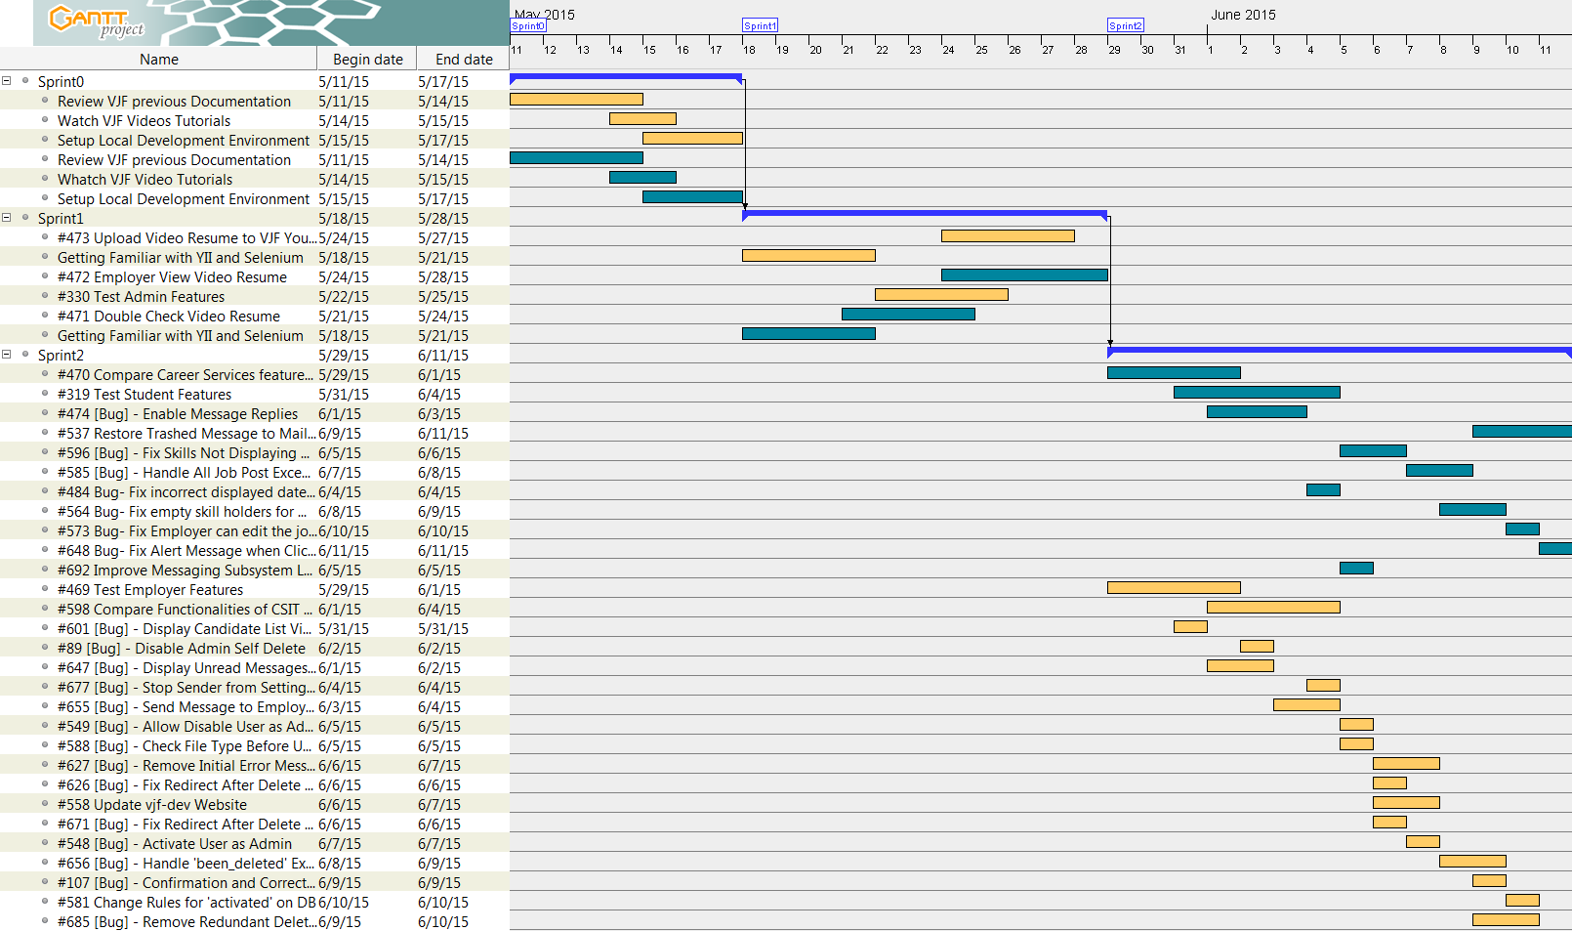

**Sprint 3 | Sprint 4 | Sprint 5**

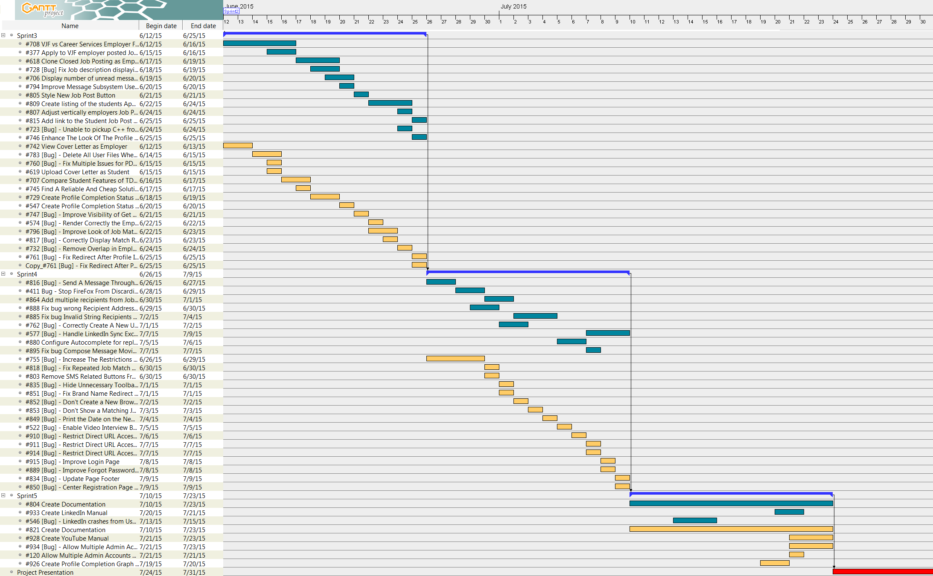

**Complete Gantt Chart**

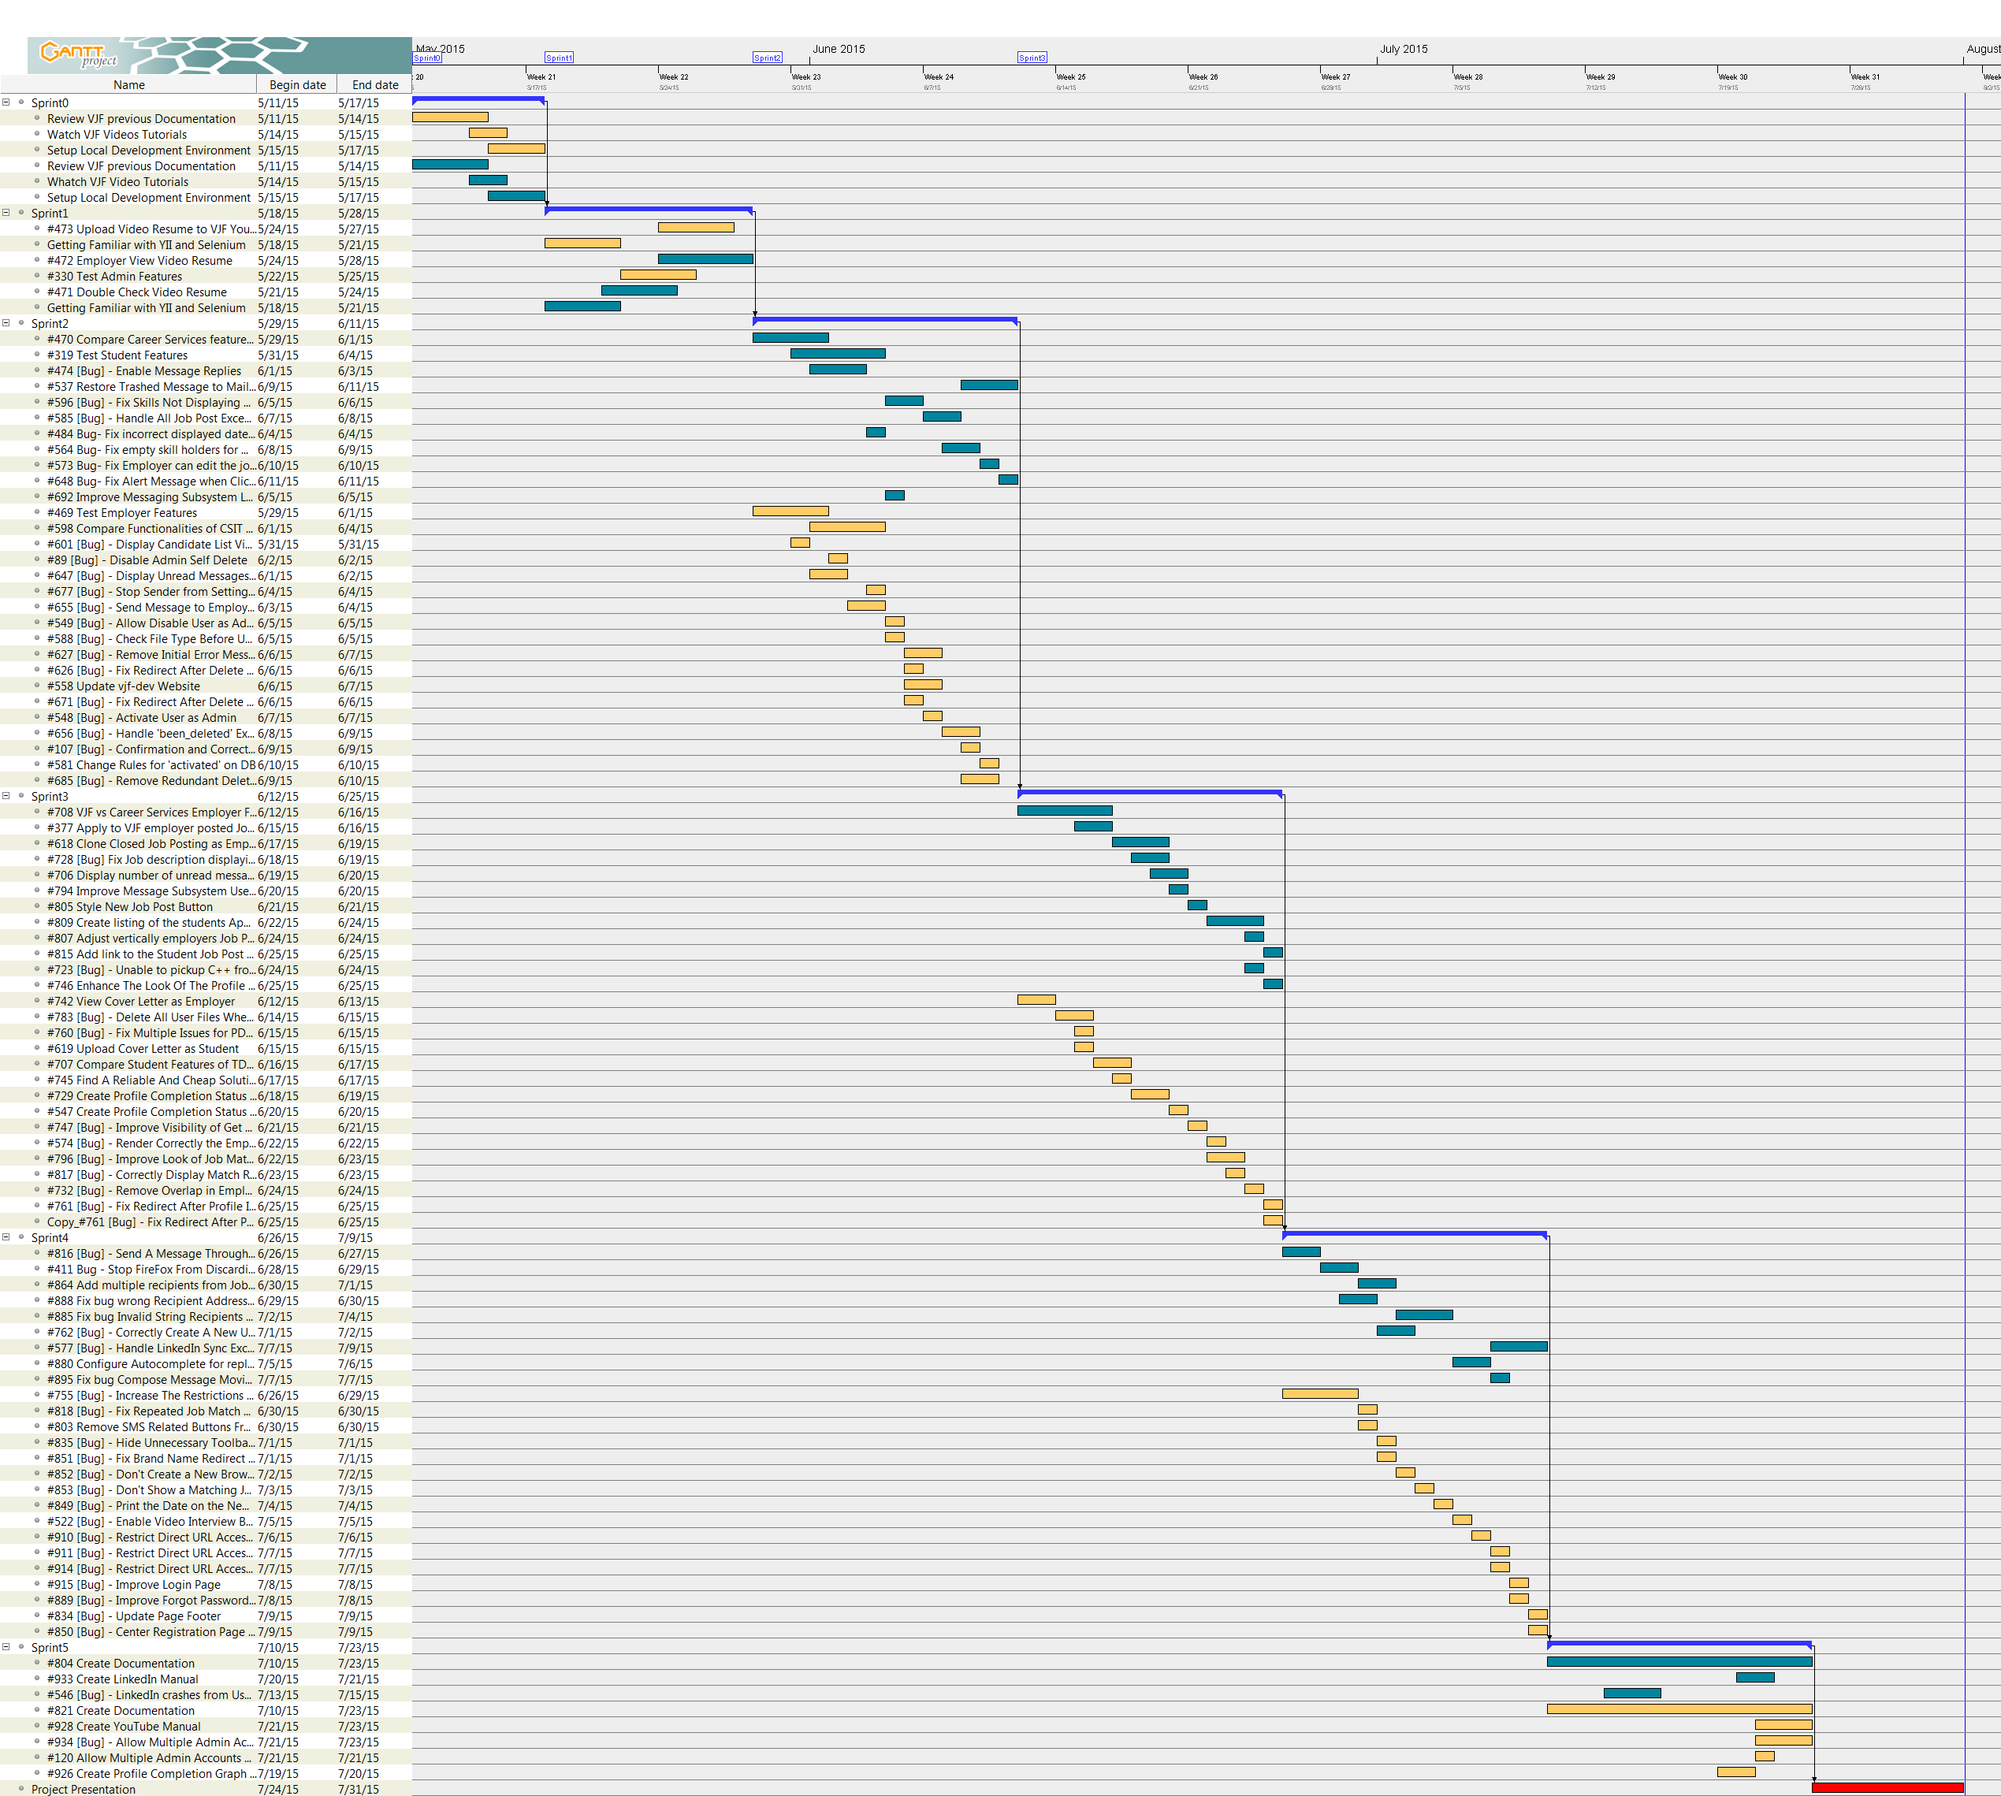

# 

# System Design

This chapter includes essential information about the system design. That is, it contains information about architectural patterns that are being used in the system, information about the system and subsystem decomposition, the deployment diagram, and the design patterns that were used to solve problems. This is fundamental chapter that provides very technical information that is required for further software engineering of the Virtual Job Fair system.

## Architectural Patterns

The original implementation of Virtual Job Fair was developed using the Model View Controller (MVC) software architectural pattern in the Yii Framework. Thus, our team continued to follow the same paradigm in order to maintain a rich, reusable, and well structure software. The benefits of MVC in regards to our software are that it separates logic controllers and models from graphical user interfaces, so that developers can easily change each part of the system without affecting the other. For example, changing the way a button looks on a view will not affect the logical functionalities of that button in the controller nor will it affect a model related to that logic.

The following diagram depicts the architecture in the Yii framework:

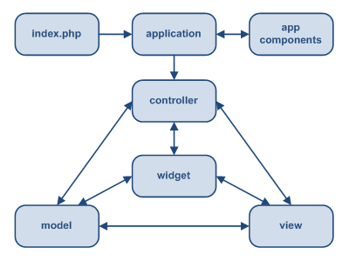

Figure AP001 - MVC in Yii Framework

## System and Subsystem Decomposition

Currently the system is composed of thirteen subsystems, each with its own unique purpose, each making the Virtual Job Fair website richer in content. The previous developers had a total of twelve subsystems. We shall describe our new modifications to those subsystems as well as the newly added subsystem, which is the YouTube subsystem.

**Messages Subsystem**

The Messages subsystem allows users to communicate with each other within our system. After our newest updates the subsystem behaves fairly similar to Gmail. The messaging subsystem uses the database to store and retrieve messages that are sent between users. It allows employers to initiate contact with students, and as of version 6.0 it allows students to reply correctly to those messages. There are several checks that ensure the correctness of the `to` field, which allows more flexible and reliable experiences for users; things such as messaging several users is now possible. The messages can be deleted correctly and they can be recovered from the trash bin if so desired. It is of paramount importance that the messages are handled as rapidly and efficiently as possible, therefore the subsystem uses AJAX to access and store data, which allows users to interact faster with the subsystem without having extensive downtime between server calls.

**Notification Subsystem**

The Notification subsystem allows users to stay upto date with the latest news and interactions from the systems. It notifies users of system interactions related to that particular users, such as scheduled video interviews, new unread messages, and job matches that fit the user’s skills. This subsystem relies on the database to maintain accurate information about the notifications that related to each user. It stores different types of notifications in the database and maps them to their respective categories. The notifications are stored in the database so that we can easily identify what notification belongs to what user. The notifications are sorted by category and level of importance and are displayed accordingly. This subsystem

**User Subsystem**

The User subsystem provides much of the needed support for the VJF website to function correctly. It is the backbone of the system. Within it we find the features that bring the website to life by allowing the most of user interactions such as: it allows us to create new users, maintain user profiles, merge user accounts, the profile completion bar and its logic, the student’s ability to upload files and videos, the home page for the users, it defines user roles and restrictions, it allows guest accounts to use the system, it provides certain securities for certain actions within the system, and it is in charge of displaying those wonderful notifications that come in from the Notification subsystem.

**Solr Subsystem**

The Solr subsystem is a search subsystem, which is tasked with all searches on our system. This subsystem makes searches for jobs, students with a particular skill, etc. work seminglesly. Its strength lies in the configuration to do full and delta imports of the database (jobfairdb). Thus, searches are extremely faster once Solr is running.

**API Subsystem**

The API subsystem allows admins to manage the API keys from other services, which in turn allows the admins to push jobs into our system. It, also, enables the CareerPath job import, and the synchronization of jobs.

**SMS message subsystem**

At the moment this subsystem is disabled do to it being cost inefficient. This subsystem gave the ability to send SMS to users directly to their phones. It was used to send reminders about important notifications. The idea is that the subsystem would allow users to stay connected and active with the system. This subsystem relies on the Twilio subsystem, which is a cloud based communication service. It is a company that provides SMS sending service for a cost. However, during VJF version 6.0 it was determined that SMS was too expensive, even when using other providers. A report was created by us and a decision of disabling the subsystem was concluded by Dr. Sadjadi.

**Alternative Logins Subsystem**

This subsystem allows different ways for users to authenticate themselves with our system. They can either use LinkedIn, Google, or the FIU login when creating their accounts; each of these being its own subsystem on itself. The LinkedIn subsystem now utilizes OAuth2 which allows our website to not only create the user account via LinkedIn but also to gather valuable user information from the LinkedIn profile. The Google sing in allows users to use their google email and password as credentials when creating an account. This provides a safe and reliable way to create a new account in very quick and easy steps. The FIU login is similar to the Google and it allows quick account creation. The alternative logins also facilitates access to our system by allowing a guest account, with limited access, to view the content of VJF.

**YouTube Subsystem**

The YouTube subsystem allows efficient and reliable means to store video resumes. In this new iteration of VJF the product owners decided that it was essential to migrate student video resumes to YouTube so that server space was not used to keep all of the student video resumes. That is, YouTube now keeps the videos for us, for free. The subsystem can only have accessed by using the YouTubeHandler Facade, within it we can request videos to be uploaded, deleted from YouTube, or to simply receive a video frame to display a video.

**Site Subsystem**

This subsystem is responsible for handling security, login validation, the navigation bar, and the index of the website. Its main goal is to handle the initial logic once the user arrives at the index, to determine if the user has valid credentials, and where in the system is the validate user should be directed to.

**Jobs Subsystem**

This subsystem is responsible for maintaining jobs, granting students the ability to apply for said jobs and is at its core one of the most important subsystem in our system, for it allows truly what we intend, for students to be hired for jobs. This subsystem allows us to edit, clone, and view job postings as employers.

**Skills Subsystem**

This subsystem is in charge of maintaining skills, how does skills match a student, and most importantly it works with the Job subsystem to allow students to be matched to a particular job as a valuable match.

**Email Subsystem**

Not to be confused with the Message subsystem, the Email subsystem allows the site to quickly and effectively send emails to users. For example, when a user first creates an account the subsystem will be used to send an email to said user asking for confirmation. When the user applies for a job both student and employer receiver an email notification, as this is the highest priority of our system.

**Collaboration Tools Subsystem**

The Collaboration Tools subsystem is intended to provide an interactive online interview, with video chat, screen share, and a whiteboard all within our system. Currently this subsystem is not working. It needs to be imported from the Collaboration Tools Senior project. Within this subsystem there are three other subsystems:

do I reword this or do I site Rogelio, because, in reality I have no clue about Collaborative tools.

The Video Interview Subsystem allows users to have a virtual interview. This is possible due to WebRTC. WebRTC is an open source project which allows web browsers to communicate directly with each other.

This new technology makes the communication between internet users easier than traditional methods. Thanks to Web-RTC one can share video feed with other users without the need for media servers or plug-ins. The synchronization of video interviews is handled in a table in the database. This is very important because we need to make sure only users scheduled to have an interview can be in the interview page. This is done by using a session key which is unique for each video interview scheduled. Users that arrive at the interview page would do so via a link which has many parameters such the session key. Once both users arrive at the interview page, the application will check for the session key parameter and match them, and only those users that have matching session keys would be able to connect to each other.

Additionally the video screen Share subsystem allows users to share their screens with one another. This functionality is facilitated by the Screen Leap API. Screen Leap is a service that provides screen sharing functionality without the need for any of the users to install any specific software all that is required to function is the latest version of Java for the broadcaster. Screen Leap is able to function perfectly with the system by providing different API calls that allow for easy sharing of information. By eliminating the need for the user to download extra software we are able to facilitate and simplify the usage of the Virtual Job Fair website.

The whiteboard subsystem will allow users to draw on a whiteboard during a live interview. The whiteboard includes drawing, writing, erasing, clearing and picture-saving functionality, which makes it an ideal tool to share images during a live interview, to jot down notes or simply to brainstorm. (Alonso)

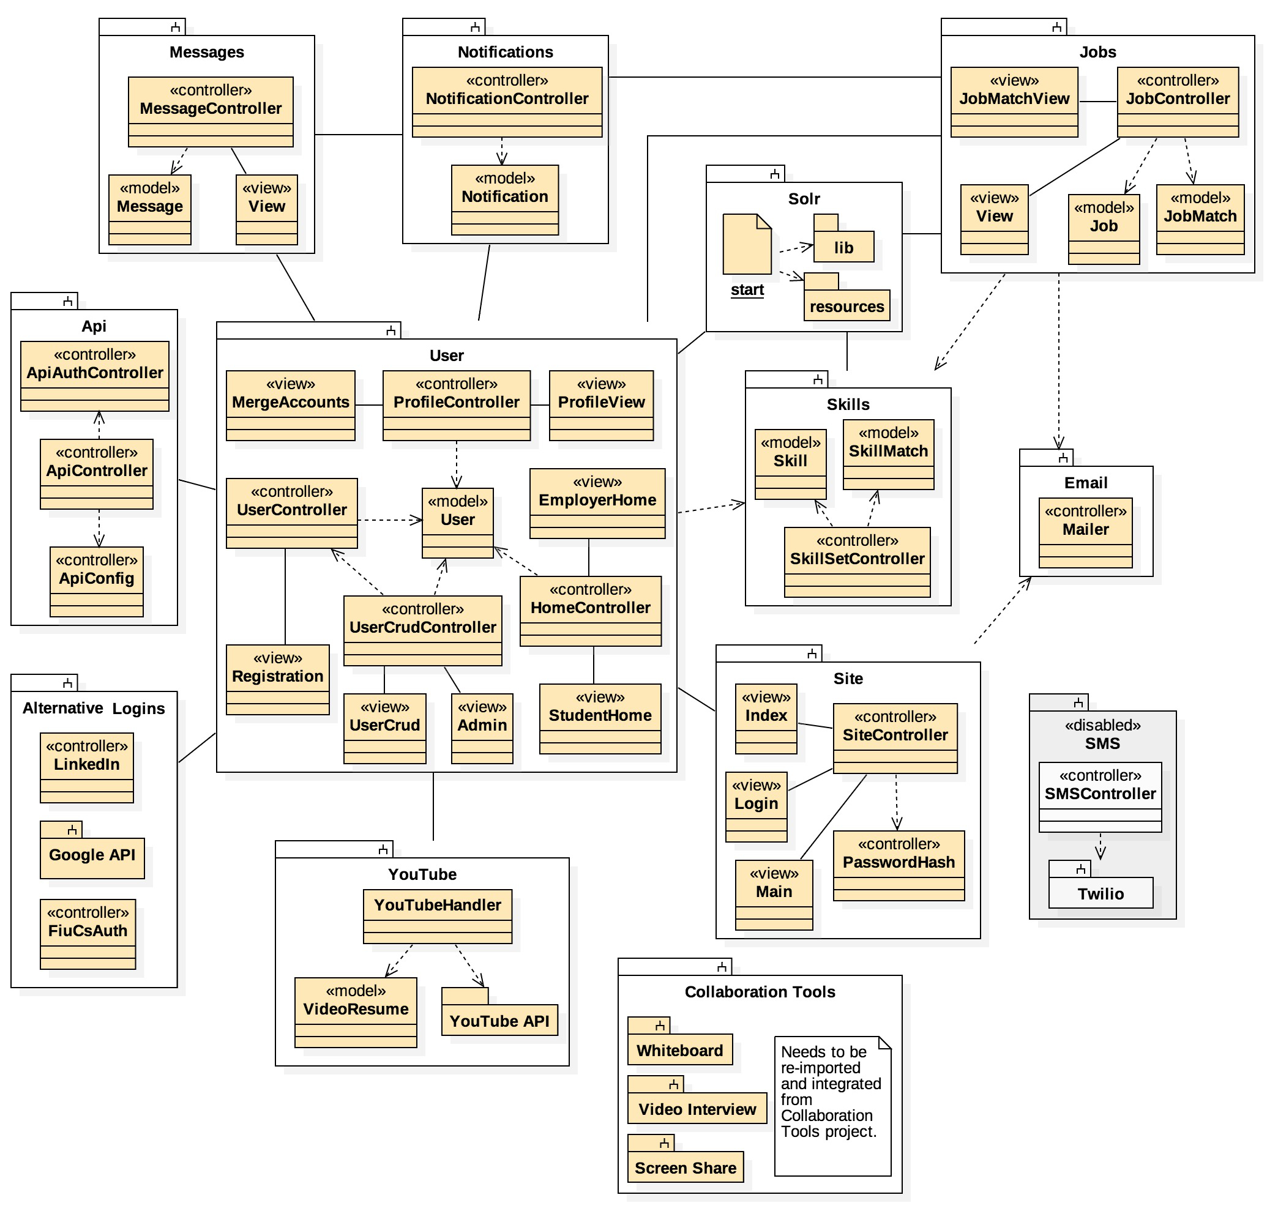

Figure SSD001 - Subsystems

## Deployment Diagram

The previous team setted up a Scientific Linux, Apache, MySQL, and PHP (LAMP) server and the Yii framework on the FIU SCIS network. It is also important to note that we are still utilizing the Model View Controller architecture pattern. And the previous team developed a deployment diagram which indicated the mapping between hard and software. Therefore, we can reuse the same concept to generate our own diagram, the previous concept remains the same, only the graphical representation of the diagram has been updated, see (Figure DD001).

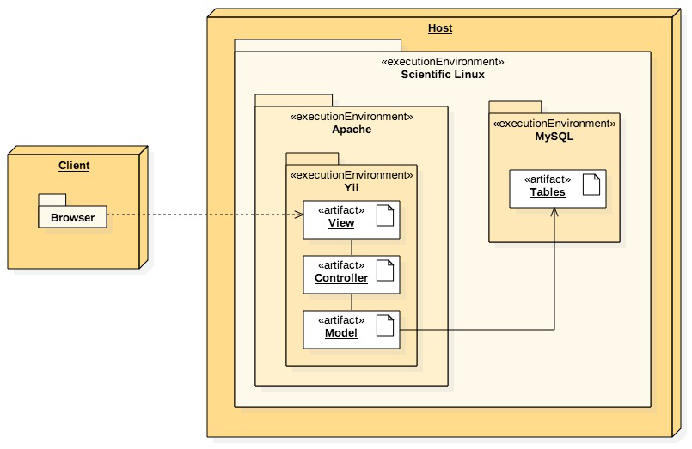

Figure DD001 - Deployment Diagram

## Design Patterns

Design patterns are the best way to solve recurring problems that already have clear solutions which can be reapplied to our needs. Thus, to avoid having many points of entry into the YouTube subsystem we added a Facade design pattern.

The YouTubeHandler controller class realizes a Facade design pattern. It was created to facilitate access to the many YouTube API calls via a single point of entry. That is, a single access point into the subsystem.

This simplified the amount of dependencies between objects by encapsulating most of the functionality through the Facade (See Figure S1-000 in Appendix A). The facade keeps a reference to each object that will be called inside the Application logic. For example, the video upload process is a multi step process, using the Facade ensued that this repetitive task happened only once every time it was needed. That is, the Facade has made the YouTube API easier to use, understand, and test due to its convenient functions for common tasks. Other controllers need not care how the logic happens, they only need but call one function in the Facade and wait for the desired results.

# 

# System Validation

This chapter introduces the system validation of VJF project release 6.0. In this section we will provide a list of all test cases implemented during the semester. Furthermore, we will show with a brief description of each test purpose. In this section we have divide all user test cases in three test suites Student, Employer and Admin.

**User Story# 318 - Test Student Features**

**System Tests**

**S0001 - Login:** The purpose of this test is validate that students can login to system after providing the correct username and password at the login page.

**S0002 - Logout:** The purpose of this test is validate that student can successfully exit the system.

**S0003 - Registration:** The purpose of this test is check that new students can register in the system after completing the registration process.

**S0004 - Validation:** The purpose of this test is check that newly registered students can activate their account.  

**S0005 - View Profile:** The purpose of this test is the student can view his profile.

**S0006 - Add Education:** The purpose of this test is check that the student can add background education information to the profile.

**S0007 - Remove Education:** The purpose of this test is check that the student can actually remove any previously input background education information in the profile.

**S0008 - Start Video Interview:** The purpose of this test is been able to access the interview session after receiving an employer interview invitation.

**S0009 - Share Screen on ScreenShare:** the purpose of this test is check that the ScreenShare is displayed in the system.

**S0010 - Show WhiteBoard:** the purpose of this test is check that the WhiteBoard interface is displayed in the system.

**S0011- Video Resume Upload:** The purpose of this test is verify how students would upload a video to YouTube.

**S0012 - Publish Video Resume:** The purpose of this test is verify that students can publish the video resume, so the employers can see it.

**S0013 - Unpublish Video Resume:** The purpose of this test is verify that students can un-publish the video resume, so the employers cannot see it.

**S0014 - Invalid Video Format:** The purpose of this test is verify that students cannot upload any other file that the permissible by the system.

**S0015 - Send Message:** The purpose of this test is verify that students can send messages to each other.

**S0016 - Upload PDF Resume:** The purpose of this test is verify that students can upload the a pdf resume to the profile.

**S0017 - View PDF Resume:** The purpose of this test is verify that students can see the pdf resume after upload to the system.

**S0018 - Search Jobs:** The purpose of this test is verify that students can search for jobs posting in the system.

**S0019 - Save Search Jobs Queries:** The purpose of this test is verify that students can save any query to speed up any future search for the same keywords.

**S0020 - Delete Saved Job Search Query:** The purpose of this test is verify that students can delete any saved query they don’t want to keep.

**S0021 - Add Skills:**  The purpose of this test is verify that students can add the skills to the student profile.

**S0022 - Remove Skill from Student Profile:** The purpose of this test is verify that students can remove skills from the student profile.

**S0023 - View Miscellaneous Activities:** The purpose of this test is verify that students can see Miscellaneous Activities at the notification section of the student home page.

**S0024- View Matching Job Listing:**  The purpose of this test is verify that students can see the matching jobs in the student home page.

**S0025 - Open a Matching Job Posted:**  The purpose of this test is verify that students can open the jobs from the matching job section in the student home page.

**S0026 - Upload Profile Image:**  The purpose of this test is verify that students can upload a new profile image.

**S0027 - Change Profile Image:** The purpose of this test is verify that students can change any existing profile image.

**S0028 - Add Experience:** The purpose of this test is verify that students can add job experience to the student profile.

**S0029 - Remove Experience:** The purpose of this test is verify that students can remove job experience from the student profile.

**S0030 - Open Expired Matched Job Posting:** The purpose of this test is verify that students receive a message when trying to open a job that expired.

**S0031 - JobSearch-Save-Delete:** The purpose of this test is verify that students can search jobs, save the job search results or delete any previous saved job search.

**User Story# 330 - Test Admin Features**

**System Tests**

**A000 LoginRainyDay:** The purpose of this test is verify that admin cannot login to the system if invalid credentials are provided.

**A001 Login-Logout:** The purpose of this test is verify that admin can successfully log out from the system.

**A002 Login:** The purpose of this test is verify that the admin can login successfully under normal conditions to the system.

**A003 AddStudent:** The purpose of this test is verify that students can be added by the admin.

**A004 AddDuplicateStudent:** The purpose of this test is verify that the admin cannot add any user that already exist in the system.

**A005 RemoveUser:** The purpose of this test is verify that the admin can delete system users.

**A006 AddEmployer:** The purpose of this test is verify that the admin can add a new employer to the system.

**A007 CheckStatistics:** The purpose of this test is verify that the admin can view the crud user’s website-statistics page.

**A008 AddSkill:** The purpose of this test is verify that the admin can add a skill to the system skills list.

**A009 AddDuplicateSkill:** The purpose of this test is verify that the admin cannot add a skill that already exist in the system.

**A010 MergeSkills:** The purpose of this test is verify that the admin can merge two skills into one.

**A011 MergeSkillsRainy:** The purpose of this test is verify that the admin cannot merge a non existing skill with an existing skill.

**A012 ViewMessages:** The purpose of this test is verify that the admin can see messages.

**A013 SendMessage:** The purpose of this test is verify that the admin can send messages the students and employers.

**A014 ReadMessage:** The purpose of this test is verify that the admin can read messages.

**A015 Settings:** The purpose of this test is verify that the admin can manage the import jobs settings of the website.

**A016 ImportJobs:** The purpose of this test is verify that the admin can import job in the system.

**A017 SearchPosting:** The purpose of this test is verify that the admin can perform job posting searches in the system.

**A018 SearchPostingTitle:** The purpose of this test is verify that the admin can perform job posting searches by Title.

**A019 DeletePosting:** The purpose of this test is verify that the admin can delete existing job postings in the system.

**A020 Update-DeleteUser:** The purpose of this test is verify that the admin can delete or update system users.

**A021 DeleteAdmin:** The purpose of this test is verify that the admin that the admin cannot delete his own account in the system.

**A022 Disable-ActivateUser:**The purpose of this test is verify that the admin can disable and enable system users.

**A023 SendMsgToEmployer:**The purpose of this test is verify that the admin can send messages to the employers.

**User Story# 469 - Test Employer Features**

**System Tests**

**E000 LoginRainyDay:** The purpose of this test is verify that employers cannot login to the system if invalid credentials are provided.

**E000 LoginRainyDay:** The purpose of this test is verify that employers cannot login to the system if invalid credentials are provided.

**E003 ViewProfile:** The purpose of this test is verify that employers view their profile information.

**E004 ChangePicRainy:** The purpose of this test is verify that employers can’t upload an invalid file format for the profile image.

**E005 ChangePic:** The purpose of this test is verify that employers are able to change the profile picture.

**E006 ViewJobPosting:** The purpose of this test is verify that employers can view any of their job posting.

**E007 EditJobPosting:** The purpose of this test is verify that employers are able to edit any of their non expired job postings.

**E008 OpenStudentProfile:** The purpose of this test is verify that employers can open existing student profiles in the system.

**E009 ViewVidResume:** The purpose of this test is verify that employers can view the students video resume correctly.

**E010 ViewSkills:** The purpose of this test is verify that employers can view students skills by looking at the student profile.

**E011 ViewProfilePic:**  The purpose of this test is verify that employers can view student profile picture by looking at the student profile.

**E012 ViewMessages:** The purpose of this test is verify that employers employer can view messages in the system.

**E013 SendMessage:** The purpose of this test is verify that employers can send messages to students.

**E014 ReadMessage:** The purpose of this test is verify that employers can successfully read system messages.

**E015 CreateVidInterview:** The purpose of this test is verify that employers can create a video interview with a student.

**E016 SearchStudentBySkill:** The purpose of this test is verify that employers can perform searches based on student’s skill criteria.

**E017 AdvanceStudentSearch:** The purpose of this test is verify that employers can perform advanced searches in the system.

**E018 NewJobPosting:** The purpose of this test is verify that employers can create new Jobs Posting in the system.

**E0019 Clone Job Posting:** The purpose of this test is verify that employers can clone any of their existing job postings.

**E0020 ChangePassword:** The purpose of this test is verify that employers are able to change the password to access the system.

**E0021 CandidateVidResume:** The purpose of this test is verify that employers can view the student’s video resume from the job matching page.

**E0022 Notifications:** The purpose of this test is verify that employers can view and interact with notifications.

**E0023 Save-Delete-EmpQuery**: The purpose of this test is verify that employers can save and delete advanced search queries.

# Glossary

In this chapter we have listed terms that might require some clarifications when reading this document. These terms are concepts that show up all over the system.

**Job:** activity performed in exchange of some kind of monetary compensation.

**Student:** an individual who currently enrolled in Florida International University.

**Employee:** a person working for another person or a business firm for pay.

**Full Time:** means 35 or more hours worked each week at a job.

**Part Time:** a period of time that is less than the usual or full time. Typically, it is less than 35 hours per week.

**Internship:** any period of time during which a beginner acquires experience in an occupation, profession, or pursuit.

**Paid Internship:** a type of internship in which the employee receives some monetary compensation in exchange of his work.

**Unpaid Internship:** a type of internship in which the employee does not receives any kind of monetary compensation in exchange of his work.

**Benefit:** non-salaried compensation for employees, such as medical, dental and life insurance, tuition reimbursement, and retirement benefits (401K).  
**Work authorization:** current legal work status of a student. Categories include U.S. Permanent Resident and U.S. Citizen.  
**Grade point average:** a measure of scholastic attainment computed by dividing the total number of grade points received by the total number of credits or hours of course work taken.  
**Salary:** a fixed monetary compensation periodically paid to a person for regular work or services.  
**Résumé:** a brief written description of personal, educational, and professional qualifications and experience, as that prepared by an applicant for a job.

**Cover Letter:** document used by students to introduce themselves to the companies that they are applying to. It usually goes together with a résumé.

**Job Posting:** is an advertisement created by an employer, or a recruiter that alerts current employees or the public of an immediate or future job opening within a company.

**Job Interview:** is a type of employment check that encompasses a conversation between a job candidate and representative of the employing organization. Interviews are one of the most commonly used procedures for employee selection.

**Job Posting Cloning:** the process of duplicating an existing Job Post, and creating a new one from the original source.

**Matching Jobs:** process of listing all jobs that match student skills criteria in the job description.

**Virtual Handshake:** Virtual Job Fair applicationmechanism that allows employer to send an email notification to prospective student persuading them to apply for a job they are announcing.

**Video Resume:** is a brief description of a job applicant's professional experience, qualifications and interests, submitted to a prospective employer in video form.

# 

# Appendix

## Appendix A - UML Diagrams

### Static UML Diagrams

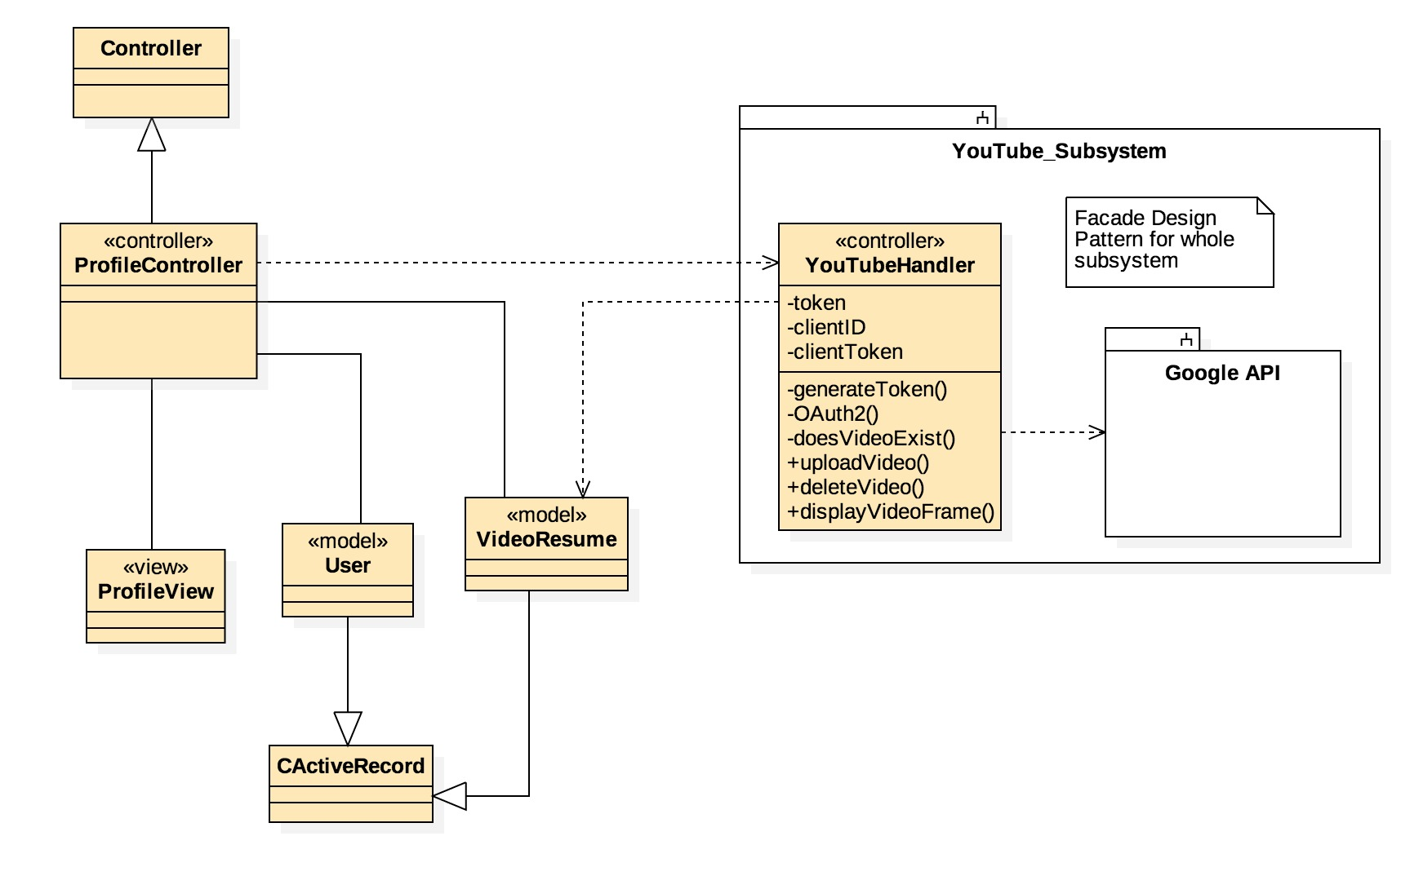

Figure S-001 - Video Resume Upload Class Diagram

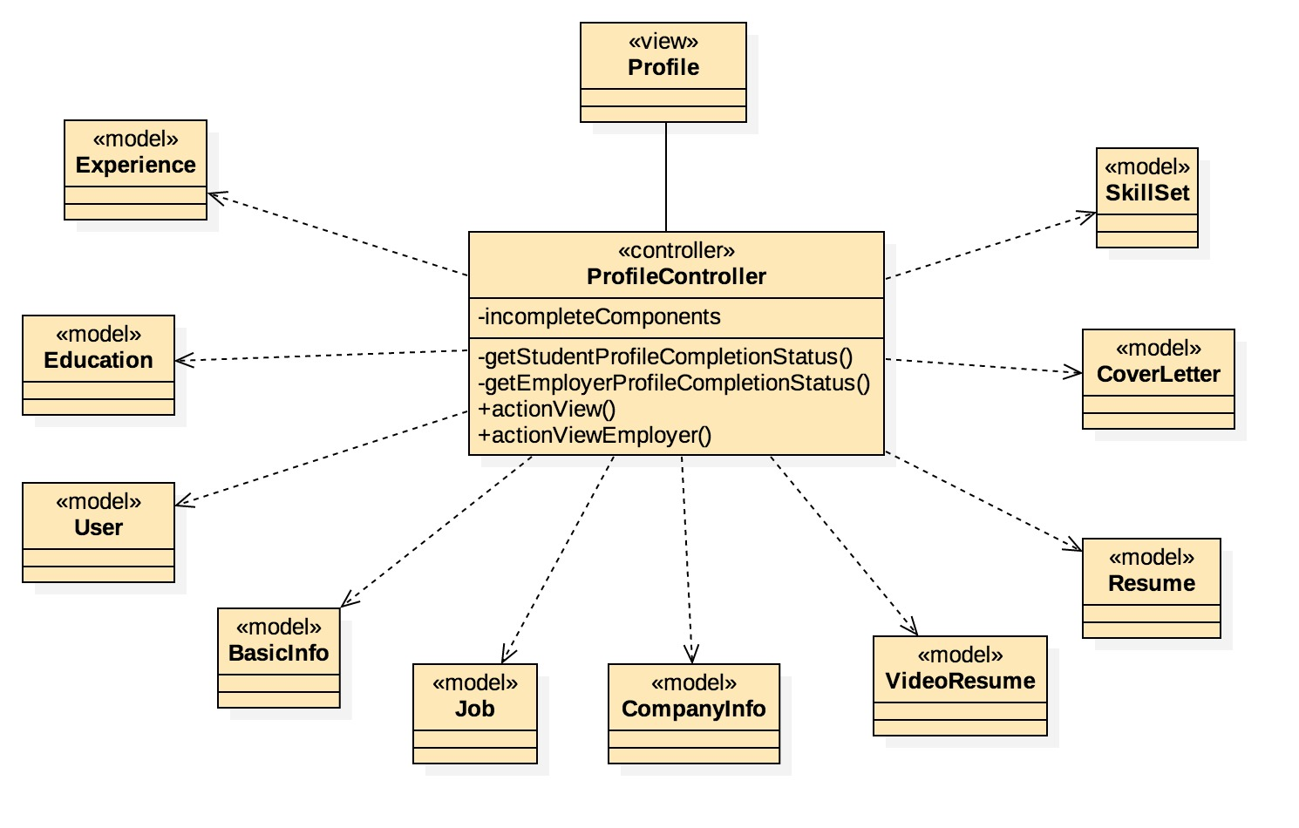

Figure S-002 – Profile Completion Graph Class Diagram

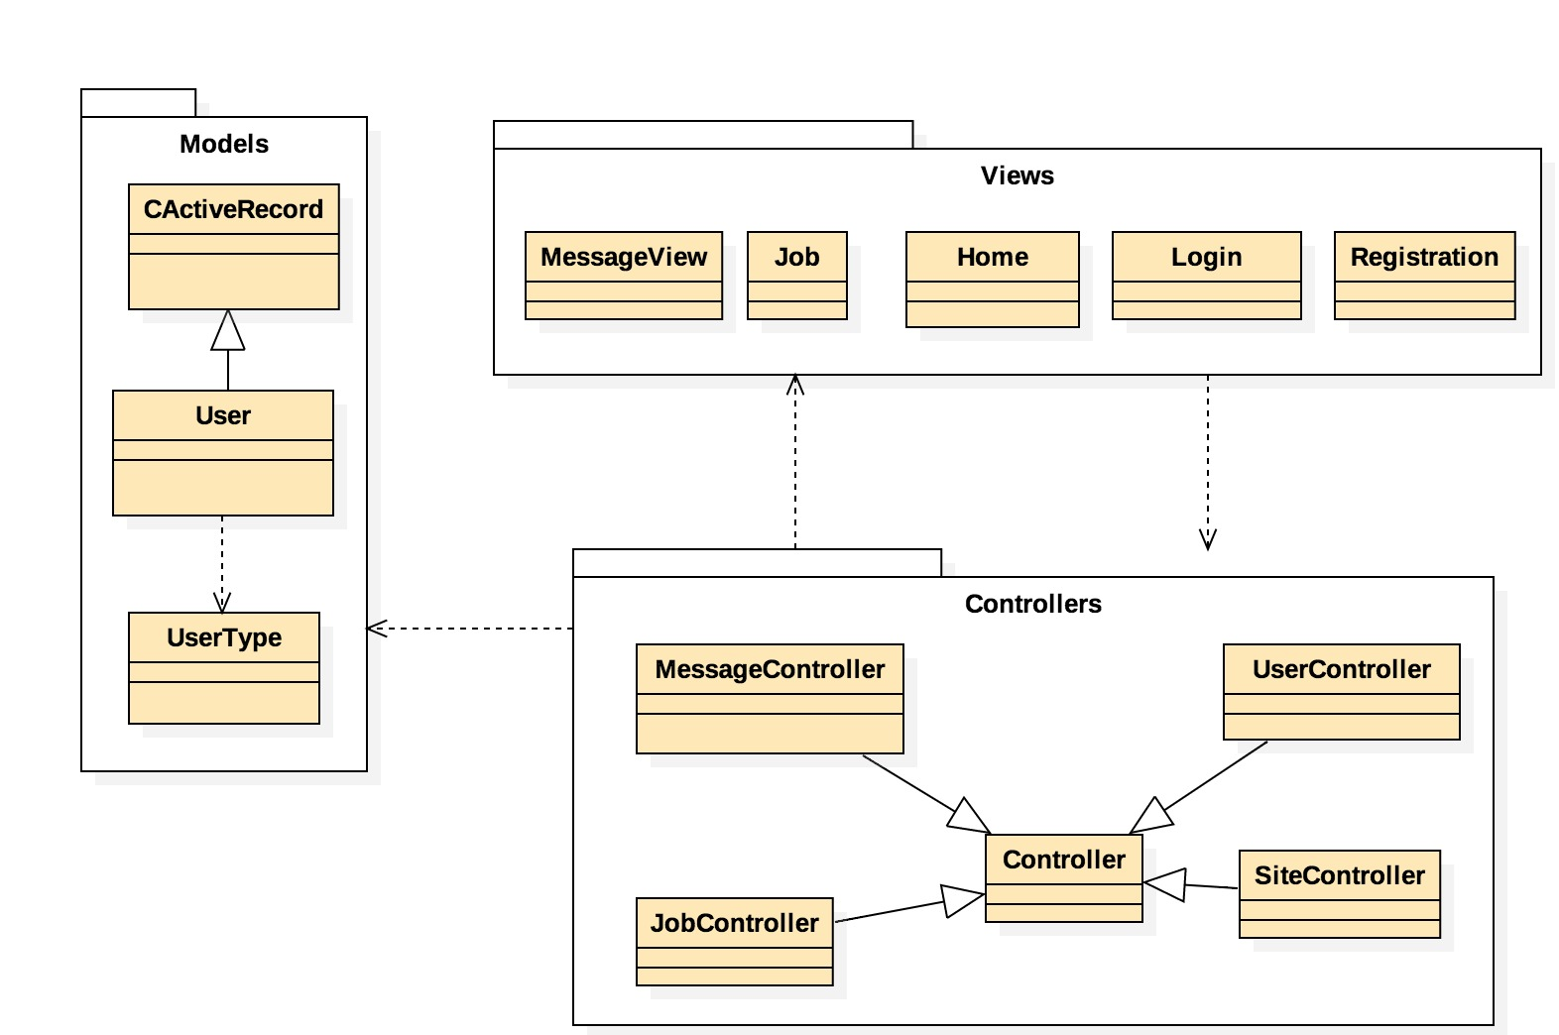

Figure S-003 – Guest Account Class Diagram

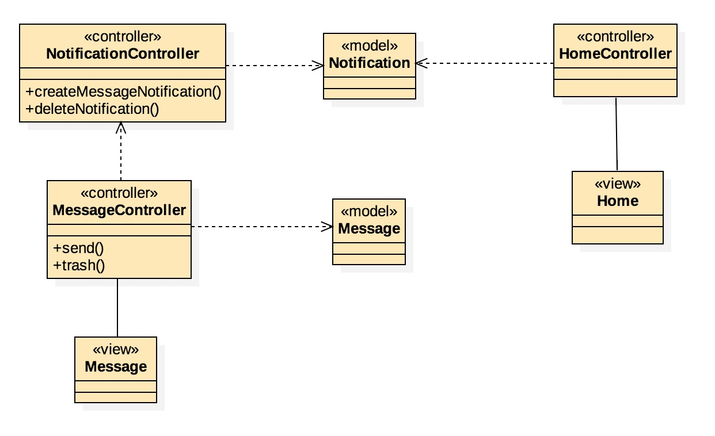

Figure S-004 – Message Notification and Display Class Diagram

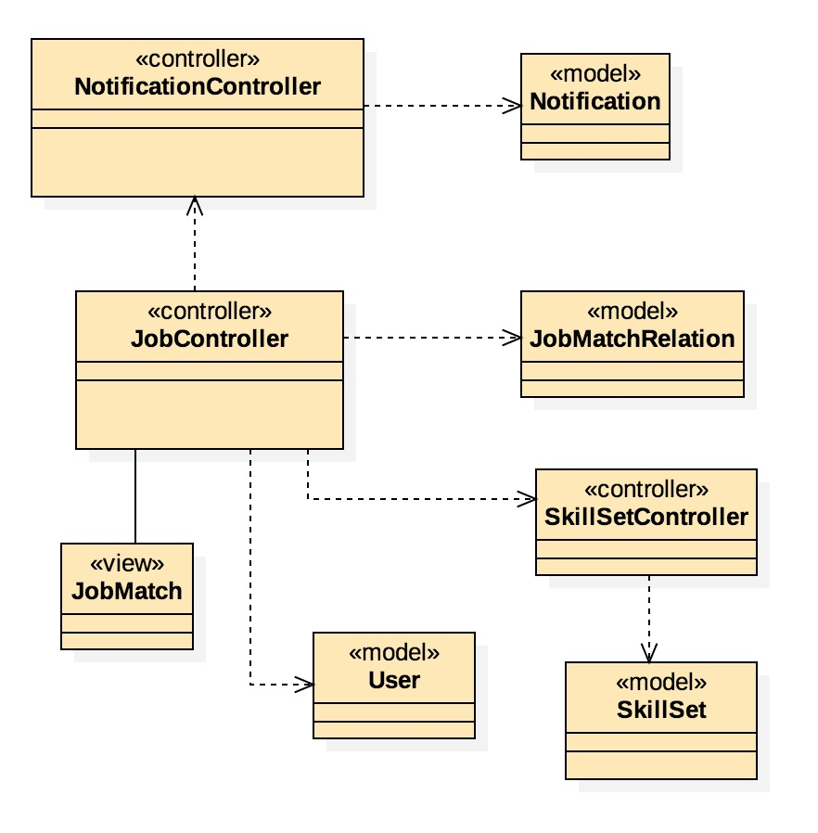

Figure S-005 – Job Match Notification Class Diagram

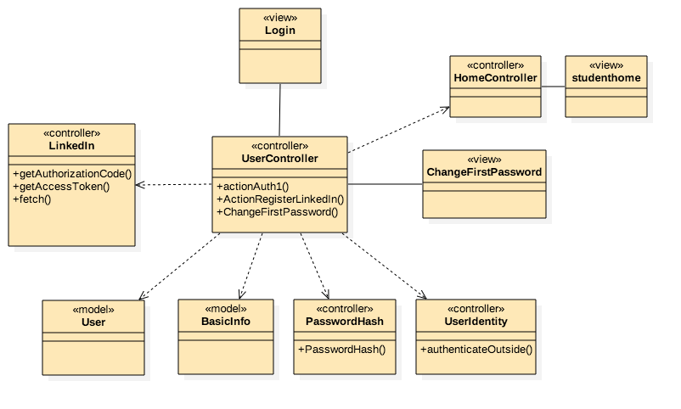

Figure S-006 – LinkedIn Login/Account Creation Class Diagram

### Dynamic UML Diagrams

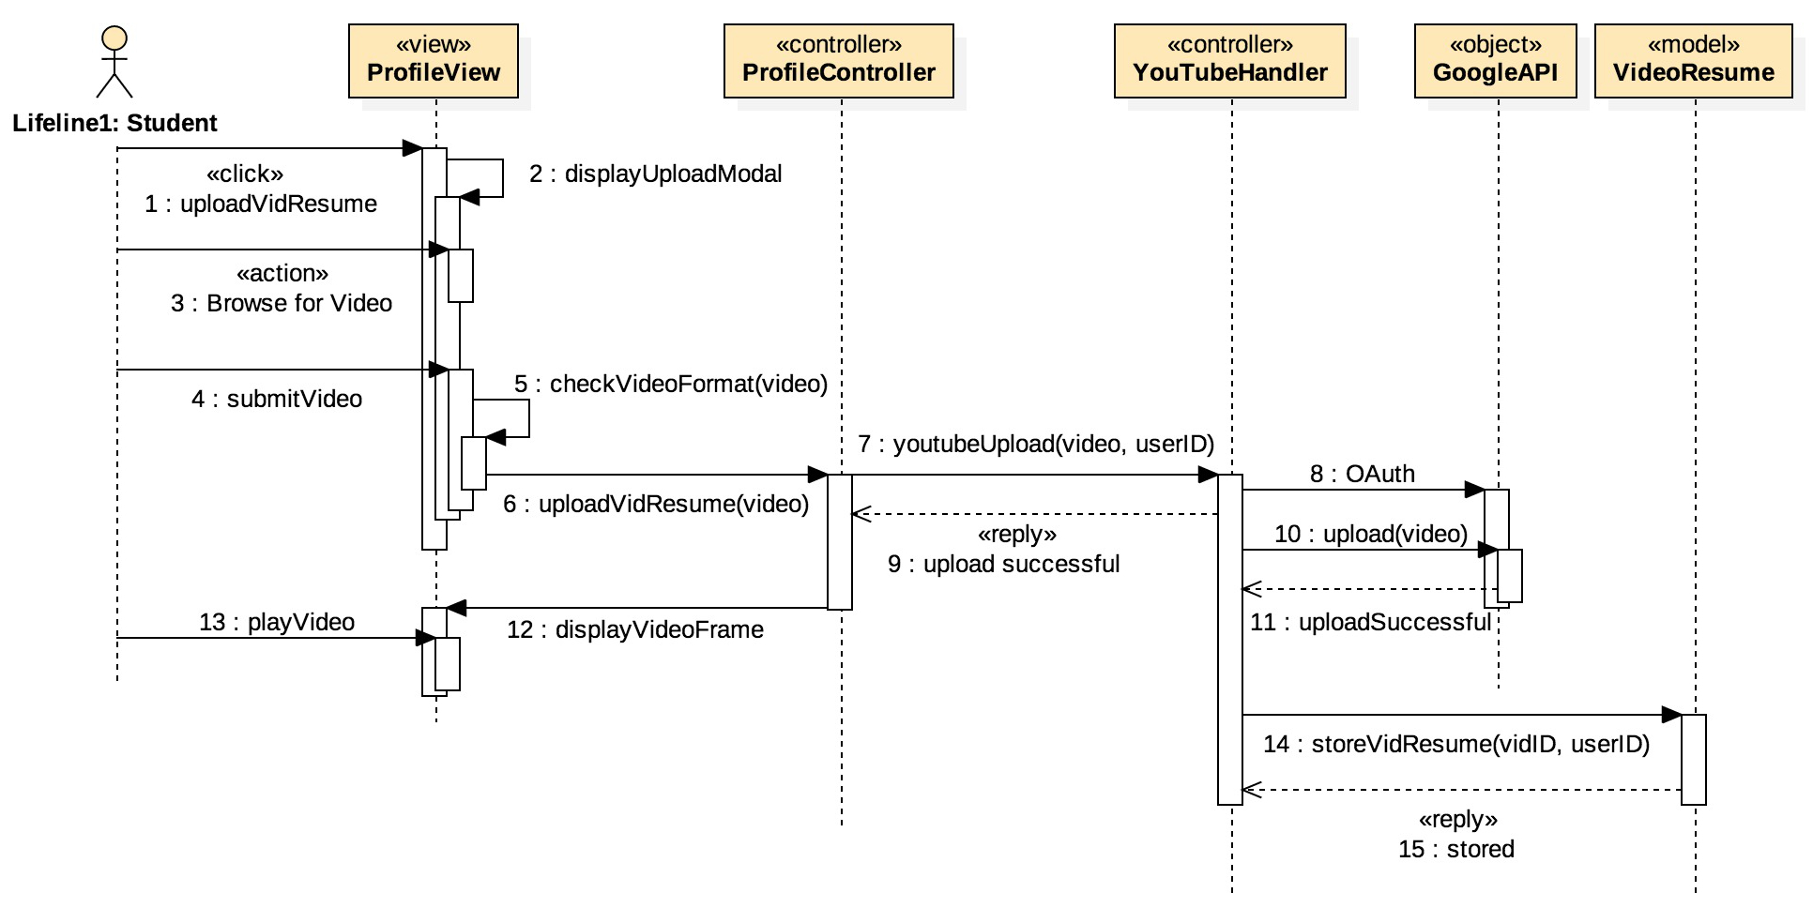

Figure D-001 - Video Resume Upload Sequence Diagram

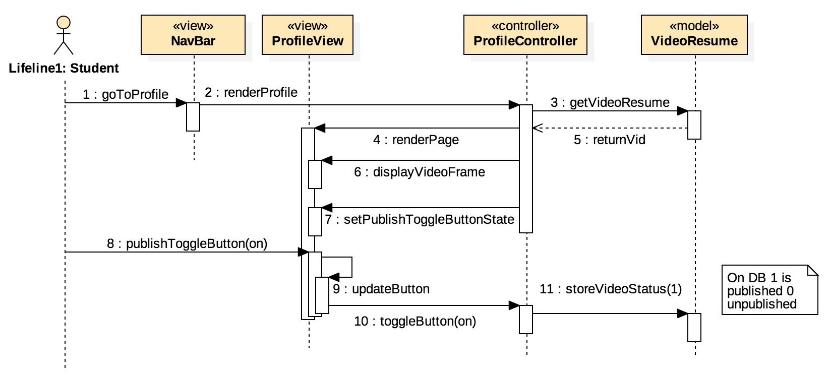

Figure D-002 - Publish Video Resume Sequence Diagram

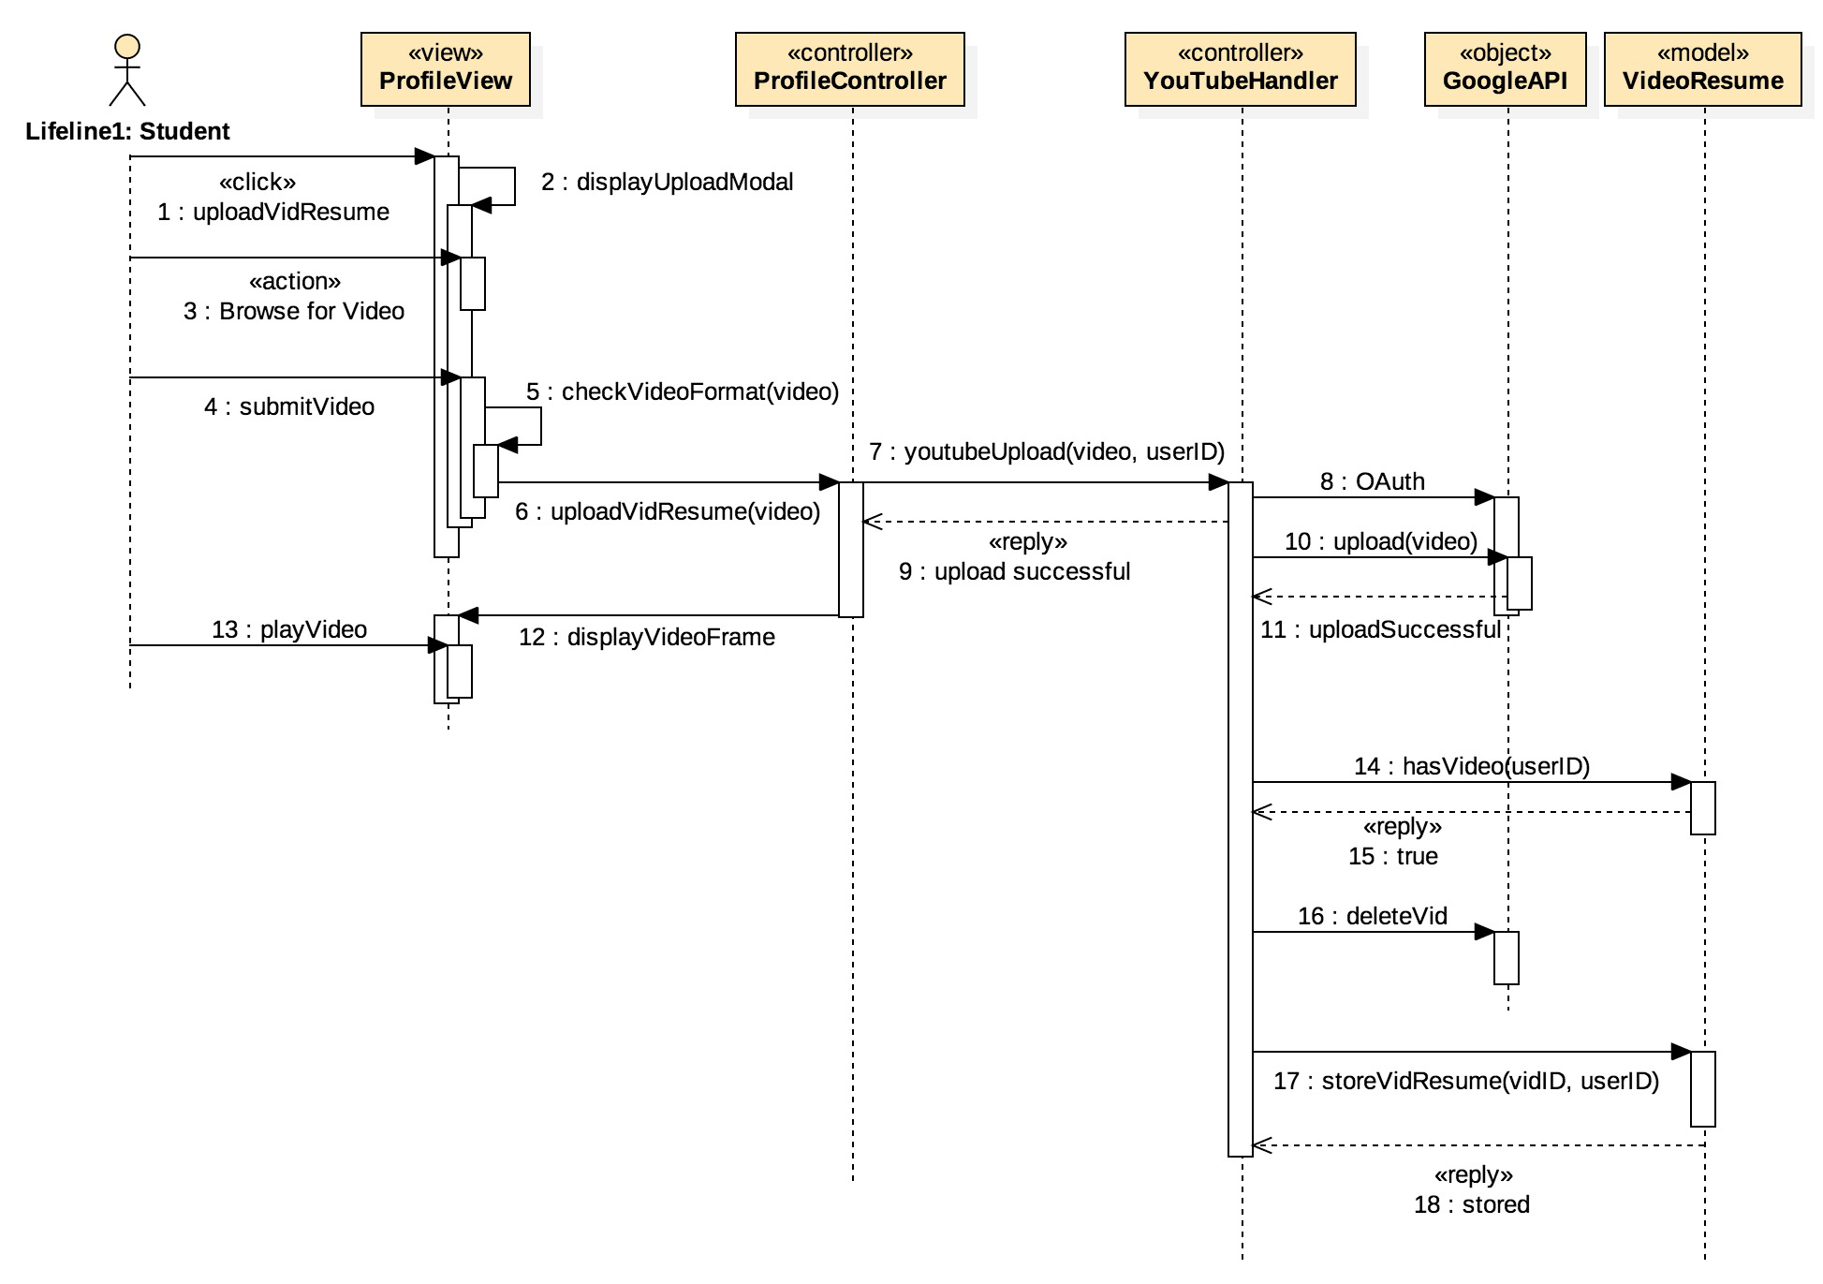

Figure D-003 - Re-Upload New Video Resume Sequence Diagram

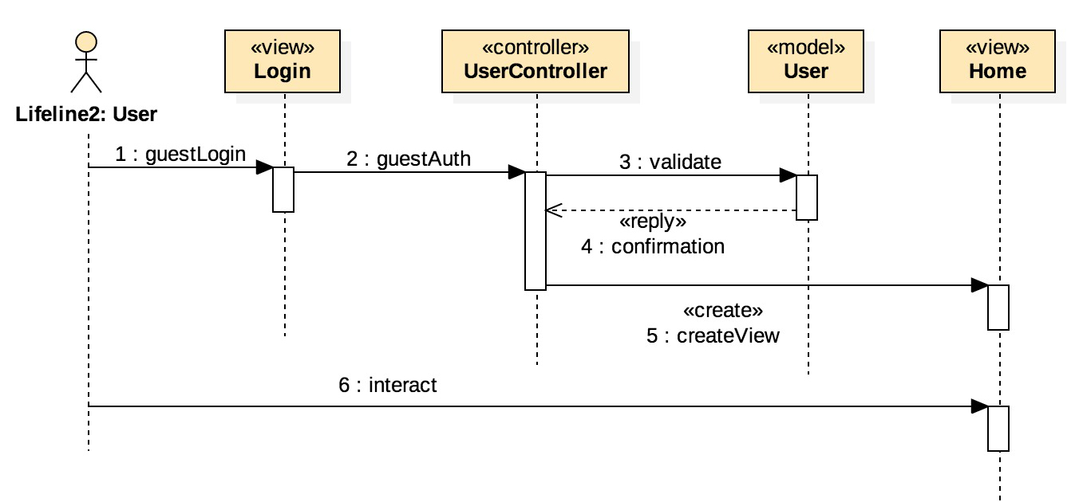

Figure D-004 - Guest Login Sequence Diagram

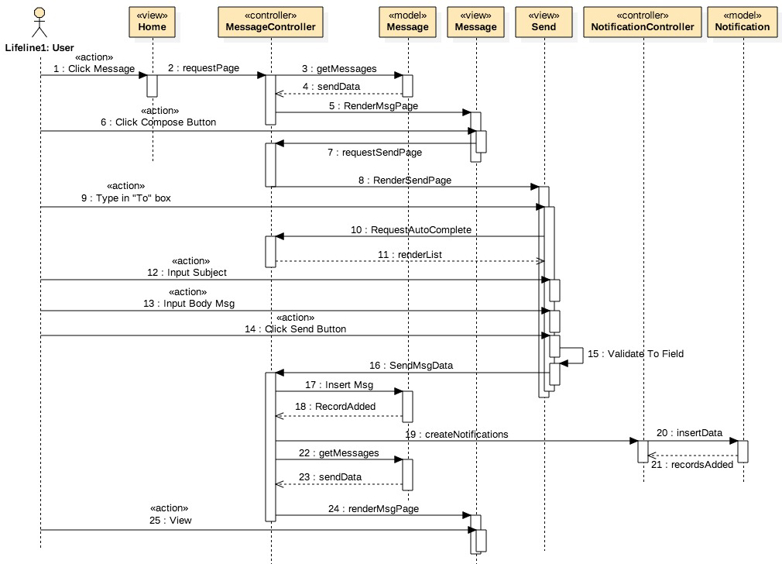

Figure D-005 - Send New Message Sequence Diagram

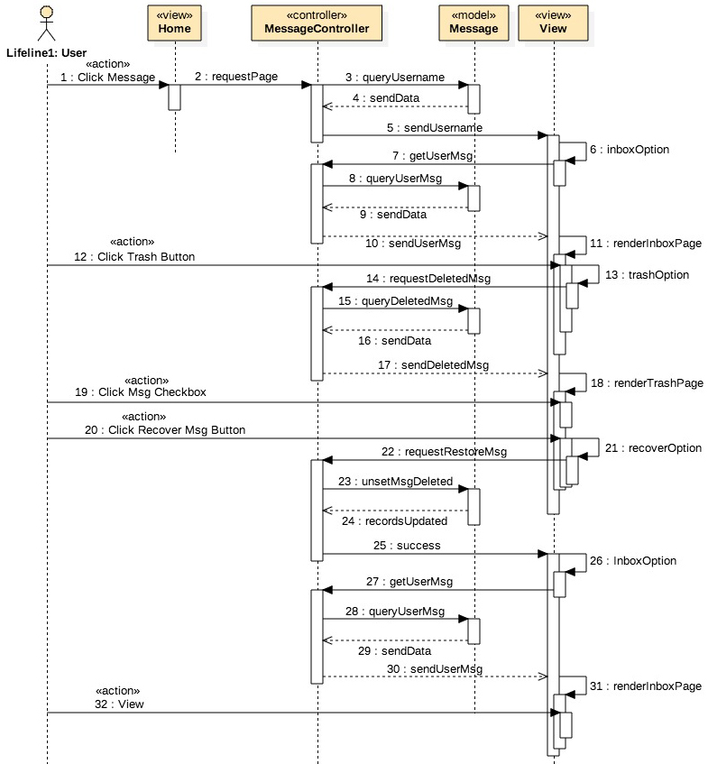

Figure D-006 - Recover Deleted Message Sequence Diagram

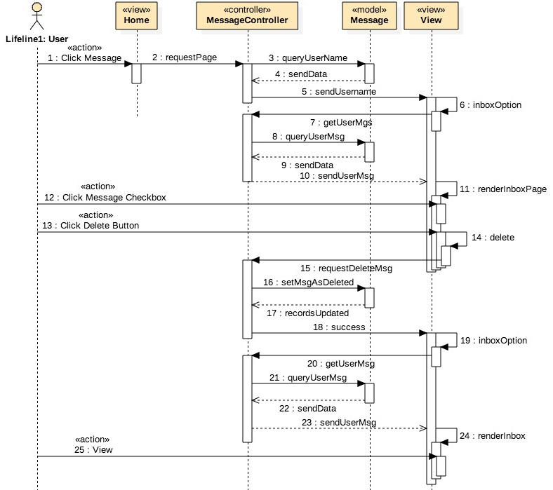

Figure D-007 - Delete Message Sequence Diagram

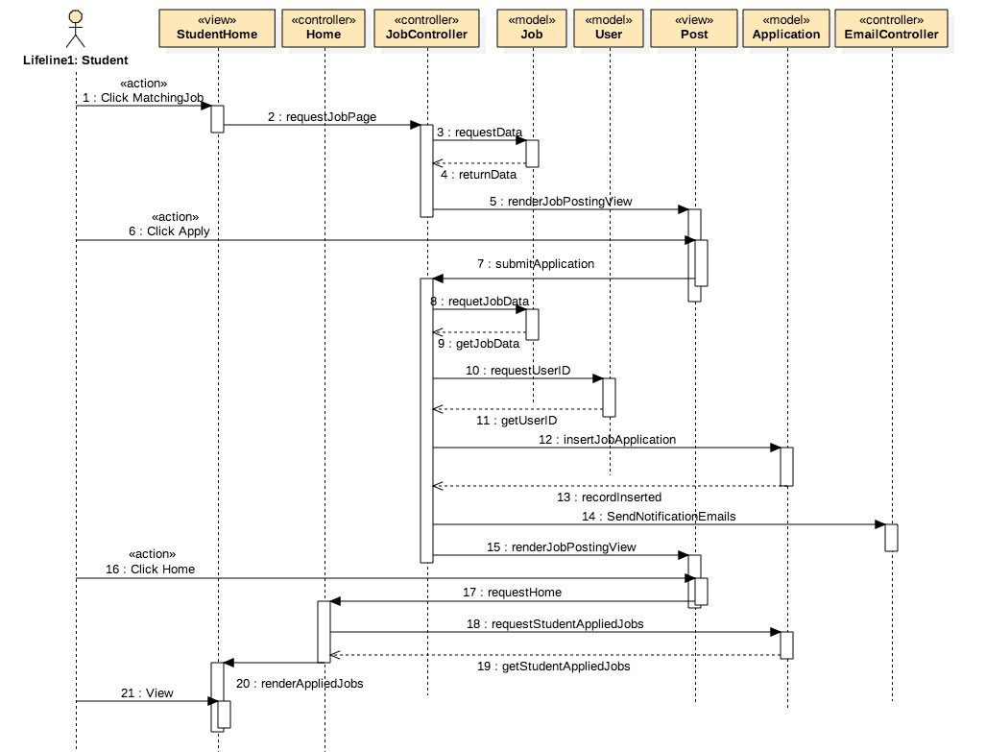

Figure D-008 - Applied Jobs Sequence Diagram

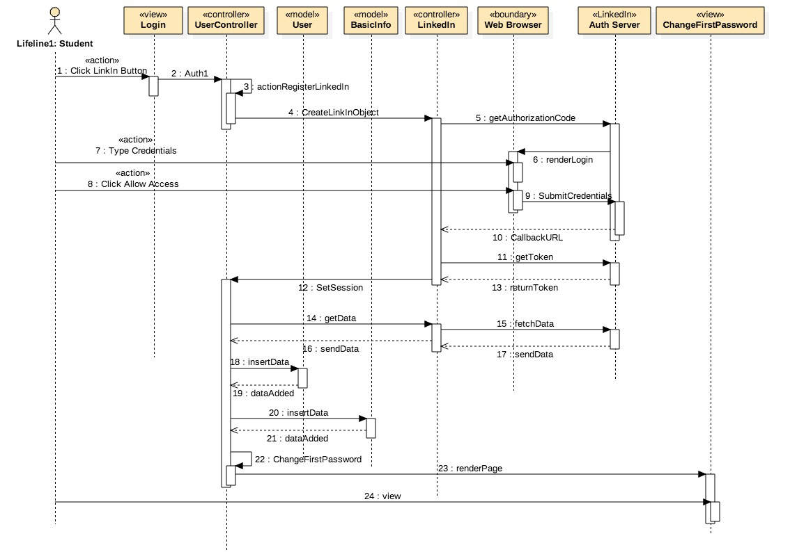

Figure D-009 - Applied Jobs Sequence Diagram

## Appendix B - User Interface Design

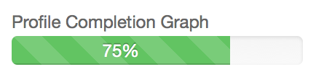

Figure UI-001 – Profile Completion Graph

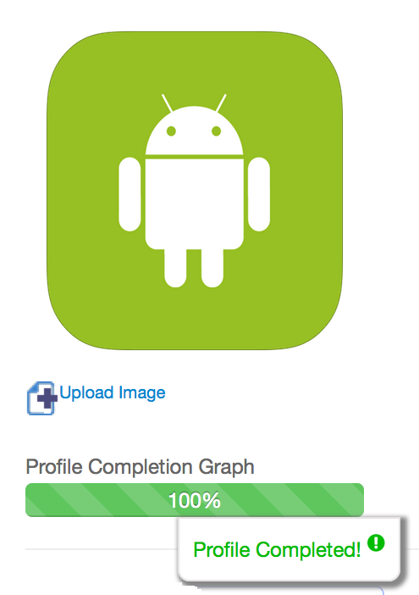

Figure UI-002 – Profile Completion Graph for Employer

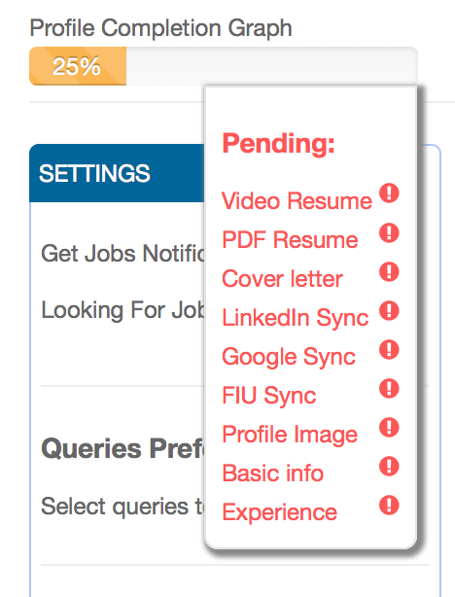

Figure UI-003 – Profile Completion Graph with Pending Drop Down

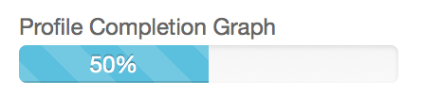

Figure UI-004 – Profile Completion Graph at 50%

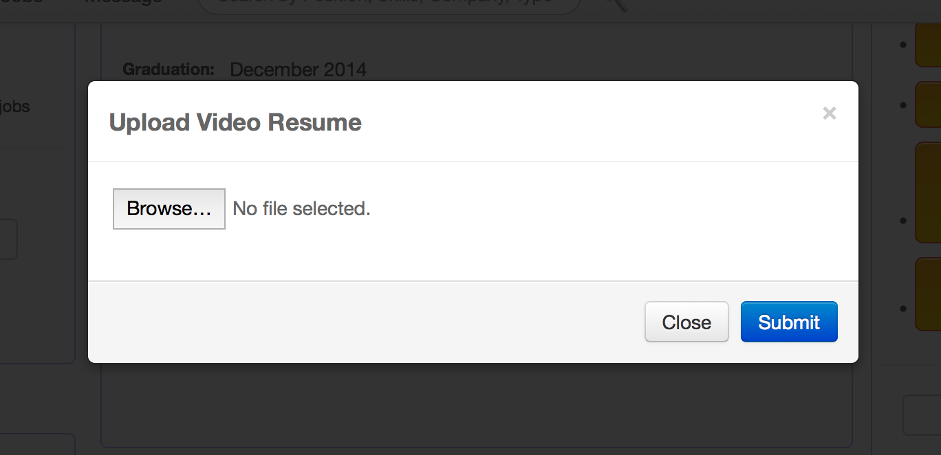

Figure UI-005 – Video Resume Uploads

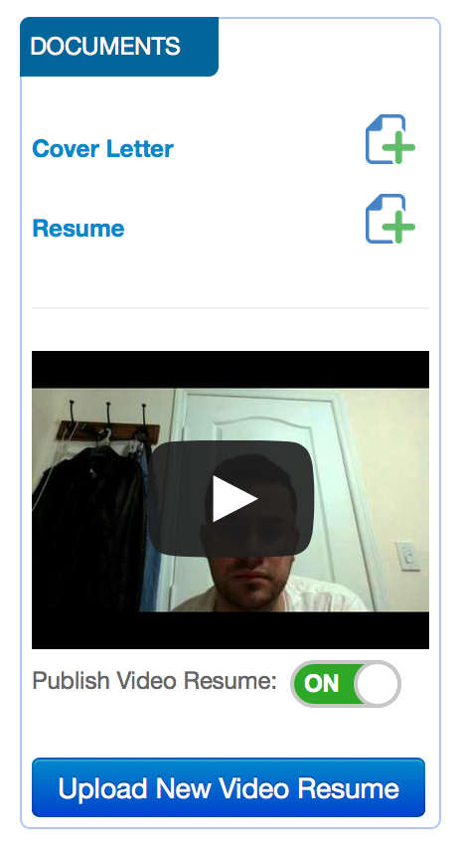

Figure UI-006 – Uploads and Documents

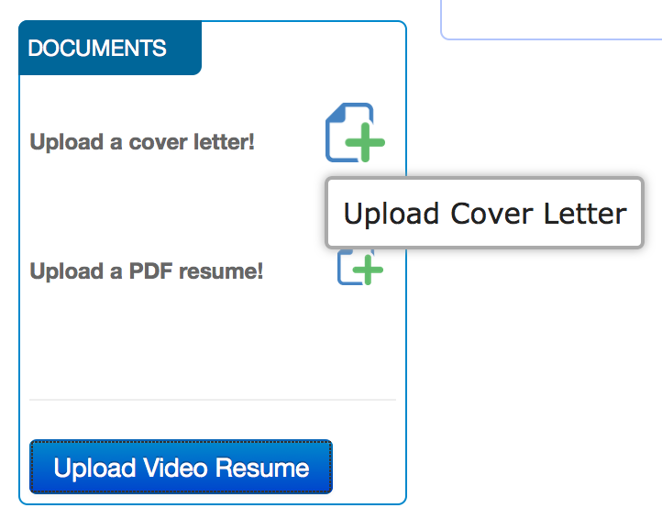

Figure UI-007 – Upload Cover Letter

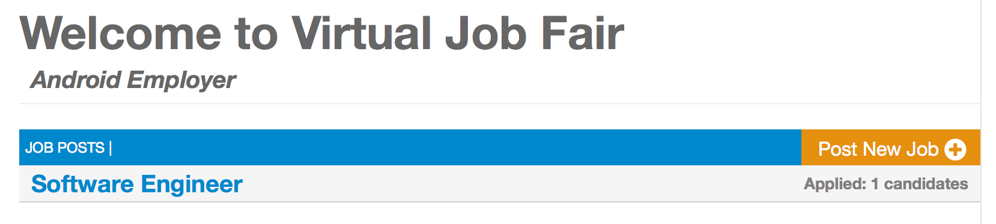

Figure UI-008 – Post New Job

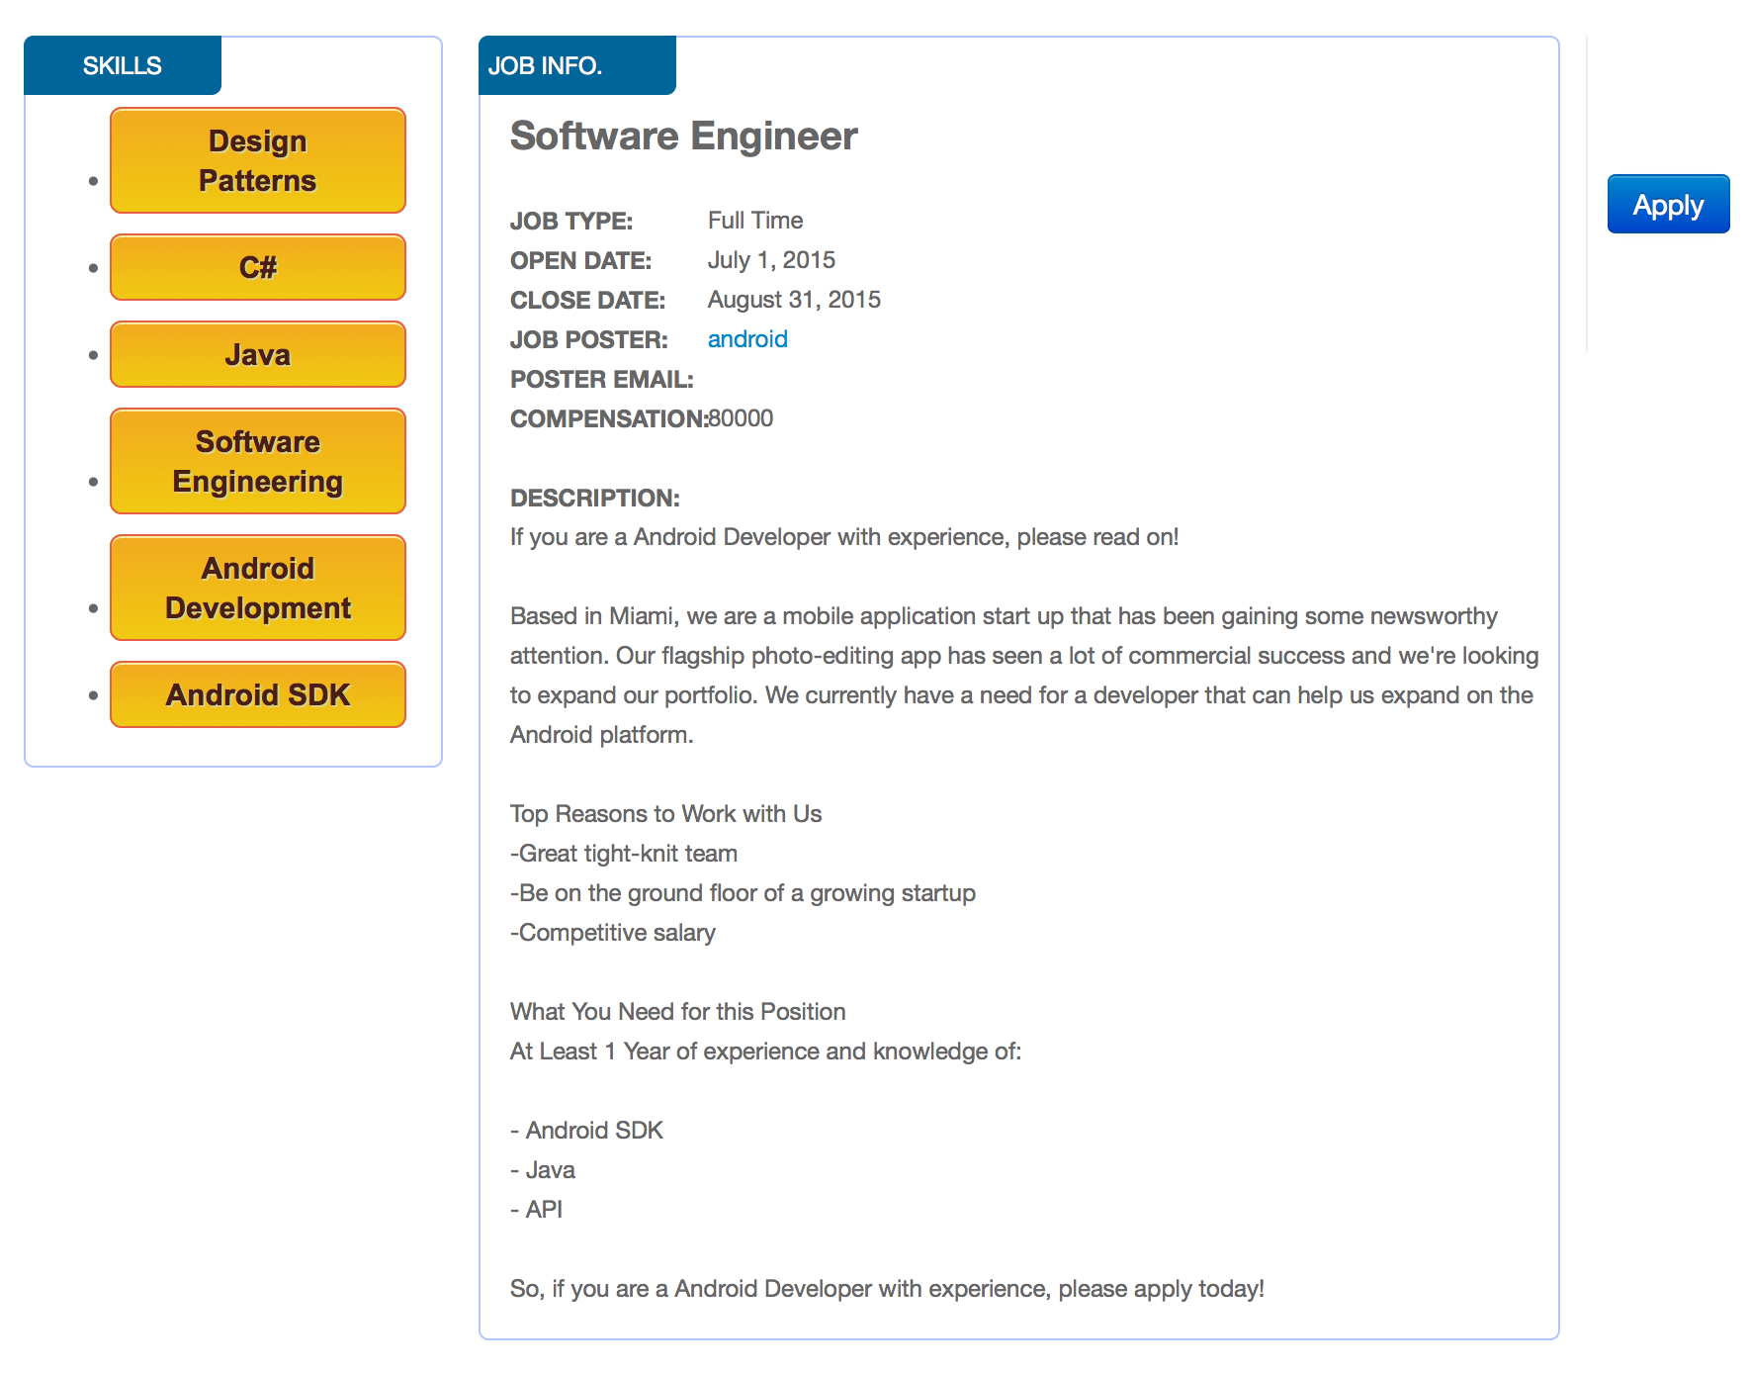

Figure UI-009 – Apply for Job

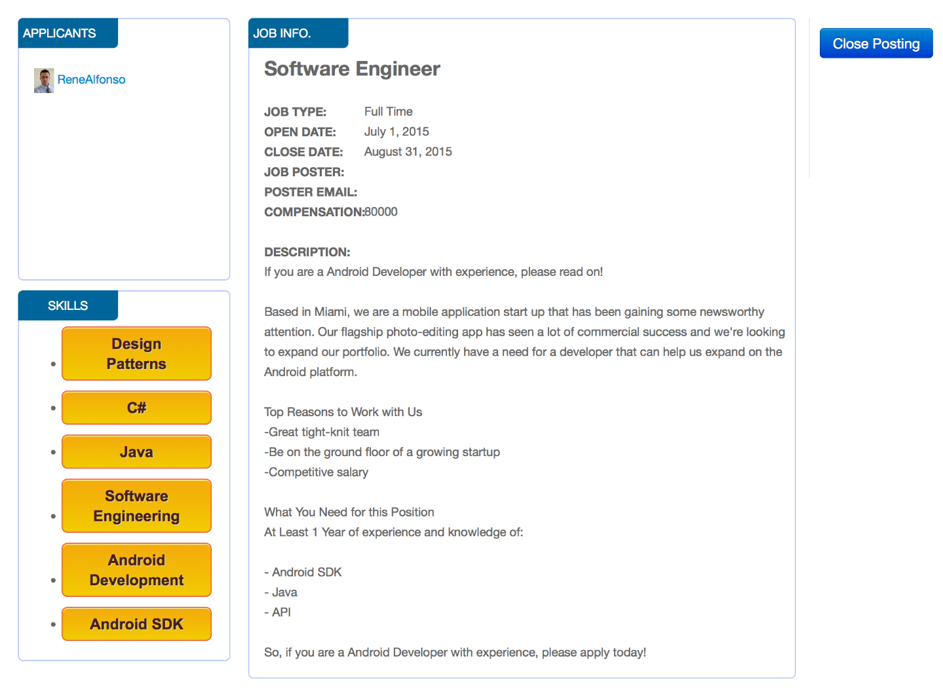

Figure UI-010 – Close Job as Employer

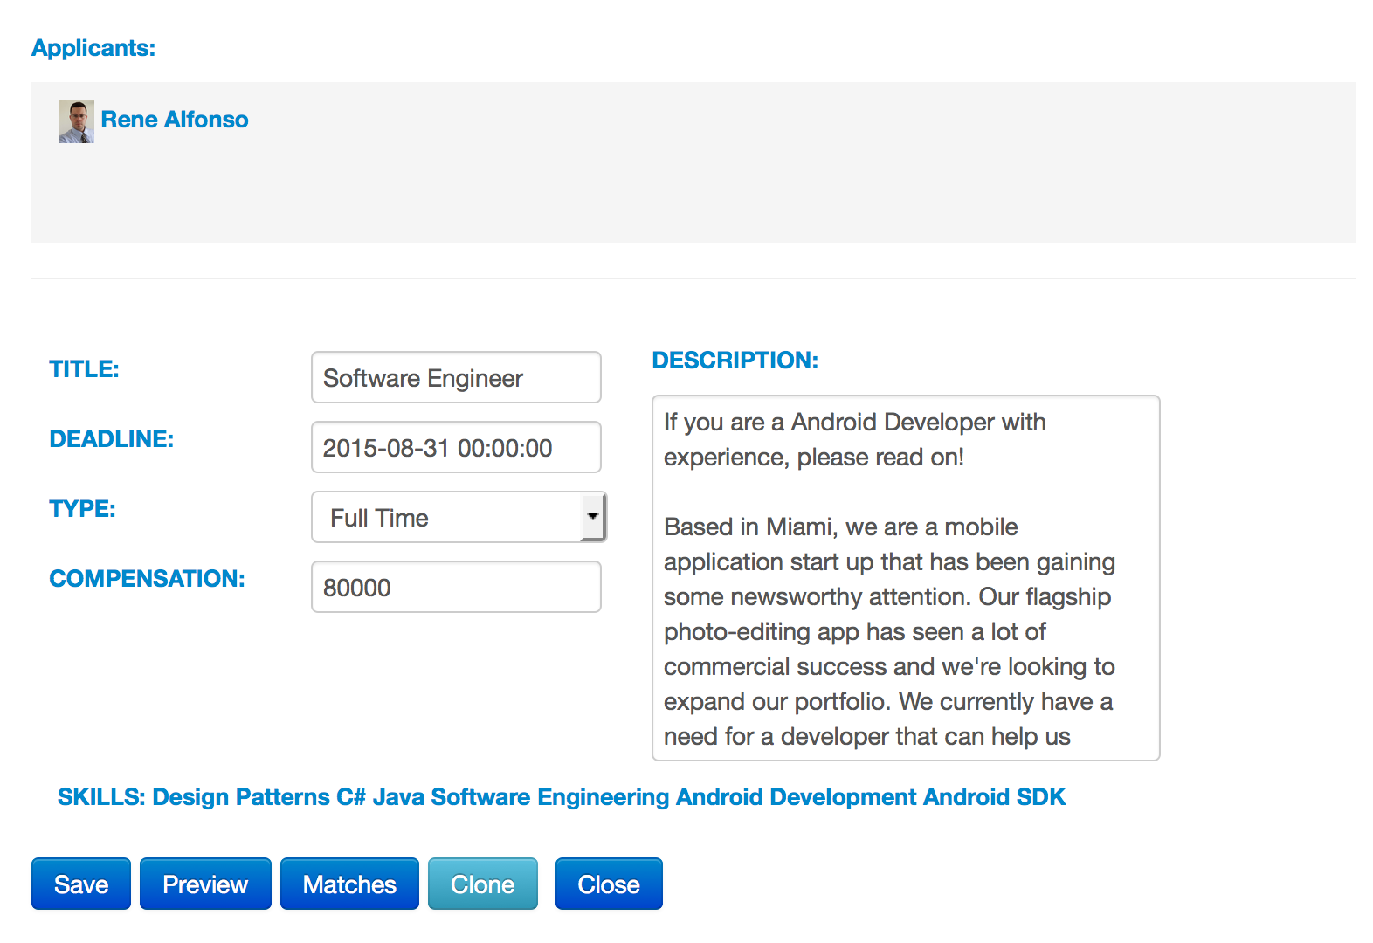

Figure UI-011 – Job View with Applicants

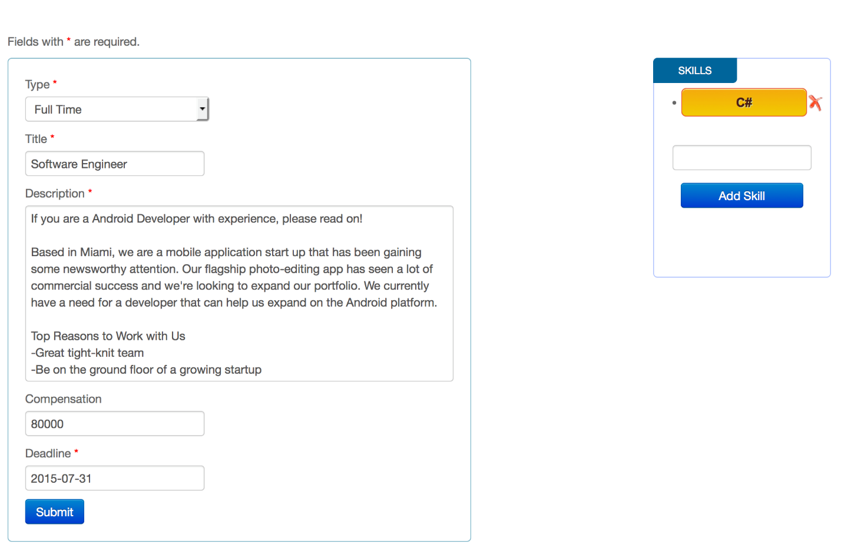

Figure UI-012 – Clone Job

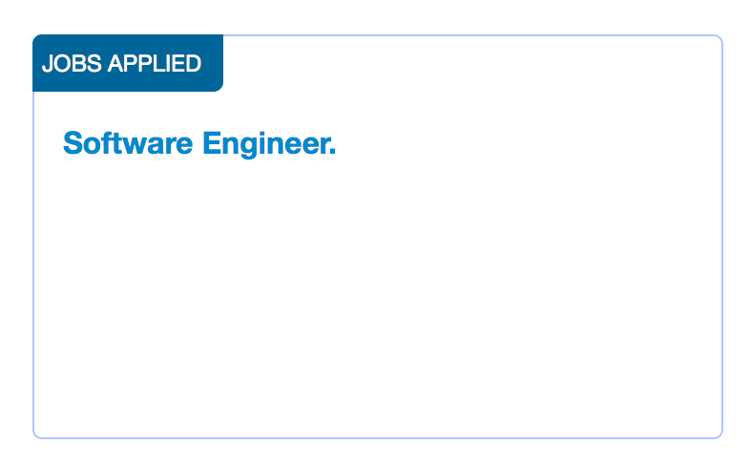

Figure UI-013 – Applied Jobs

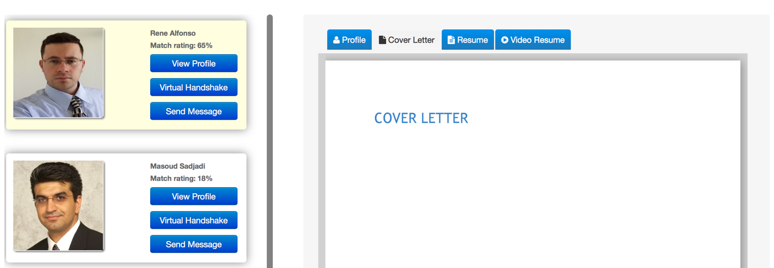

Figure UI-014 – Job Matching Page

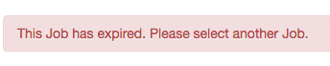

Figure UI-014b – Expired Job

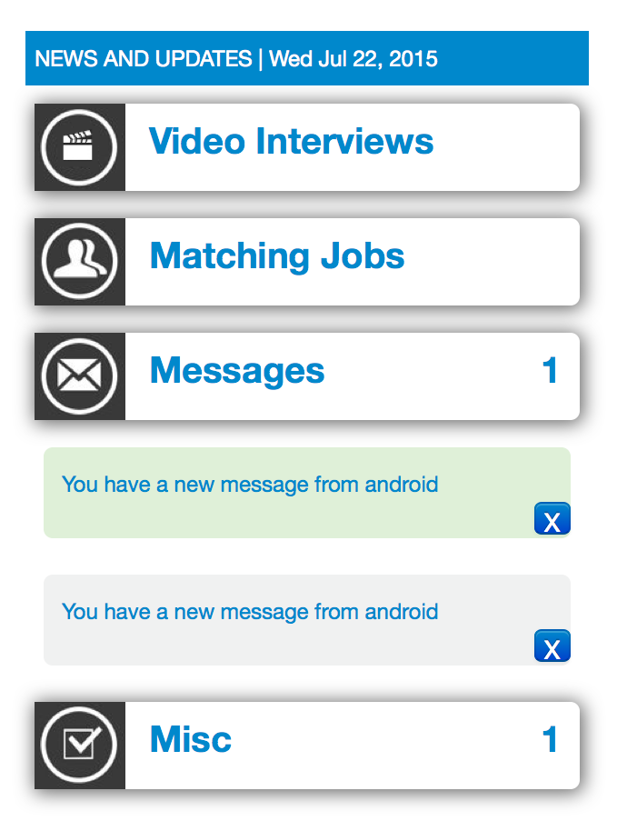

Figure UI-015 – Message Notifications

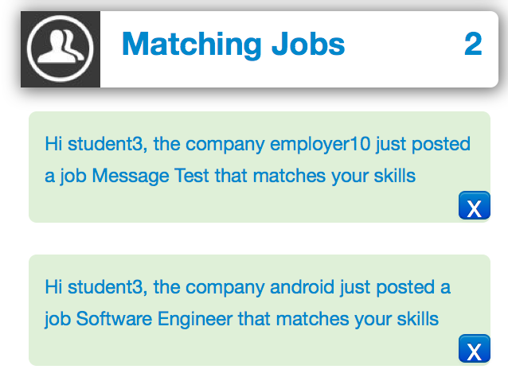

Figure UI-016 – Matching Jobs Notifications

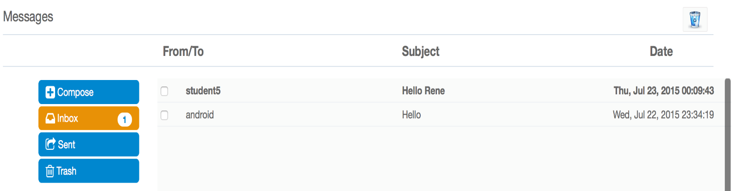

Figure UI-017 – Message Subsystem GUI

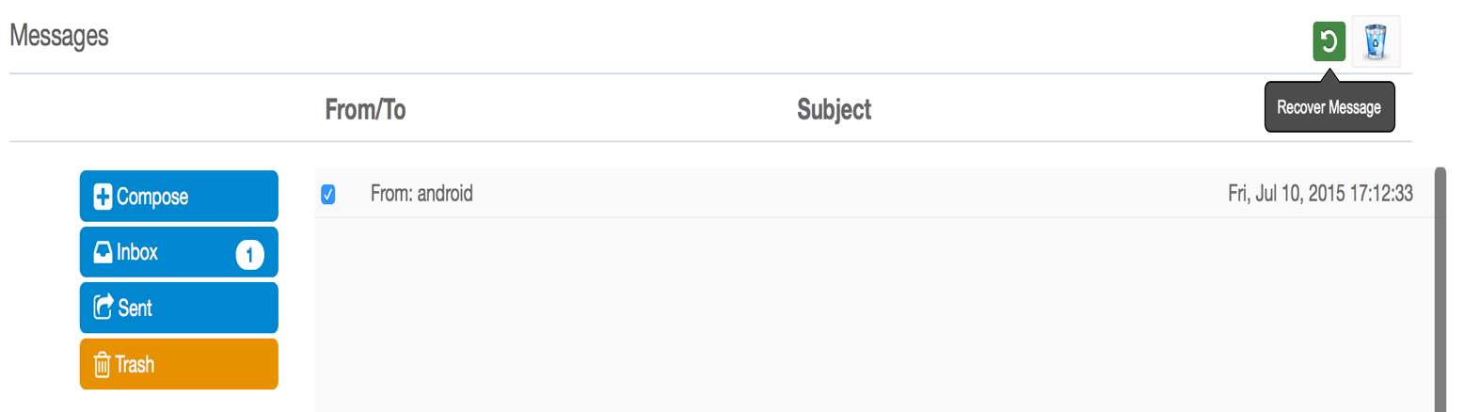

Figure UI-018 – Message Subsystem Recover Trashed Message

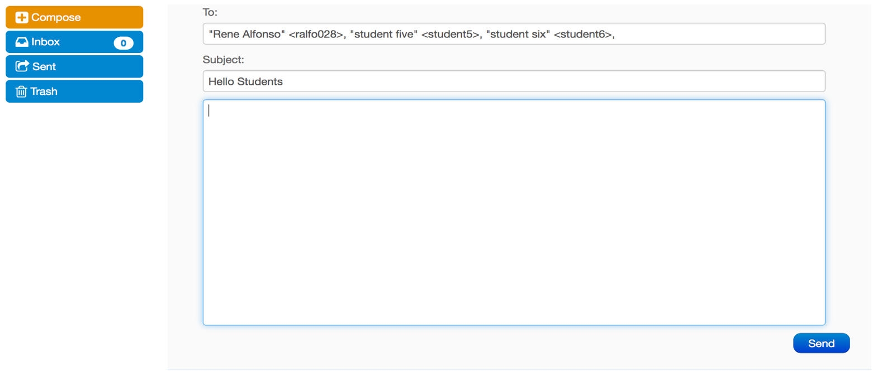

Figure UI-019 – Message to Multiple Recipients

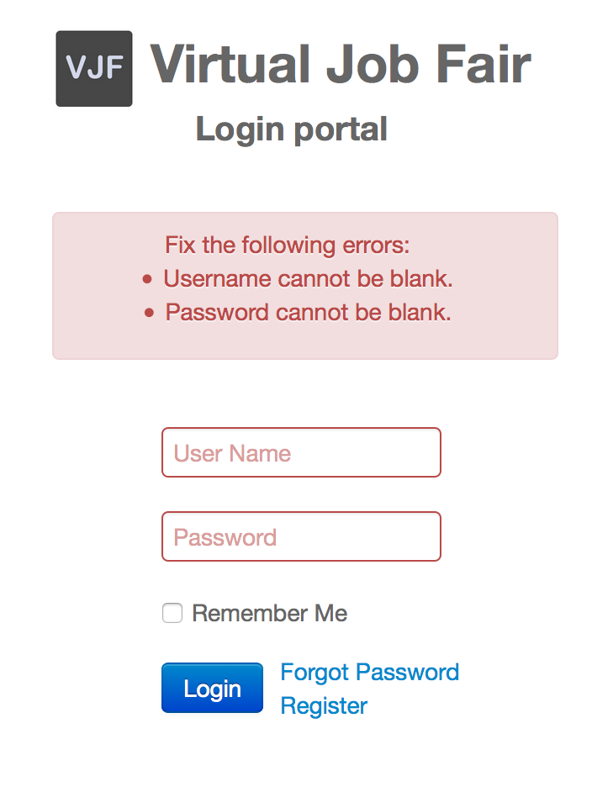

Figure UI-020 – Login

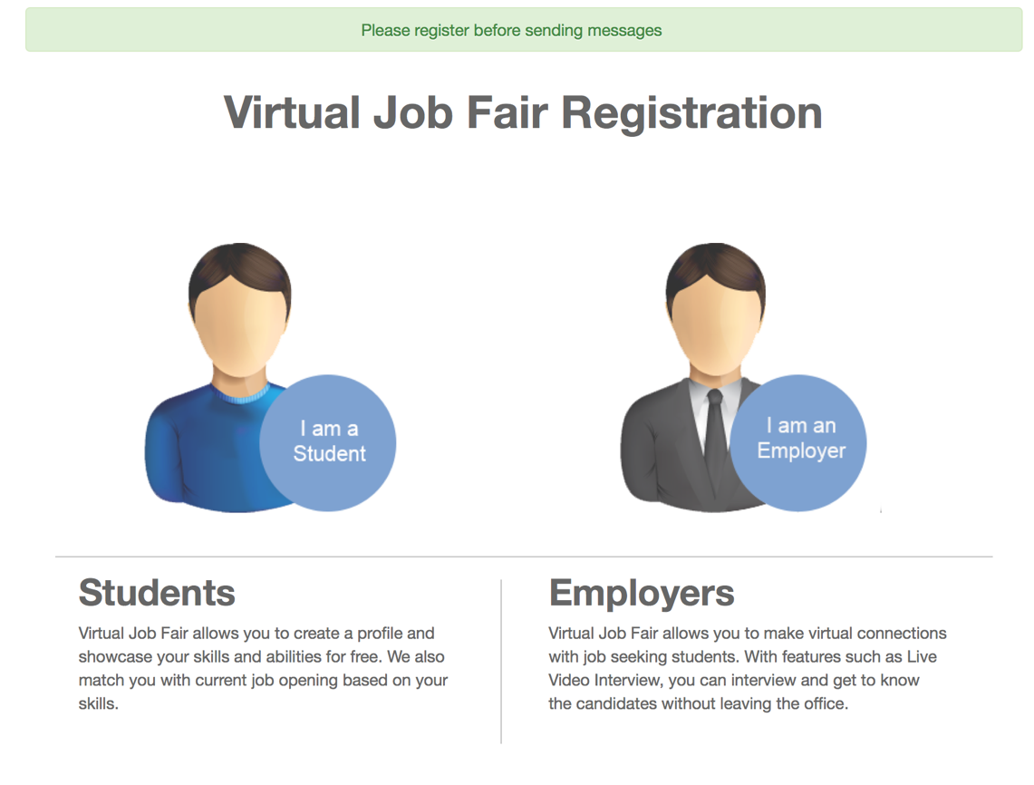

Figure UI-021 – Guest Sent to Register

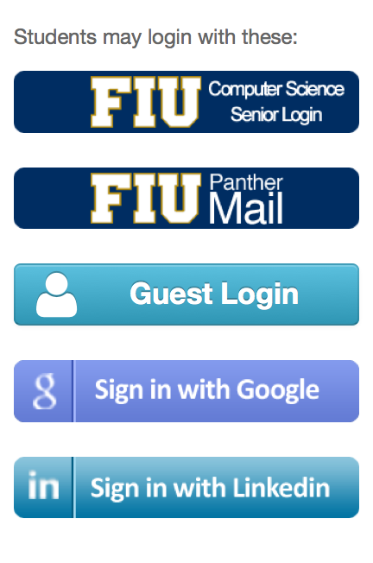

Figure UI-022 – Alternative Logins

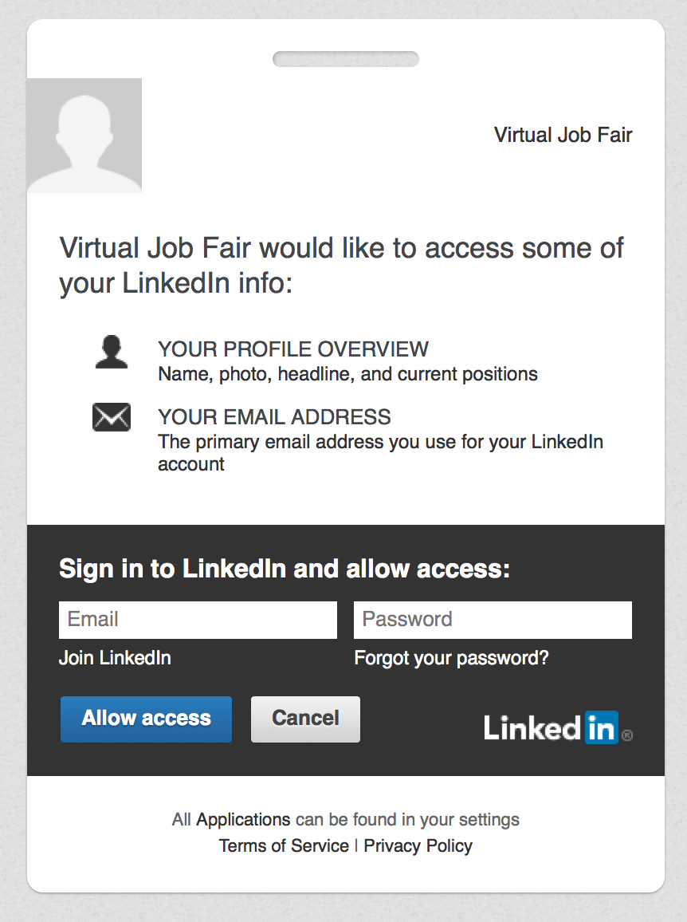

Figure UI-023 – LinkedIn

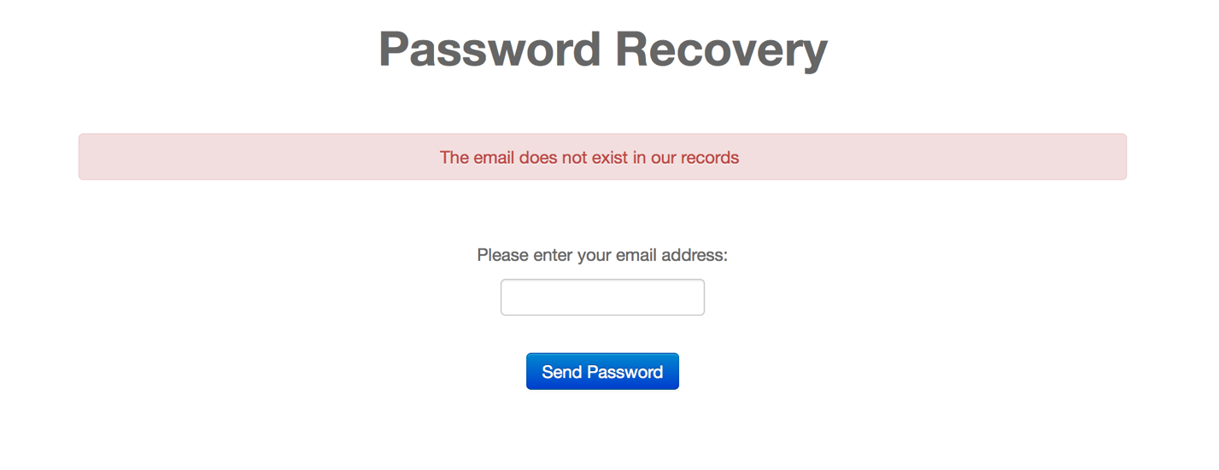

Figure UI-024 – Password Recovery

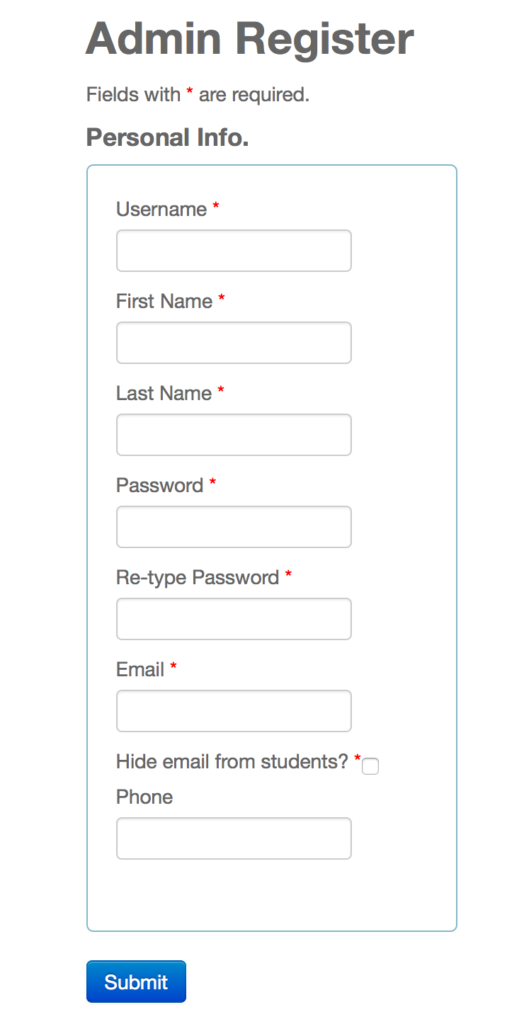

Figure UI-025 – Admin Creation



## Appendix C - Sprint Review Reports

Considering the initial goals, cost estimates, and acceptance criteria, briefly explain what was achieved and what was not achieved in this sprint. Specify the reasons for not being able to finish all the work that was initially planned for this sprint. Specify if the product backlog was modified as a result of this meeting and if so, how.

**Sprint 1 Report**

**Date:** May 29, 2015

**Attendees:** Masoud Sadjadi, Yanniel Malagon, and Rene Alfonso

**Discussed Topics:**

The initial goals were: to create the new feature which would upload video resumes to the VJF YouTube channel, to allow employers and students to view these video resumes at will, to test the admin features, the student features, and the employer features, and compare and contrast Career Services features with those of VJF.

We achieved the new feature of uploading a video resume and viewing it, as well as testing all the admin features. From this testing a lot of defect user stories were created for any bug that was found.

Test employer features and student features were not completed.

Compare features was not completed.

**Sprint 2 Report**

**Date**: June 12, 2015

**Attendees:** Fernando Figueredo, Masoud Sadjadi, Yanniel Malagon, and Rene Alfonso

**Discussed Topics:**

The initial goals were to finish testing all the website’s features, to create defect stories for all the bugs that were identified, and to fix those bugs. We ended the Sprint with 117 hours completed and with multiple bugs fixed. We agreed that there were still many more bugs in the defect backlog that we had identified and that those bugs needed to be fixed. We finished all the work we set out to do. Thus, we were able to makeup all the lost hours from Sprint 1.

We presented all our work. We also presented all the current features of the website to the product owner Fernando Figueredo.

We presented using Selenium to show all the fixes we had made.

We concluded we the professor congratulating us on our work and reminding us to keep up the good work.

**Sprint 3 Report**

**Date**: June 26, 2015

**Attendees:** Masoud Sadjadi, and Rene Alfonso

**Discussed Topics:**

Due to scheduling conflicts Yanniel Malagon was not able to attend the meeting at 5:00pm. However, the meeting went well. We talked about all the work we had done and presented it to professor Sadjadi. We went over the logic behind the profile completion graph and about its ingenious reusability, that lends itself for further use and improvement of the website. We went over the new feature that lets students upload cover letters and lets employers view them. We discussed the many enhancements to the Message subsystem. We concluded we the professor congratulating us on our work. Professor Sadjadi decided that “for Sprint 4 all the bugs are to be fixed”. The plan was to get the website production ready by the end of Sprint 4.

**Sprint 4 Report**

**Date**: July 10, 2015

**Attendees:** Emmanuela Stanislaus, Masoud Sadjadi, and Rene Alfonso

**Discussed Topics:**

We discussed all the bugs that were fixed during this sprint; amongst the most important were the guest account restrictions that were implemented, error checking for sending internal messages, the notifications subsystem was improved, and several others.

It was discussed that Emmanuela would be extremely happy to see a video of the profile completion graph feature and that completing such video would be high priority.

Dr. Sadjadi made it clear that for Sprint 5 the documentation was of utmost priority. All of our work should be well documented in the Final Deliverable document.

**Sprint 5 Report**

**Date**: July 24, 2015

**Attendees:** Masoud Sadjadi PhD, and Rene Alfonso

**Discussed Topics:**

…

## 

## 

## Appendix D - Sprint Retrospective Reports

**Sprint 1 Retrospective**

**Date:** May 29, 2015

**Attendees:** Yanniel Malagon and Rene Alfonso

**Discussed Topics:**

During our retrospective meeting we agreed that we worked well as a team. Our biggest struggle was learning selenium. We did not calculate how long it would take us to learn both Selenium and to get familiar with the Yii framework, therefore we could not finish all our user stories. We agreed that we would make up the lost hours from Sprint 1 in this Sprint, that is, we would go over the eighty-hour cap limit for Sprint 2. We did, however, marvel about how nicely the YouTube subsystem was integrated into the system. We also agreed to be more organized with Mingle, so that we could quickly distinguish individual user stories by section, Yanniel’s user stories would always go above Rene’s by order of priority of course.

**Sprint 2 Retrospective**

**Date**: June 12, 2015

**Attendees:** Yanniel Malagon and Rene Alfonso

**Discussed Topics:**

It was discussed that we did an excellent job with all the user stories that we picked. We finished all the user stories that were carried over from the last sprint; we finished the test features user stories. We then found, recorded into the Defect Backlog, and fixed many bugs. We enhanced certain areas of the website. Ultimately we agreed that we found our rhythm and that we should continue at this pace for Sprint 3.

**Sprint 3 Retrospective**

**Date**: June 26, 2015

**Attendees:** Yanniel Malagon and Rene Alfonso

**Discussed Topics:**

It was discussed that we solved many bugs. That we did very well with our time. And that the profile completion graph, especially the logic behind it, was well received by Dr. Sadjadi. We discussed that for Sprint 4 it was of paramount importance to fix all the bugs left in the Defect Backlog. We also agreed to seek out the mentors for actively as it was becoming a bit more difficult to get in contact with them.

**Sprint 4 Retrospective**

**Date**: June 10, 2015

**Attendees:** Yanniel Malagon and Rene Alfonso

**Discussed Topics:**

We discussed that one of the product owners, Emmanuela, was interested in seeing the Profile Completion Graph feature in a video. We also discussed that our main priority was to work on documentation, as suggested by professor Sadjadi. Any user story unfinished, in this case the LinkedIn profile link is to be finished at the end of this sprint. Everything must be well documented. It was also agreed that both students should make arrangements to be present at the next Sprint Review meeting, which will be of critical importance.

**Sprint 5 Retrospective**

**Date**: July 24, 2015

**Attendees:** Yanniel Malagon and Rene Alfonso

**Discussed Topics:**

We discussed that we finished the documentation. That we did an excellent job concluding the final document, however, we still needed to keep focus and prepare video tutorials that will be used by future developers. That we need to prepare a presentation and posters. We agreed that the last week would require extreme focus and dedication to finish the semester strongly and with quality work.

# References

Alonso, R. (2015). 1.2 Background. In *Feasibility Study and Project Plan*. Miami, FL.

OAuth 1.0 for Web Applications. (n.d.). Retrieved July 23, 2015, from https://developers.google.com/identity/protocols/OAuthForWebApps